Create Repository and Clone It

.git folder
# Source: AI Source: Provided by: [Data Path: Persons Table -> ID Column: 1, Name_En Column: Motasem Essam] -> From: [Chatgpt (GPT‑5 Mini)] on [2/17/2026]
The .git folder is the hidden directory inside a Git repository that stores all the data and metadata Git needs to track your project. It’s basically the “brain” of your repository.
Here’s what the .git folder contains:
Core parts
- HEAD
Points to the current branch you are on.
- config
Repository-specific settings (user, remotes, hooks, etc.).
- index
The staging area (what will go into the next commit).
- objects/
The most important folder — stores all commits, files, and history in compressed form (blobs, trees, commits, tags).
- refs/
Stores pointers to commits (branches, tags, remotes).
- logs/
History of where HEAD and branches have pointed (used for recovery like git reflog).
- hooks/
Scripts that run automatically on events (e.g., pre-commit, pre-push). Disabled by default.
- info/
Extra repository info (like exclude file for ignored files locally).
In simple terms
The .git folder contains:
- Your entire commit history
- All branches and tags
- The staging area
- Repo configuration
- Recovery and internal tracking data
If you delete the .git folder, your project files remain, but Git loses all history and version control.
# Source: ScreenShots Source: Provided by: [Persons Table -> ID Column: 1, Name_En Column: Motasem Essam] -> Tool: [Lightshot Program] -> From [Windows] on [2/17/2026]
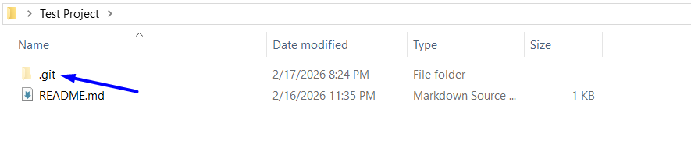
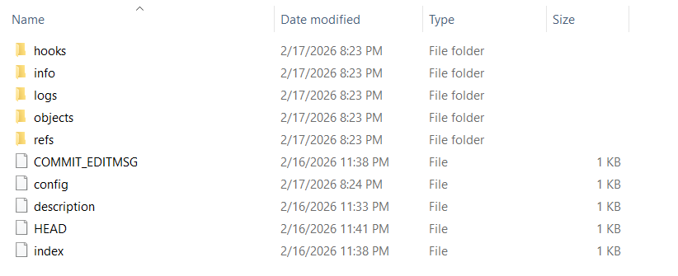

Github

Sign Up
# Source: ScreenShots Source: Provided by: [Persons Table -> ID Column: 1, Name_En Column: Motasem Essam] -> Tool: [Lightshot Program] -> From [Site: Google Search: All: Git] on [2/17/2026]
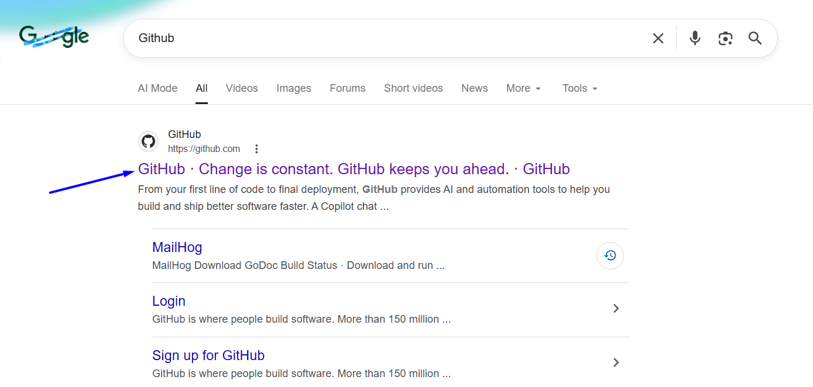
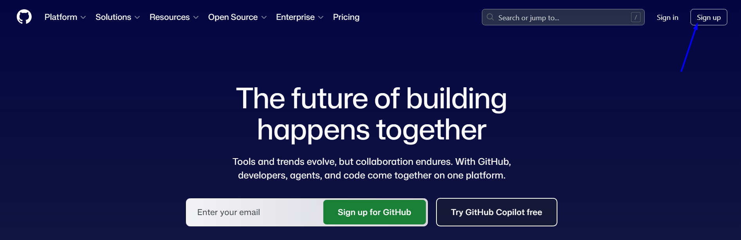
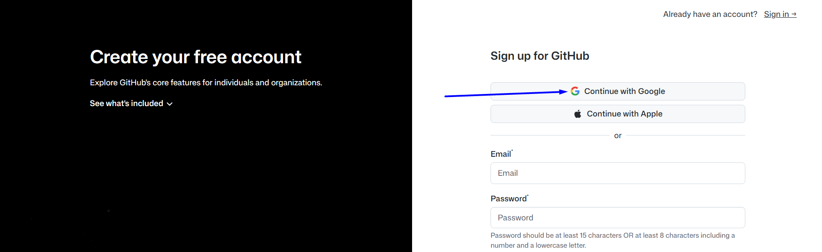
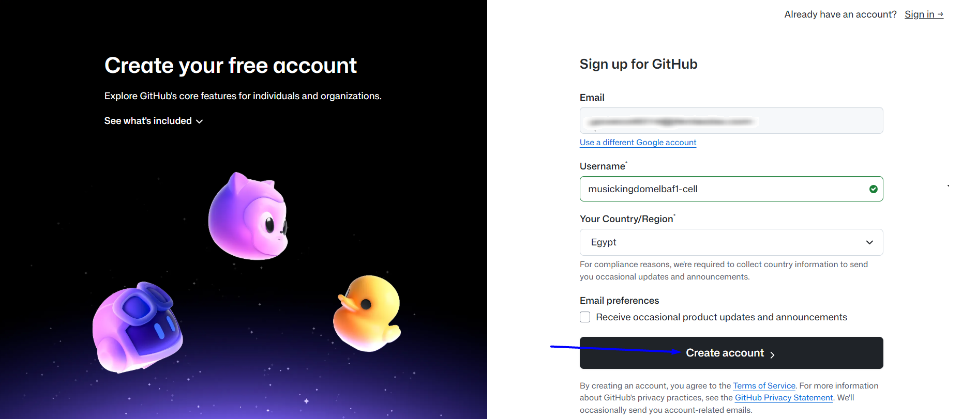
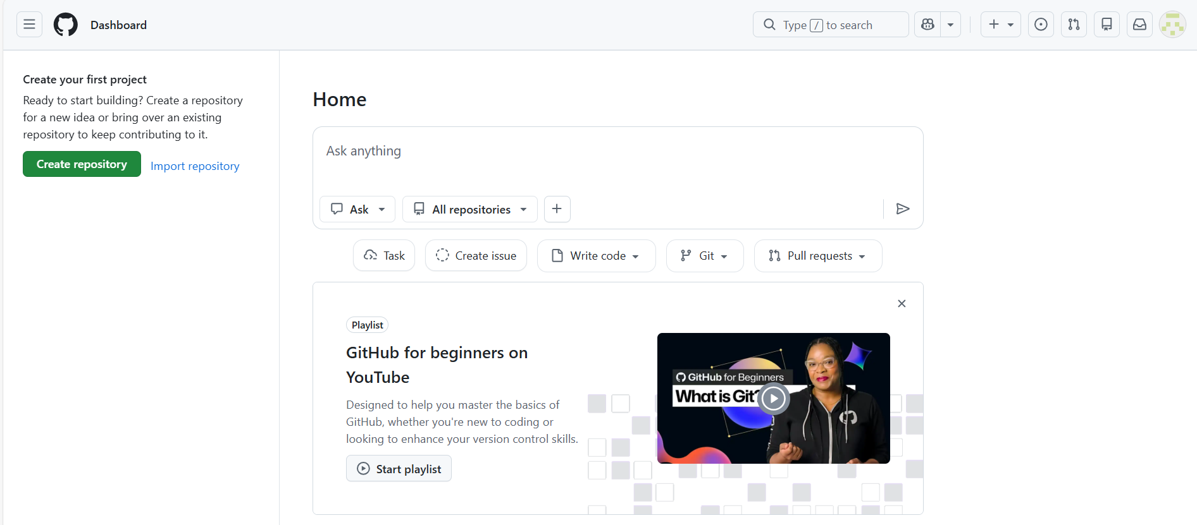

Create repository
# Source: ScreenShots Source: Provided by: [Persons Table -> ID Column: 1, Name_En Column: Motasem Essam] -> Tool: [Lightshot Program] -> From [Site: https://github.com] on [2/17/2026]
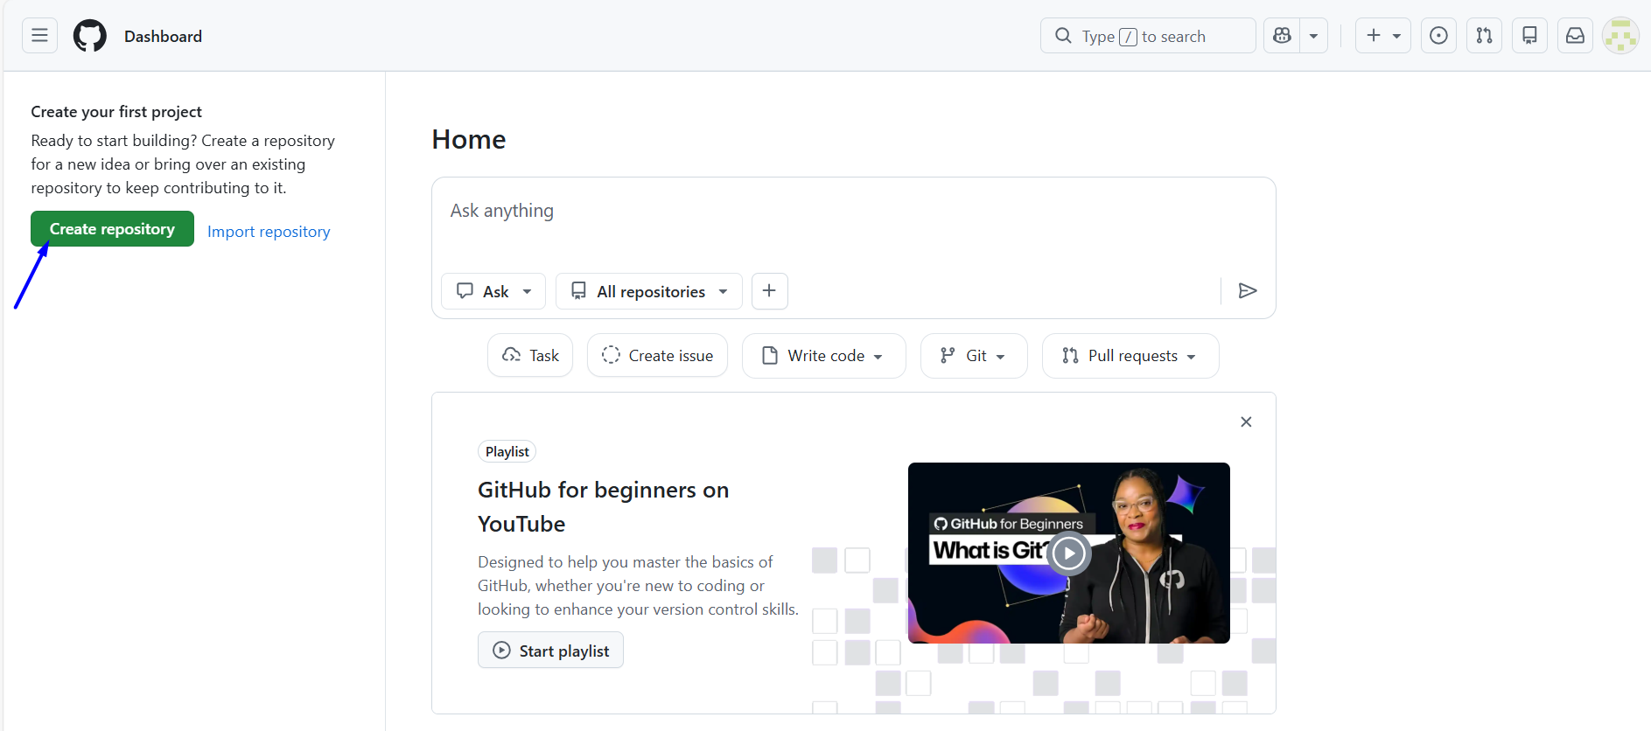
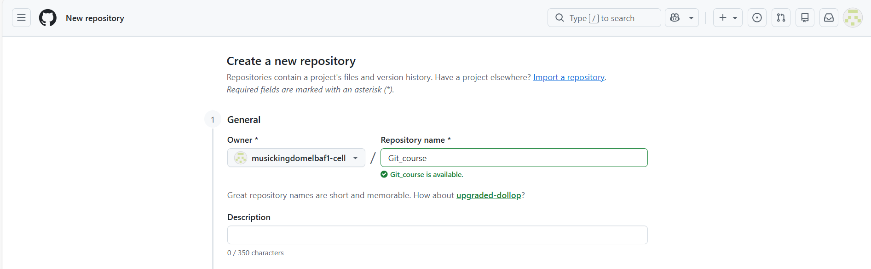

Create repository Without Readme
# Source: ScreenShots Source: Provided by: [Persons Table -> ID Column: 1, Name_En Column: Motasem Essam] -> Tool: [Lightshot Program] -> From [Site: https://github.com] on [2/17/2026]
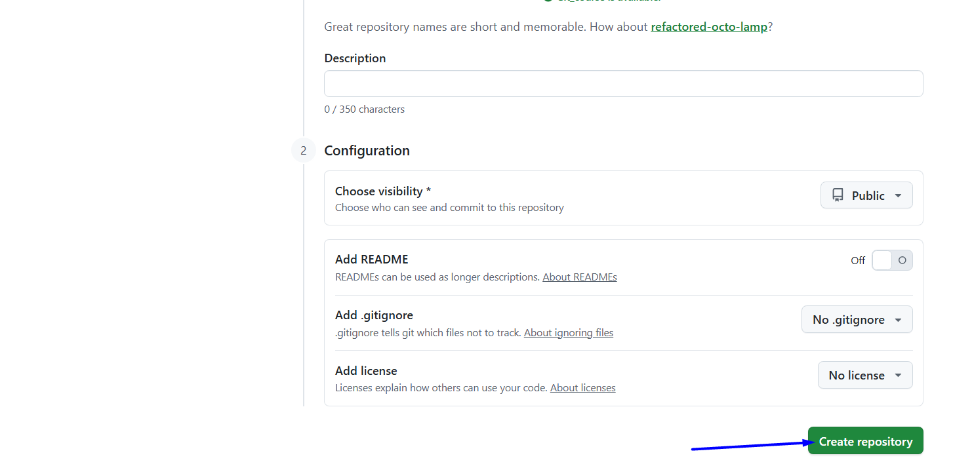
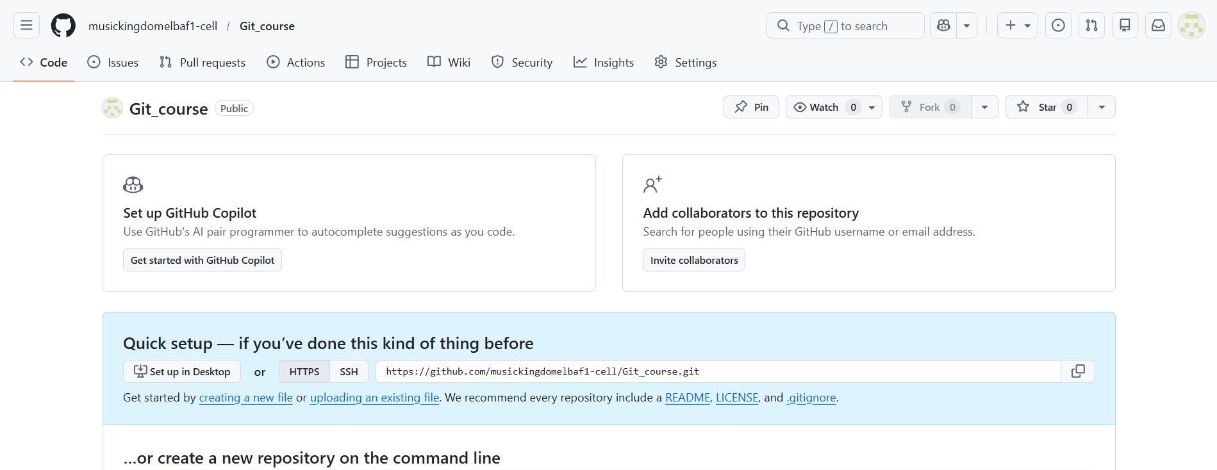

Create repository with Readme
# Source: ScreenShots Source: Provided by: [Persons Table -> ID Column: 1, Name_En Column: Motasem Essam] -> Tool: [Lightshot Program] -> From [Site: https://github.com] on [2/17/2026]

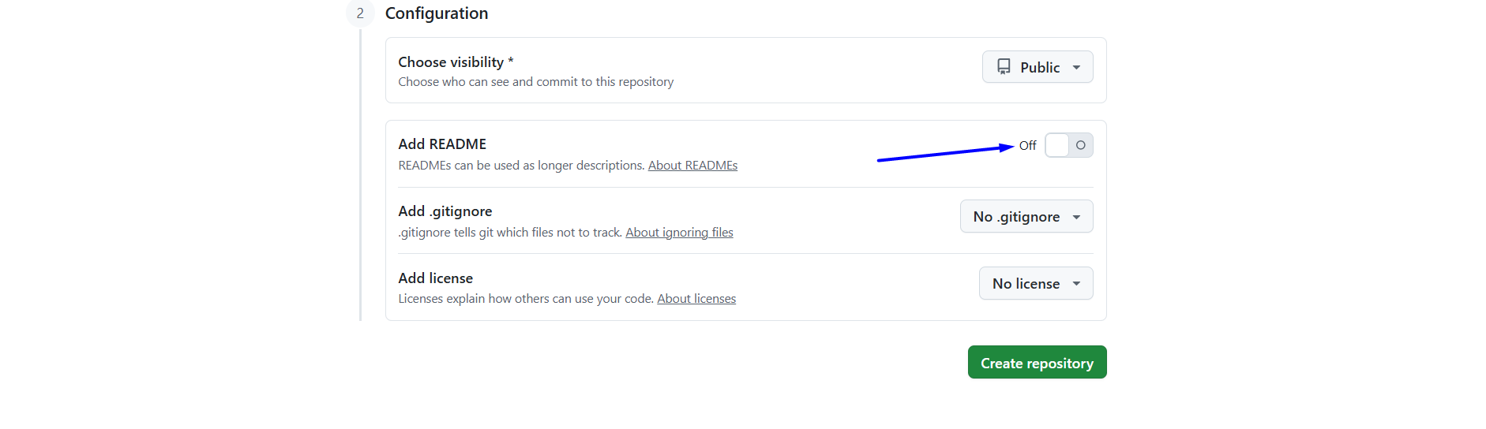
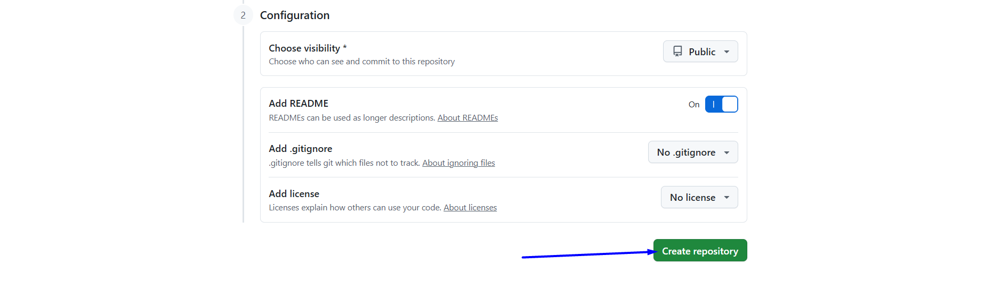
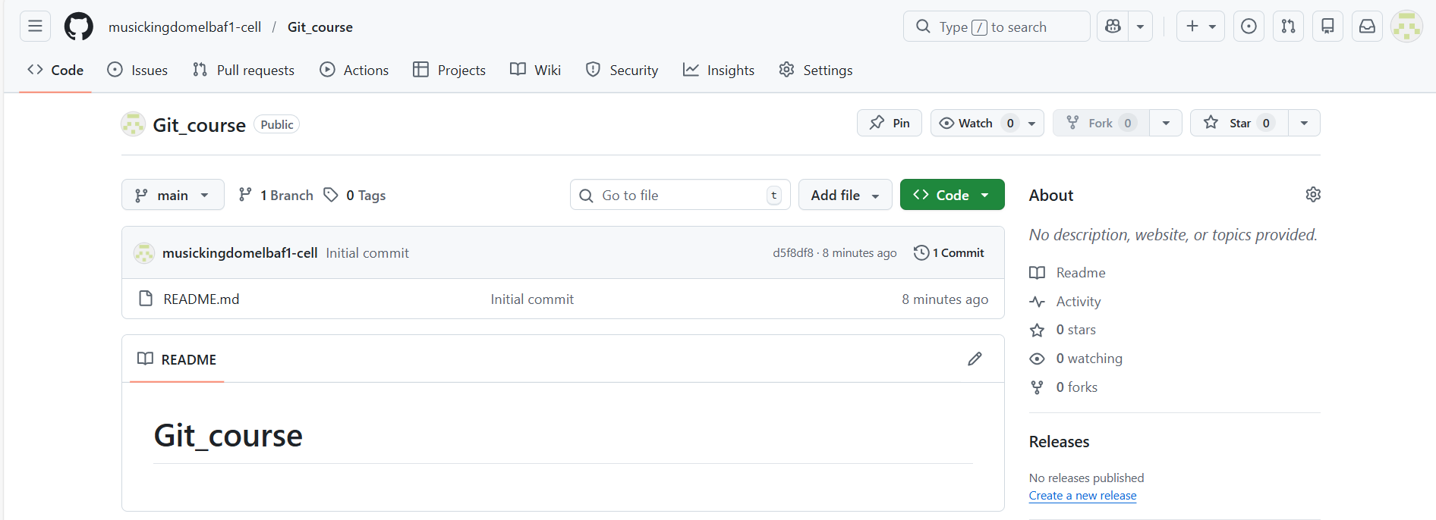

Edit Readme
# Source: ScreenShots Source: Provided by: [Persons Table -> ID Column: 1, Name_En Column: Motasem Essam] -> Tool: [Lightshot Program] -> From [Site: https://github.com] on [2/17/2026]
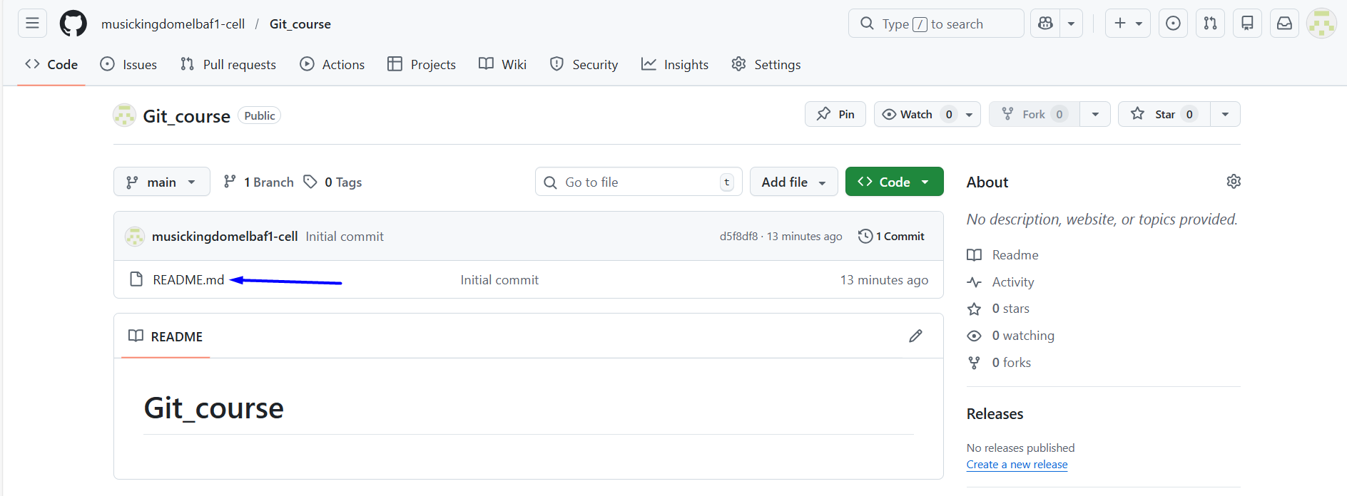
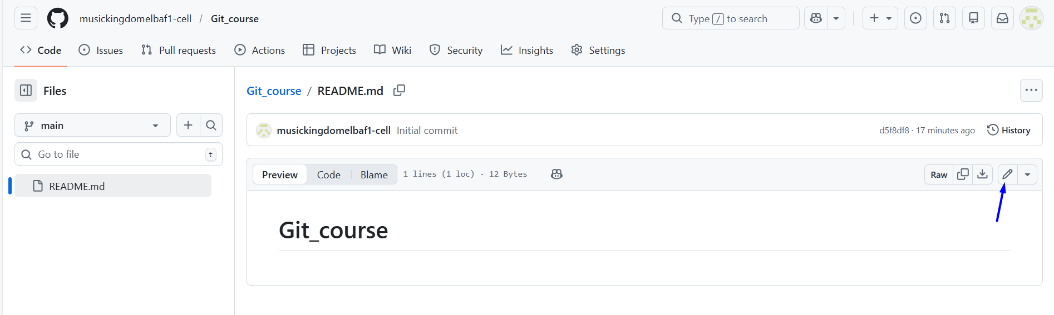
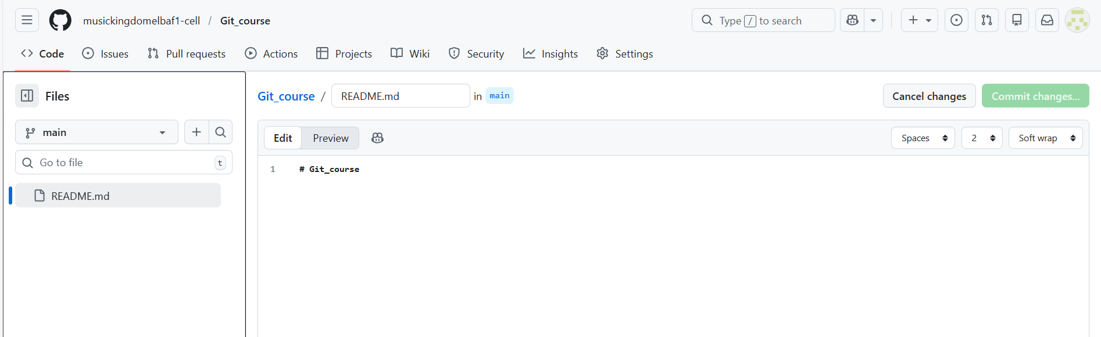
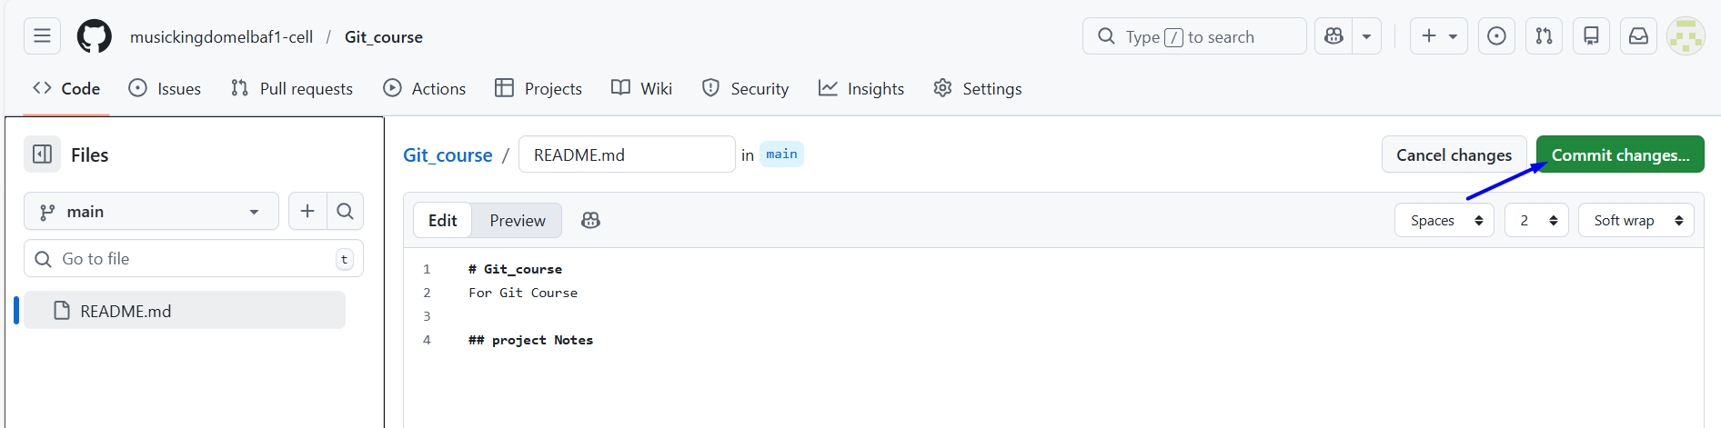
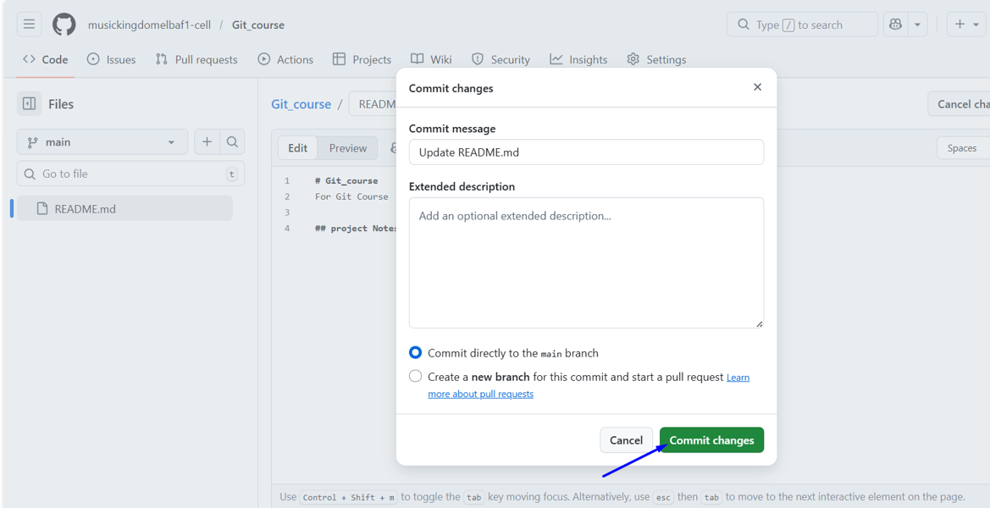

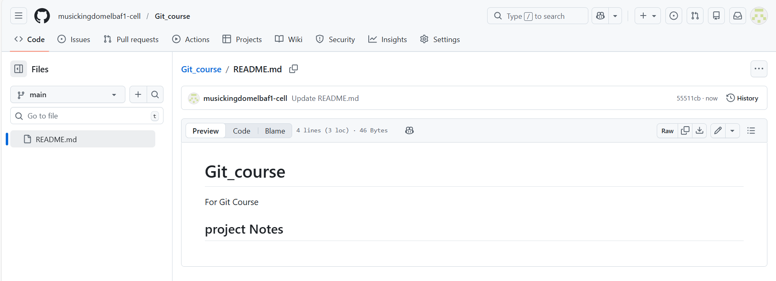

Add access to that repo
# Source: ScreenShots Source: Provided by: [Persons Table -> ID Column: 1, Name_En Column: Motasem Essam] -> Tool: [Lightshot Program] -> From [Windows] on [2/17/2026]
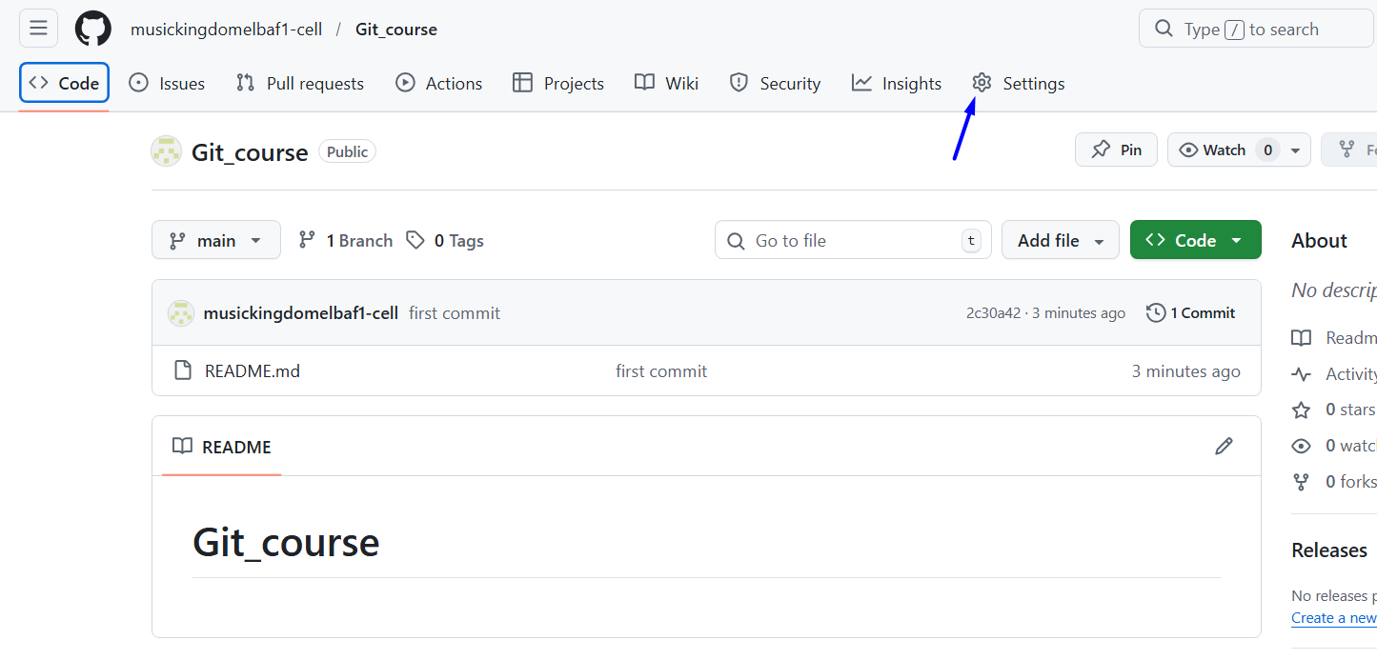
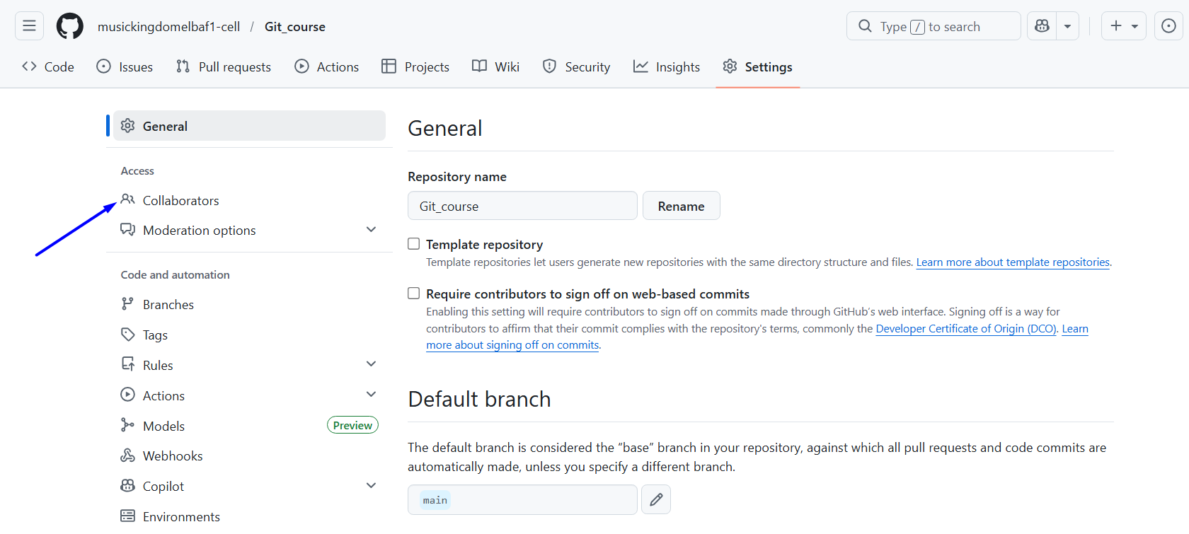
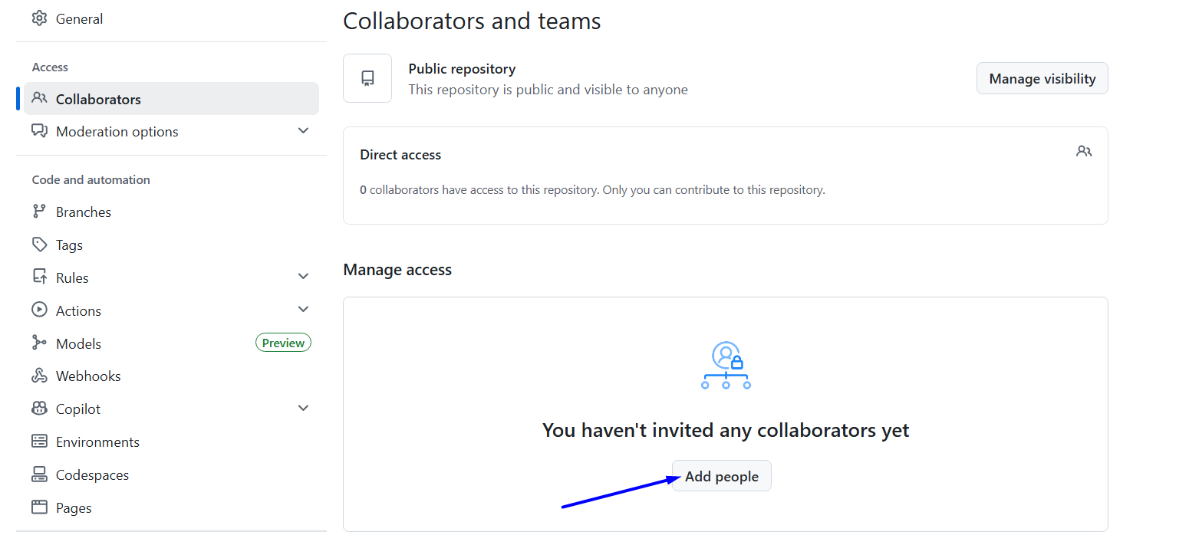
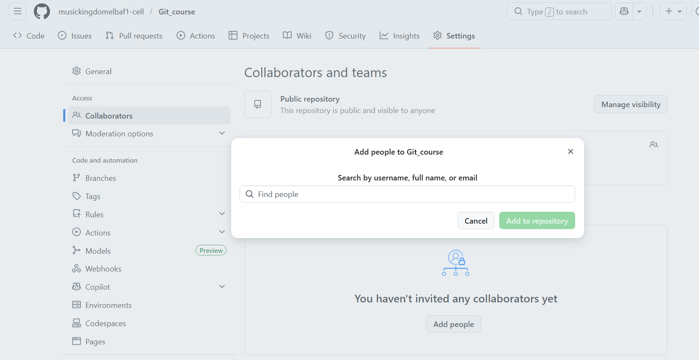
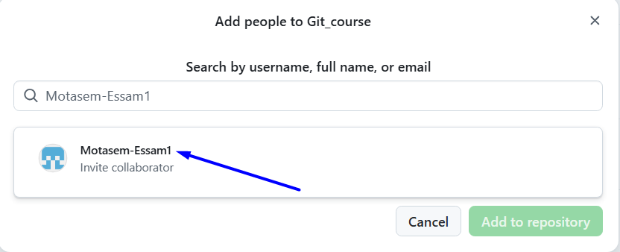
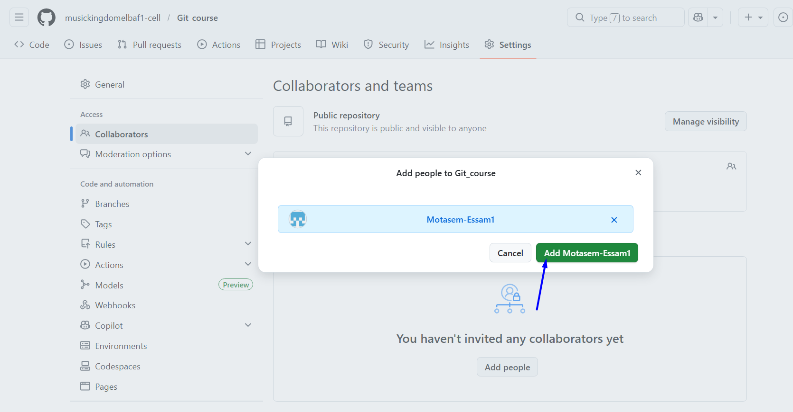
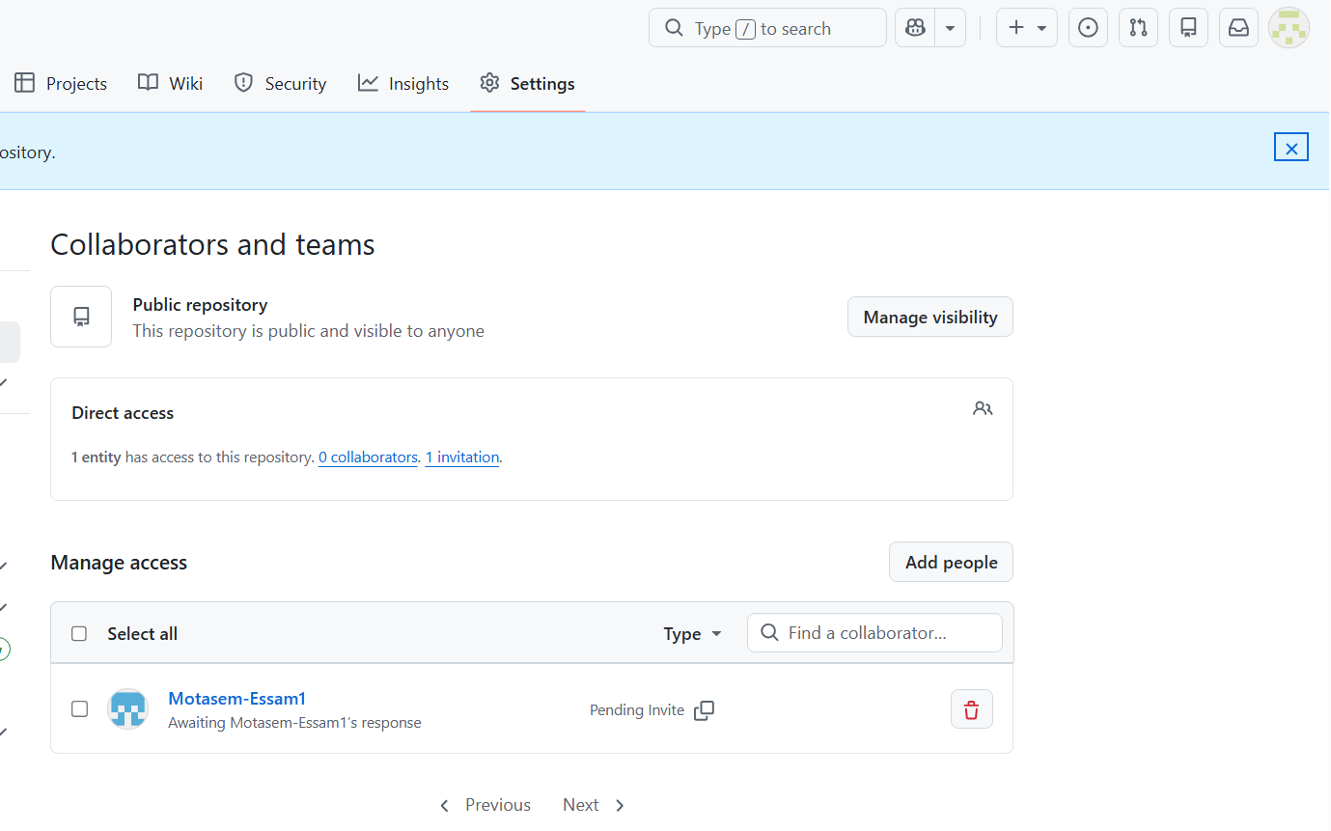
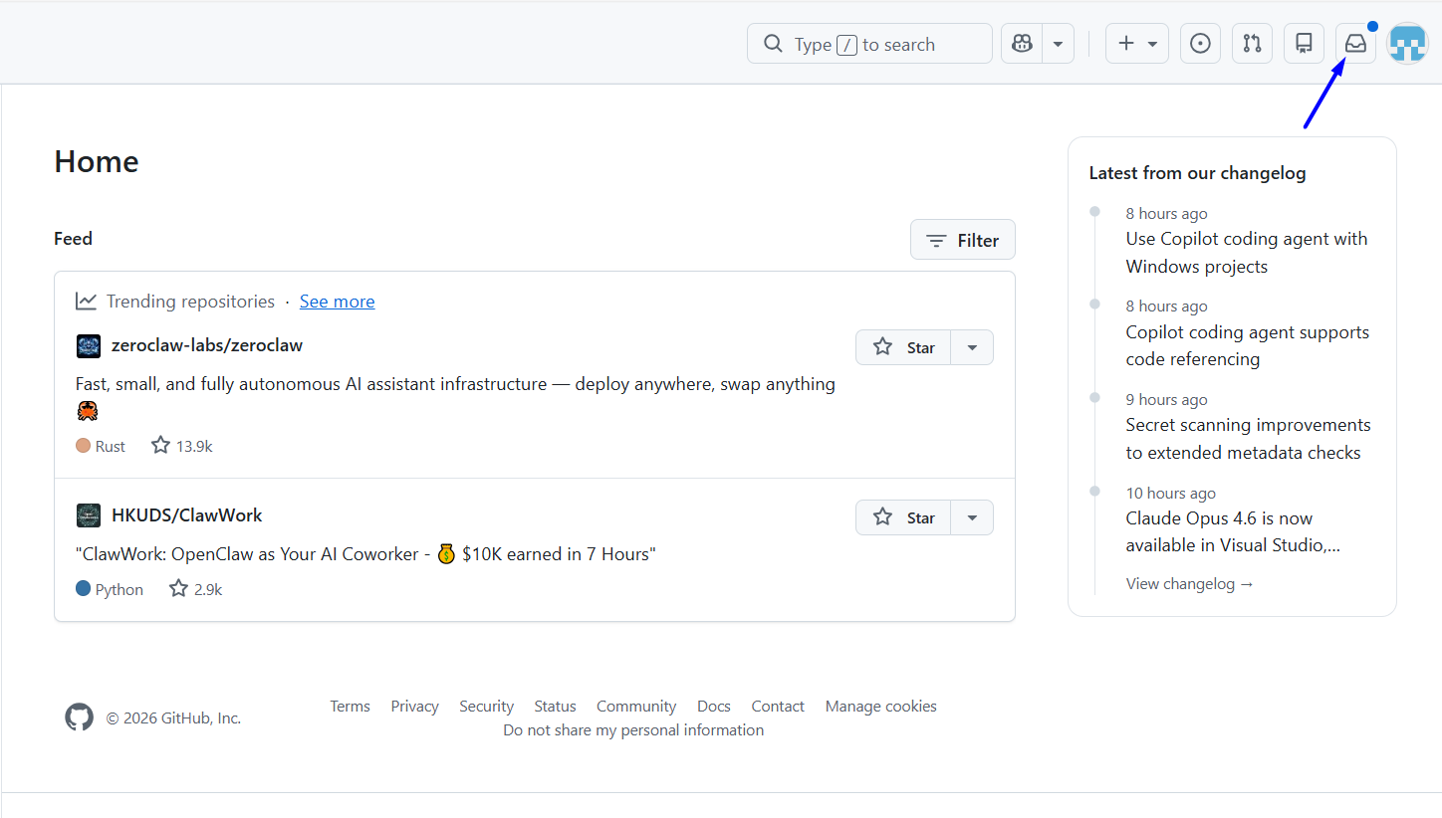
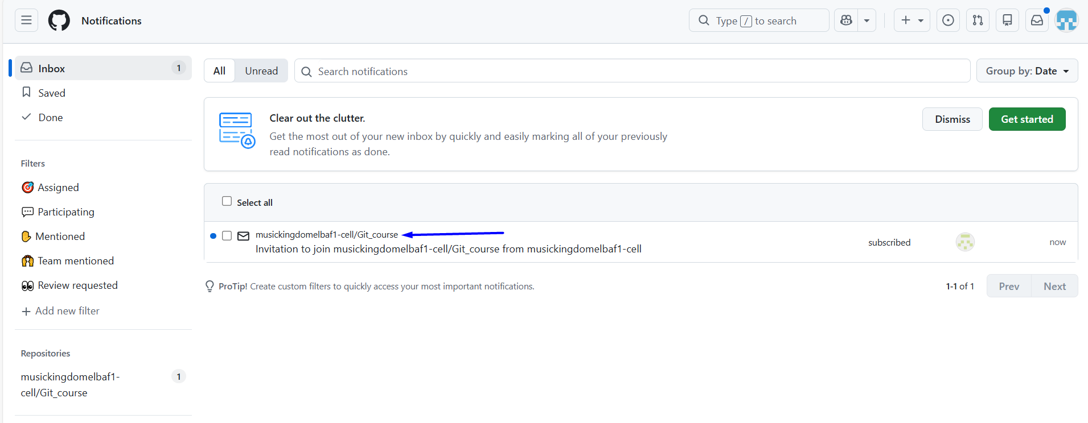
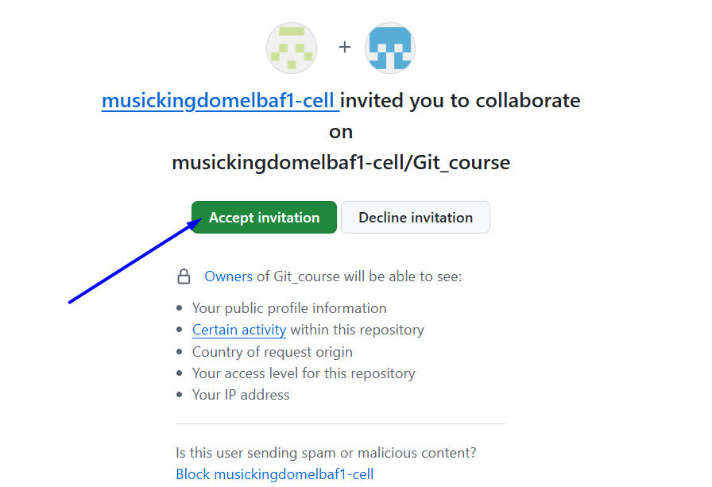

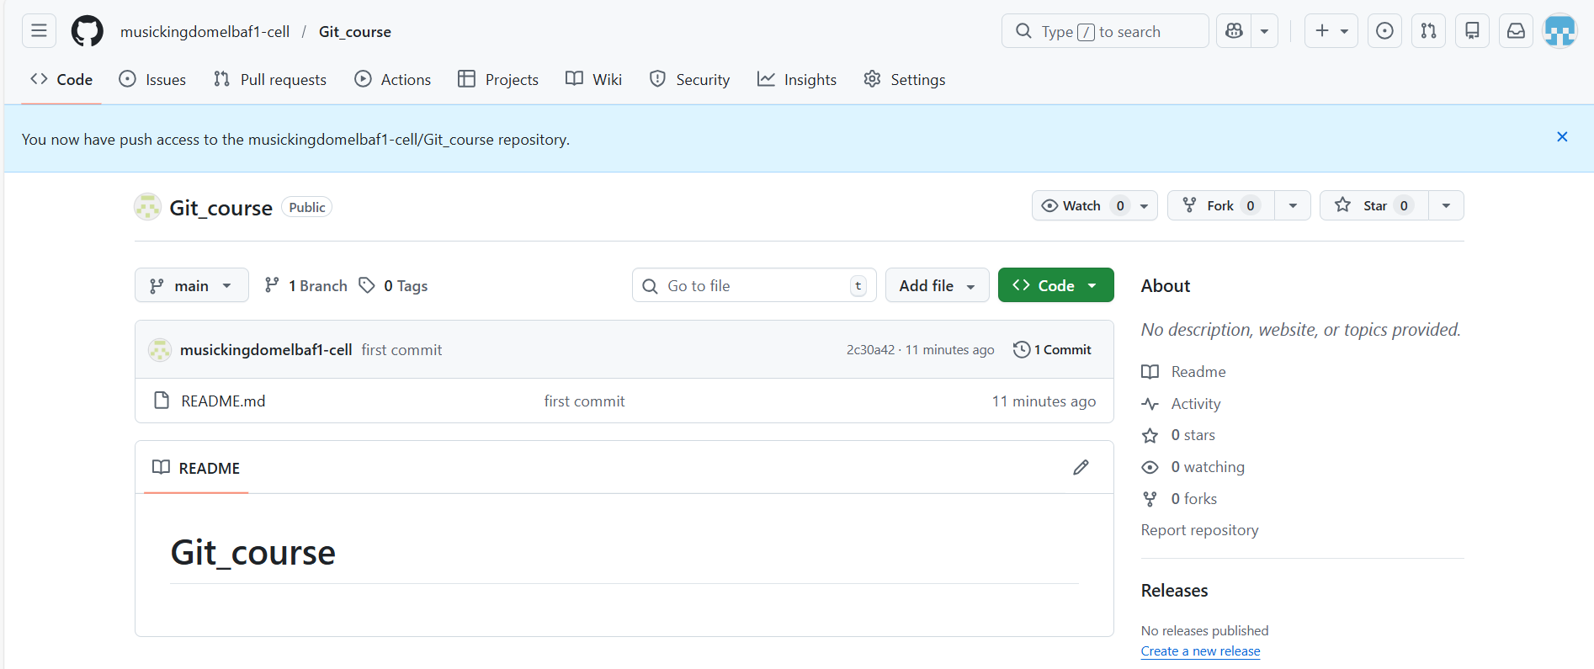
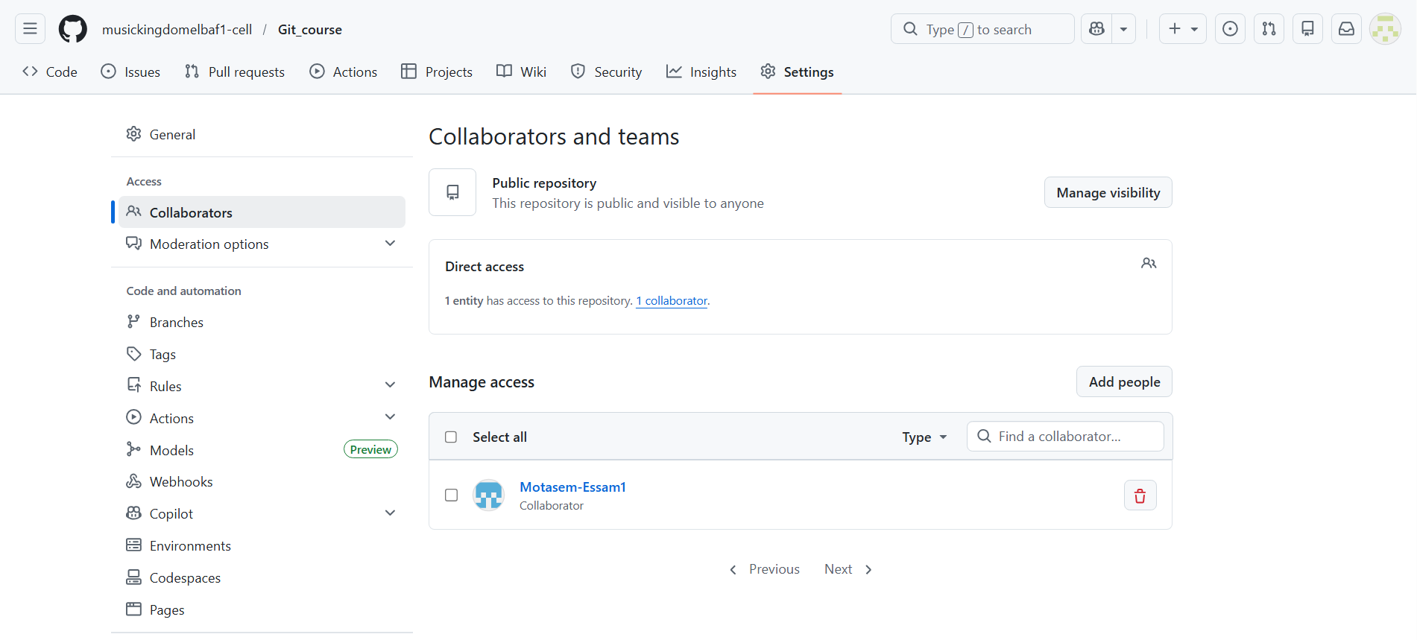

create a new repository on the command line

create a new repository on the command line
# Source: ScreenShots Source: Provided by: [Persons Table -> ID Column: 1, Name_En Column: Motasem Essam] -> Tool: [Lightshot Program] -> From [Site: https://github.com] on [2/17/2026]
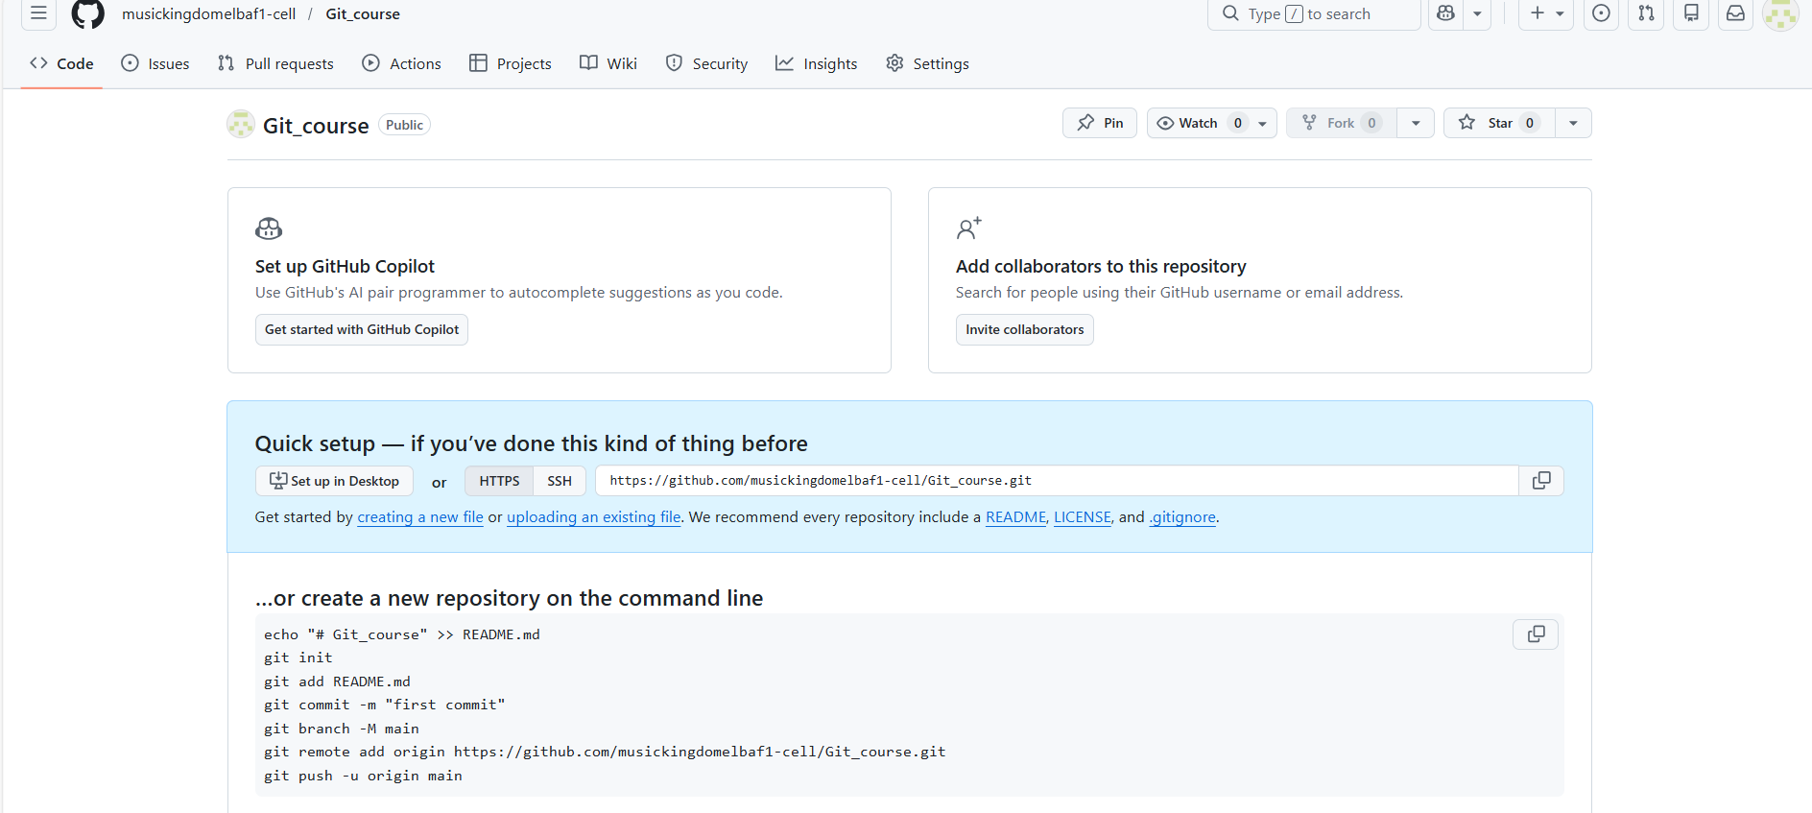
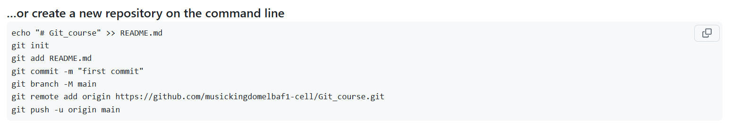
echo "# Git_course" >> README.md
git init
git add README.md
git commit -m "first commit"
git branch -M main
git remote add origin https://github.com/musickingdomelbaf1-cell/Git_course.git
git push -u origin main

Steps
# Source: AI Source: Provided by: [Data Path: Persons Table -> ID Column: 1, Name_En Column: Motasem Essam] -> From: [Chatgpt (GPT‑5 Mini)] on [2/17/2026]
Here’s how to create a new Git repository from the command line (Git Bash):

1. Go to the folder where you want the repo
# Source: AI Source: Provided by: [Data Path: Persons Table -> ID Column: 1, Name_En Column: Motasem Essam] -> From: [Chatgpt (GPT‑5 Mini)] on [2/17/2026]
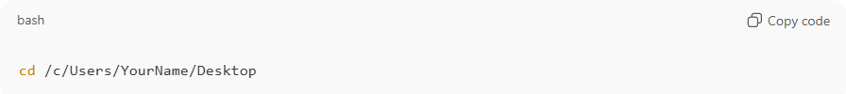
cd /c/Users/YourName/Desktop
(Replace with your path)
Or create a new project folder and enter it:
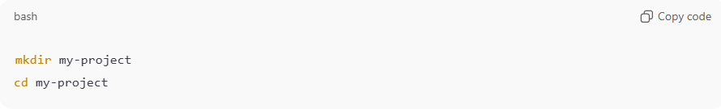
mkdir my-project
cd my-project

2. Initialize a new Git repository
# Source: AI Source: Provided by: [Data Path: Persons Table -> ID Column: 1, Name_En Column: Motasem Essam] -> From: [Chatgpt (GPT‑5 Mini)] on [2/17/2026]
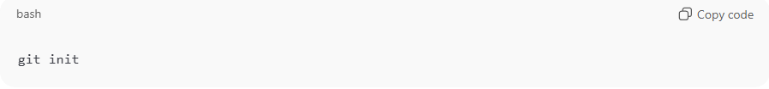
git init
You should see something like:
Initialized empty Git repository in .../my-project/.git/

What git init does
- Creates a .git folder inside your project directory
  - This folder contains all of Git’s metadata: commits, branches, configuration, and history.
  - It’s hidden (.git) but it’s what makes the folder a Git repository.
- Initializes Git for tracking changes
  - Git starts monitoring the files in your directory.
  - At this point, no files are committed yet — your repo is empty.
- Sets up the default branch
  - Usually main (or master in older Git versions).
What you see after running git init
Example output:
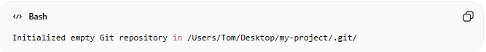
Initialized empty Git repository in /Users/Tom/Desktop/my-project/.git/

3. Create a test file
# Source: AI Source: Provided by: [Data Path: Persons Table -> ID Column: 1, Name_En Column: Motasem Essam] -> From: [Chatgpt (GPT‑5 Mini)] on [2/17/2026]
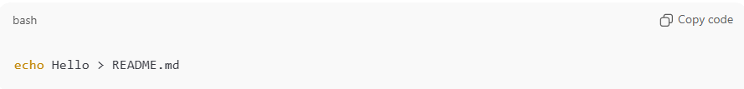
echo Hello > README.md

4. Add the file to Git
# Source: AI Source: Provided by: [Data Path: Persons Table -> ID Column: 1, Name_En Column: Motasem Essam] -> From: [Chatgpt (GPT‑5 Mini)] on [2/17/2026]
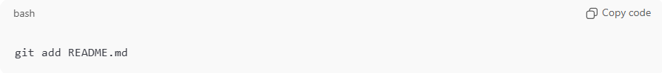
git add README.md

5. Make your first commit
# Source: AI Source: Provided by: [Data Path: Persons Table -> ID Column: 1, Name_En Column: Motasem Essam] -> From: [Chatgpt (GPT‑5 Mini)] on [2/17/2026]
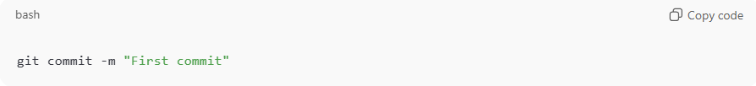
git commit -m "First commit"

6. (Optional) Check repo status
# Source: AI Source: Provided by: [Data Path: Persons Table -> ID Column: 1, Name_En Column: Motasem Essam] -> From: [Chatgpt (GPT‑5 Mini)] on [2/17/2026]
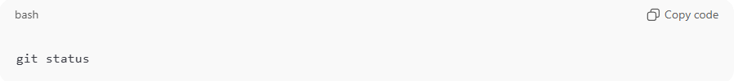
git status

Done 🎉
You just created a Git repository locally.

7. Rename branch to main
# Source: AI Source: Provided by: [Data Path: Persons Table -> ID Column: 1, Name_En Column: Motasem Essam] -> From: [Chatgpt (GPT‑5 Mini)] on [2/17/2026]
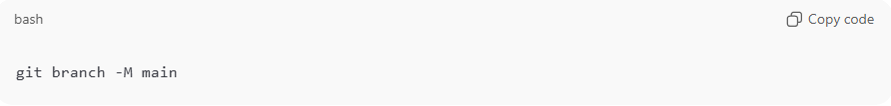
git branch -M main

1️⃣ What it does
- git branch → manages branches in your repository.
- -M → stands for “move/rename” and forces the rename even if the new branch name already exists.
- main → the new name you want for your branch.
So this command:
Renames the current branch to main, replacing any existing branch with that name if needed.

2️⃣ Why we use it
- Git used to create the default branch as master.
- Nowadays, many people use main as the default branch name.
- If you have a local repository where the branch is still called master, you can rename it to main using this command.

8. Connect your repo to GitHub
# Source: AI Source: Provided by: [Data Path: Persons Table -> ID Column: 1, Name_En Column: Motasem Essam] -> From: [Chatgpt (GPT‑5 Mini)] on [2/17/2026]
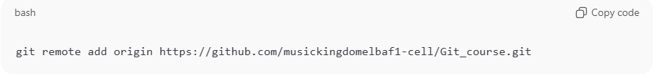git remote add origin https://github.com/musickingdomelbaf1-cell/Git_course.git

1️⃣ What it does
- git remote → manages connections to remote repositories (repositories on the internet or another server).
- add → adds a new remote connection.
- origin → a name you give to the remote repository (most people use origin as the default name).
- https://github.com/... → the URL of the remote repository you want to connect to.
So this command:
Adds a remote repository called origin pointing to the URL you provided.
After this, Git knows where to push your code or pull changes from.

2️⃣ Why we use it
You use this command when:
- You created a local Git repository on your computer:
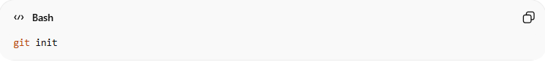
git init
- You want to connect it to a repository on GitHub (or GitLab, Bitbucket, etc.) so you can:
- Push your commits to GitHub:
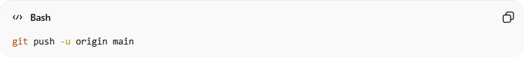
git push -u origin main
- Pull changes from GitHub later:
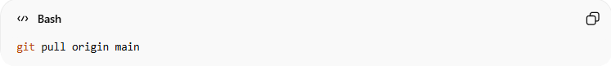
git pull origin main

9. Push to GitHub
# Source: AI Source: Provided by: [Data Path: Persons Table -> ID Column: 1, Name_En Column: Motasem Essam] -> From: [Chatgpt (GPT‑5 Mini)] on [2/17/2026]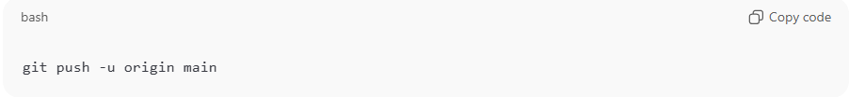
git push -u origin main
Note
If Git asks for username/password
GitHub no longer accepts password. Use Personal Access Token (PAT) instead of password.

Example

1. Go to the folder where you want the repo
# Source: ScreenShots Source: Provided by: [Persons Table -> ID Column: 1, Name_En Column: Motasem Essam] -> Tool: [Lightshot Program] -> From [Windows] on [2/17/2026]
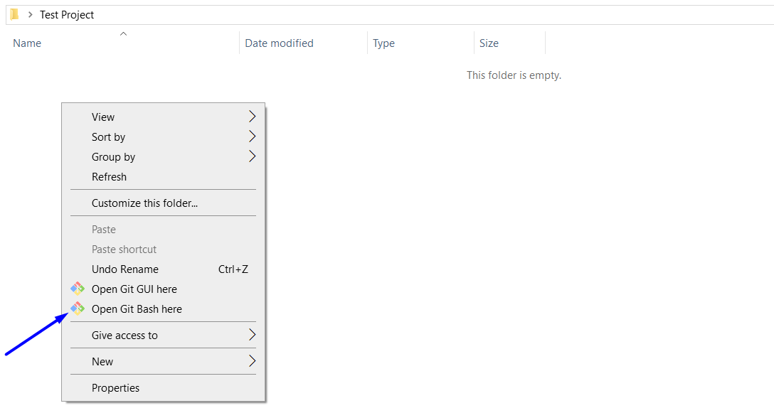

2. Initialize a new Git repository
# Source: ScreenShots Source: Provided by: [Persons Table -> ID Column: 1, Name_En Column: Motasem Essam] -> Tool: [Lightshot Program] -> From [Windows] on [2/17/2026]
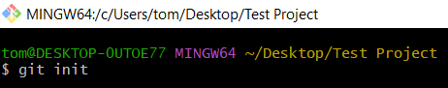
git init
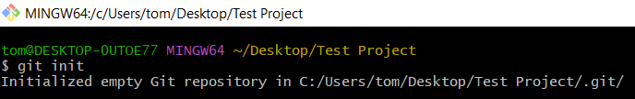
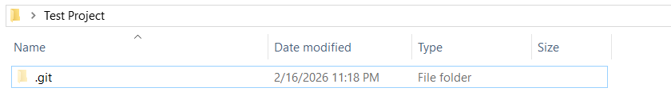
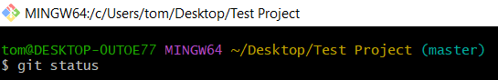
git status
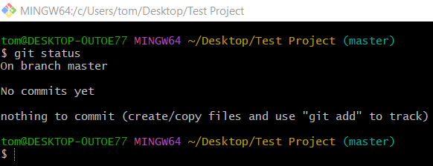

3. Create a test file
# Source: ScreenShots Source: Provided by: [Persons Table -> ID Column: 1, Name_En Column: Motasem Essam] -> Tool: [Lightshot Program] -> From [Windows] on [2/17/2026]
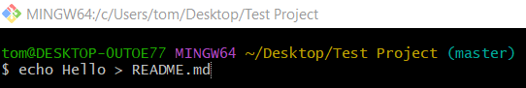
echo Hello > README.md
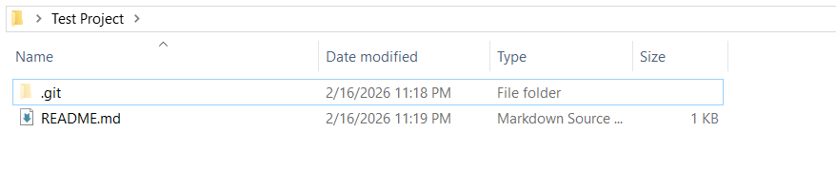
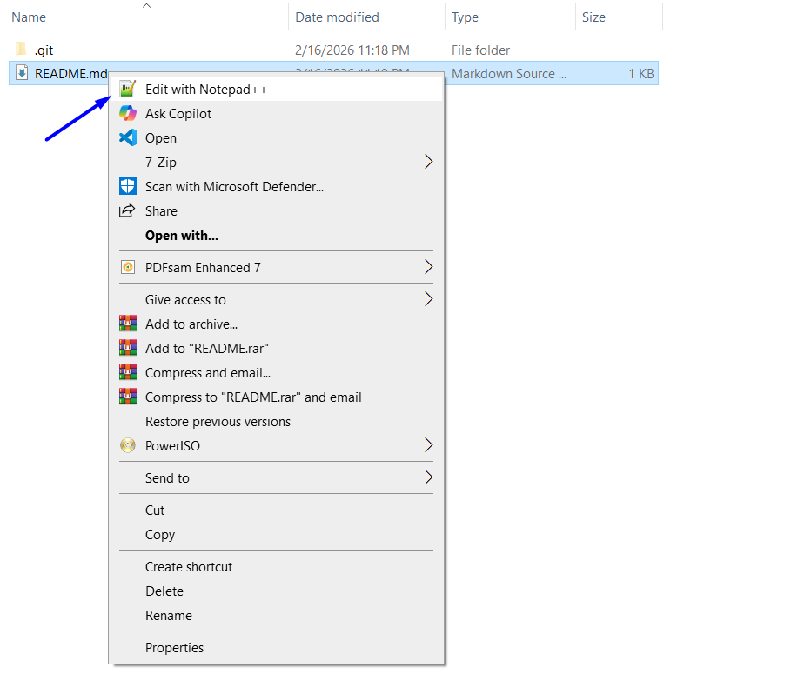
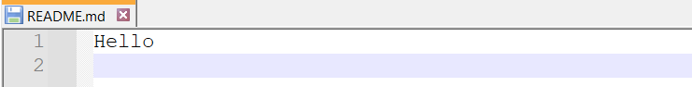

git status
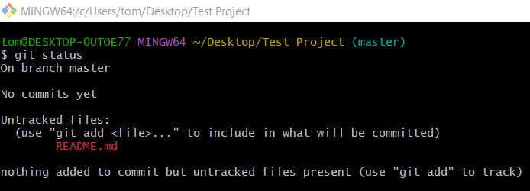

4. Add the file to Git
# Source: ScreenShots Source: Provided by: [Persons Table -> ID Column: 1, Name_En Column: Motasem Essam] -> Tool: [Lightshot Program] -> From [Windows] on [2/17/2026]
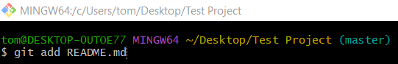
git add README.md

git status
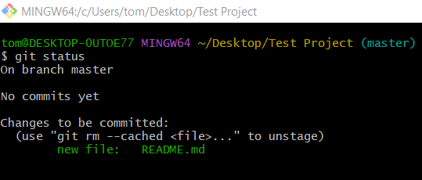

5. Make your first commit
# Source: ScreenShots Source: Provided by: [Persons Table -> ID Column: 1, Name_En Column: Motasem Essam] -> Tool: [Lightshot Program] -> From [Windows] on [2/17/2026]
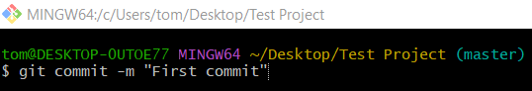
$ git commit -m "First commit"
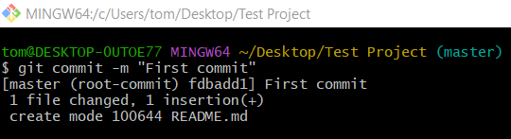

git status
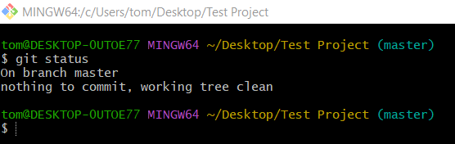

6. Rename branch to main
# Source: ScreenShots Source: Provided by: [Persons Table -> ID Column: 1, Name_En Column: Motasem Essam] -> Tool: [Lightshot Program] -> From [Windows] on [2/17/2026]
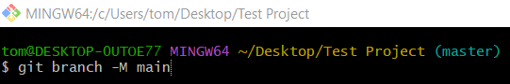
git branch -M main

git status
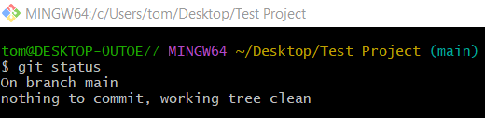

7. Connect your repo to GitHub
# Source: ScreenShots Source: Provided by: [Persons Table -> ID Column: 1, Name_En Column: Motasem Essam] -> Tool: [Lightshot Program] -> From [Windows] on [2/17/2026]
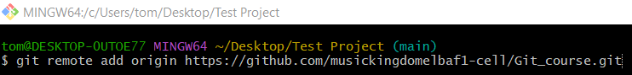
git remote add origin https://github.com/musickingdomelbaf1-cell/Git_course.git


git status


8. Push to GitHub
# Source: ScreenShots Source: Provided by: [Persons Table -> ID Column: 1, Name_En Column: Motasem Essam] -> Tool: [Lightshot Program] -> From [Site: https://github.com] on [2/17/2026]
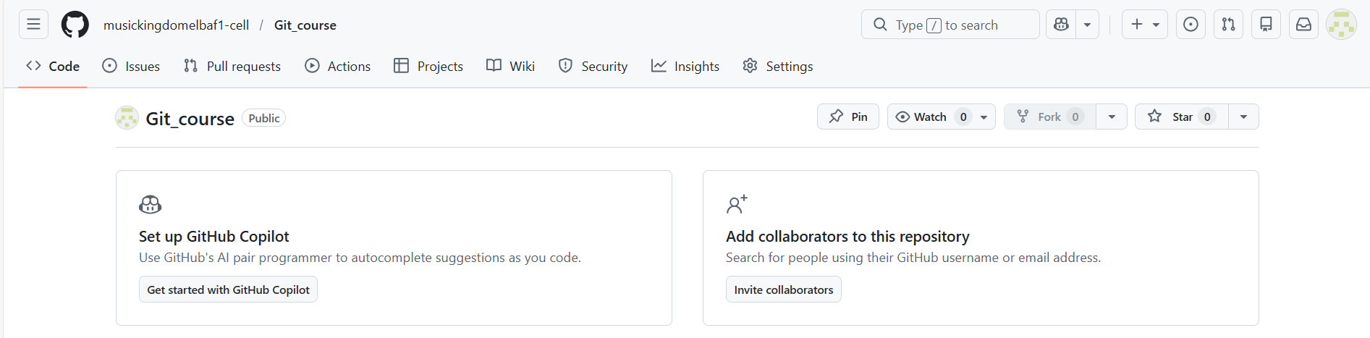
# Source: ScreenShots Source: Provided by: [Persons Table -> ID Column: 1, Name_En Column: Motasem Essam] -> Tool: [Lightshot Program] -> From [Windows] on [2/17/2026]
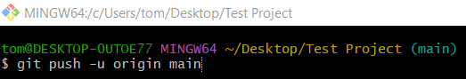
git push -u origin main
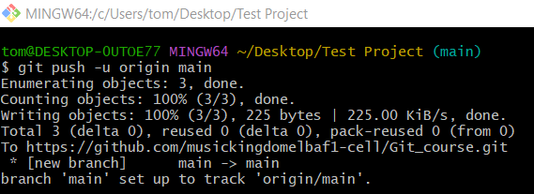
# Source: ScreenShots Source: Provided by: [Persons Table -> ID Column: 1, Name_En Column: Motasem Essam] -> Tool: [Lightshot Program] -> From [Site: https://github.com] on [2/17/2026]
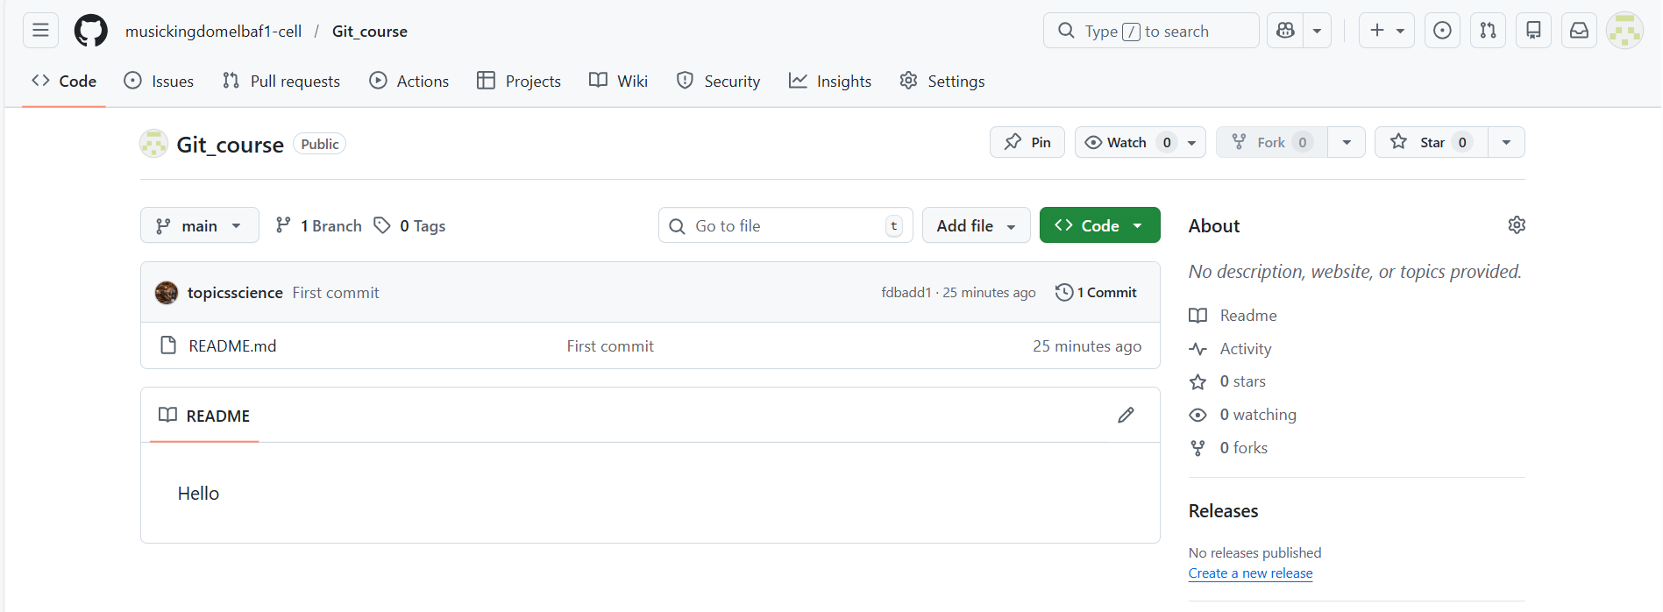

Errors

At Step 7: Error remote origin already exists Error

Error
# Source: ScreenShots Source: Provided by: [Persons Table -> ID Column: 1, Name_En Column: Motasem Essam] -> Tool: [Lightshot Program] -> From [Windows] on [2/17/2026]
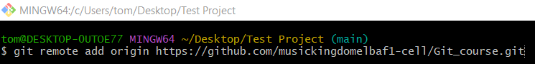 git remote add origin https://github.com/musickingdomelbaf1-cell/Git_course.git
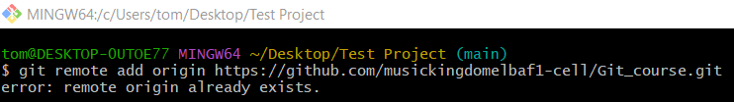

Solve
# Source: ScreenShots Source: Provided by: [Persons Table -> ID Column: 1, Name_En Column: Motasem Essam] -> Tool: [Lightshot Program] -> From [Windows] on [2/17/2026]
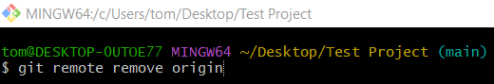
git remote remove origin

At Step 8: Repository not found

Error
# Source: ScreenShots Source: Provided by: [Persons Table -> ID Column: 1, Name_En Column: Motasem Essam] -> Tool: [Lightshot Program] -> From [Windows] on [2/17/2026]

git push -u origin main
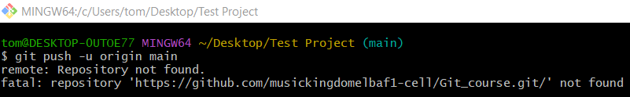

Solve
# Source: ScreenShots Source: Provided by: [Persons Table -> ID Column: 1, Name_En Column: Motasem Essam] -> Tool: [Lightshot Program] -> From [Site: https://github.com] on [2/17/2026]





At Step 8: Permission Error

Error
# Source: ScreenShots Source: Provided by: [Persons Table -> ID Column: 1, Name_En Column: Motasem Essam] -> Tool: [Lightshot Program] -> From [Windows] on [2/17/2026]

git push -u origin main
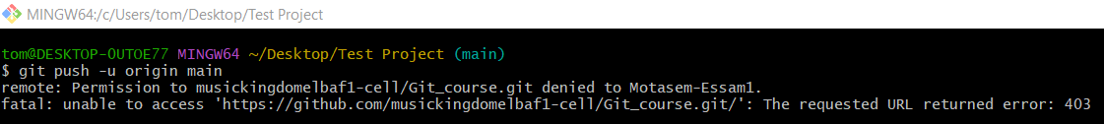

Solve
# Source: AI Source: Provided by: [Data Path: Persons Table -> ID Column: 1, Name_En Column: Motasem Essam] -> From: [Chatgpt (GPT‑5 Mini)] on [2/17/2026]
1. Fix permission (get access to that repo)
2. Use the correct GitHub account on your PC
3. Switch to SSH (no login every push)
4. Fork the repo and push to your own copy

get access to that repo
# Source: ScreenShots Source: Provided by: [Persons Table -> ID Column: 1, Name_En Column: Motasem Essam] -> Tool: [Lightshot Program] -> From [Site: https://github.com] on [2/17/2026]
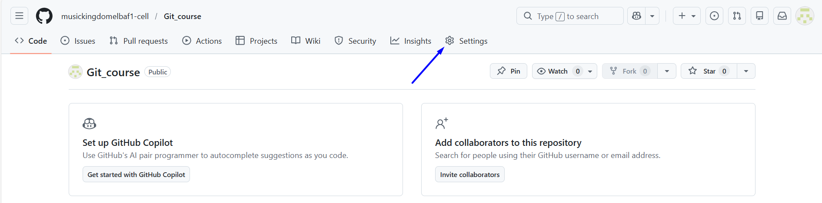
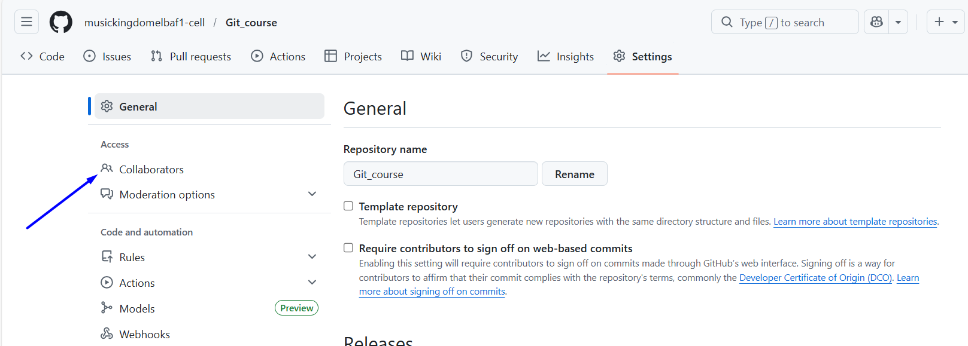
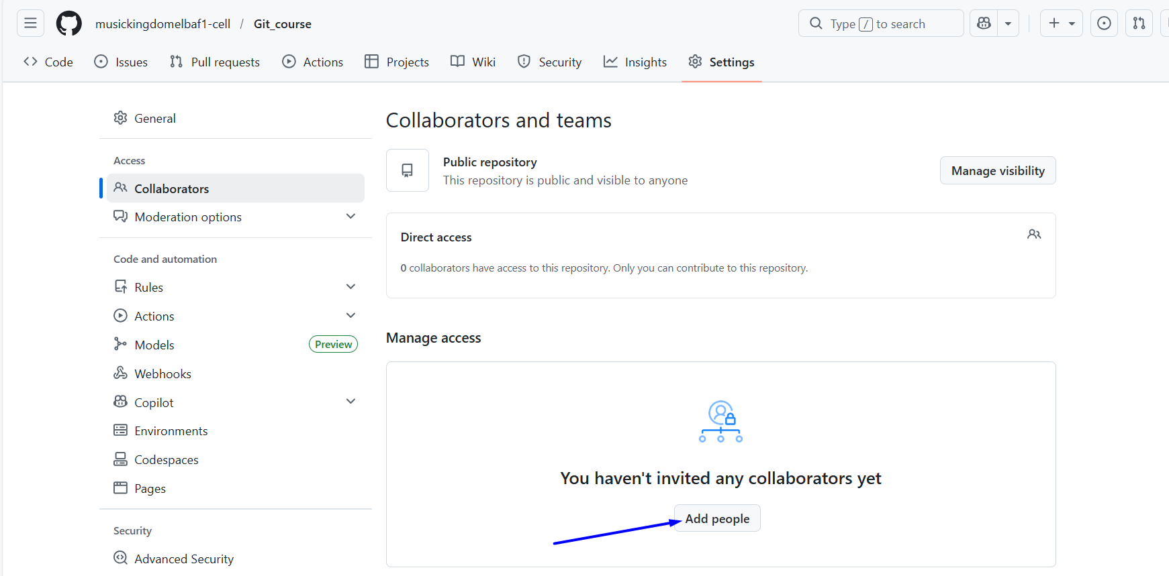
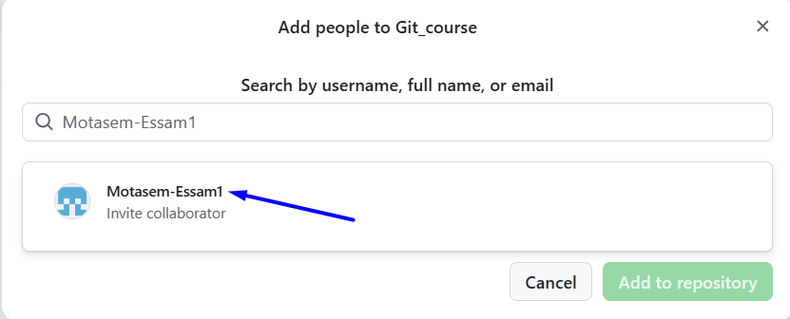
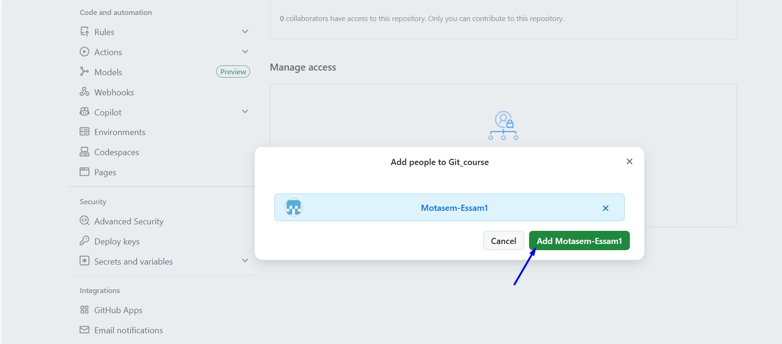

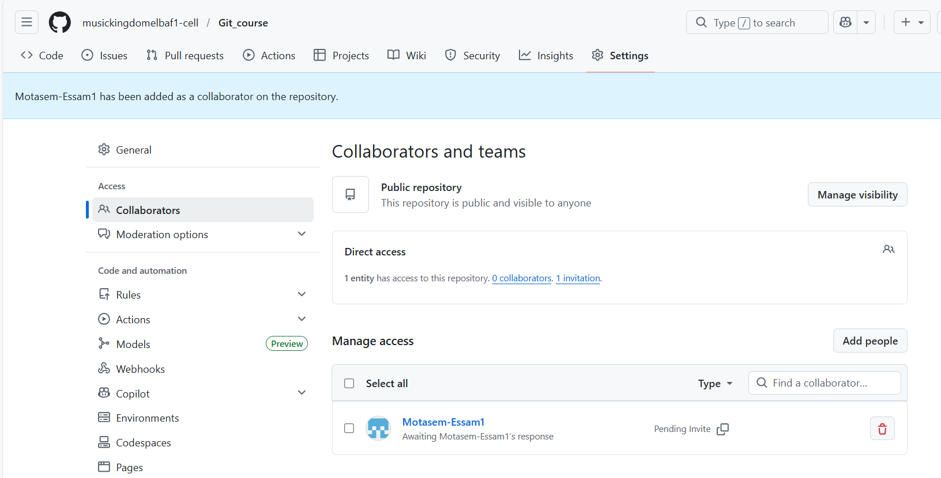
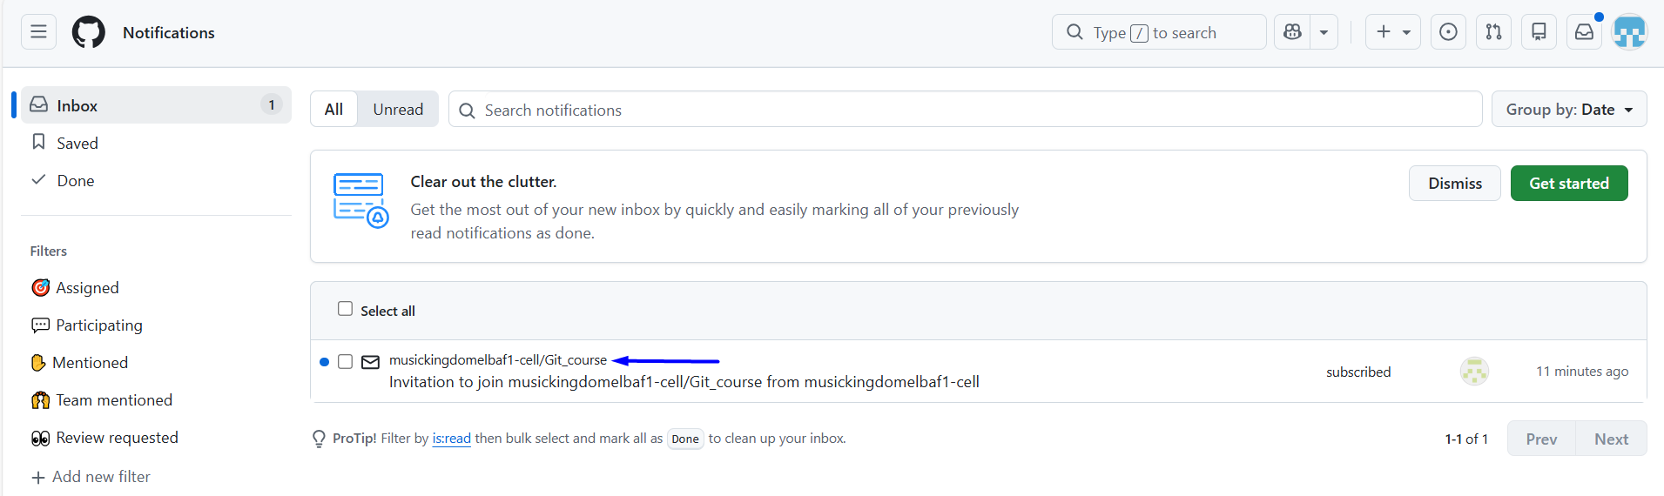
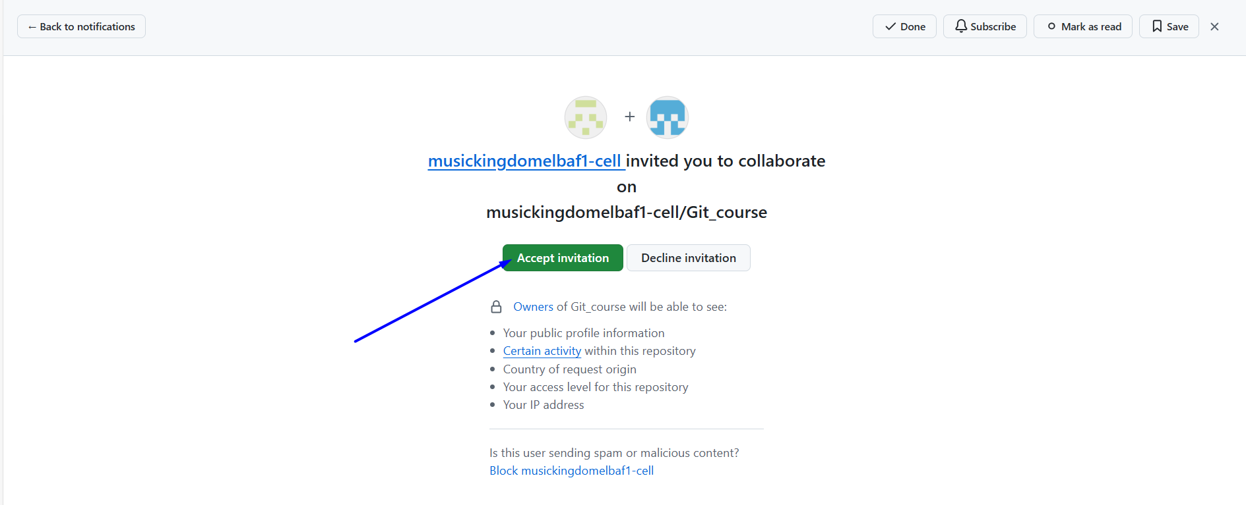
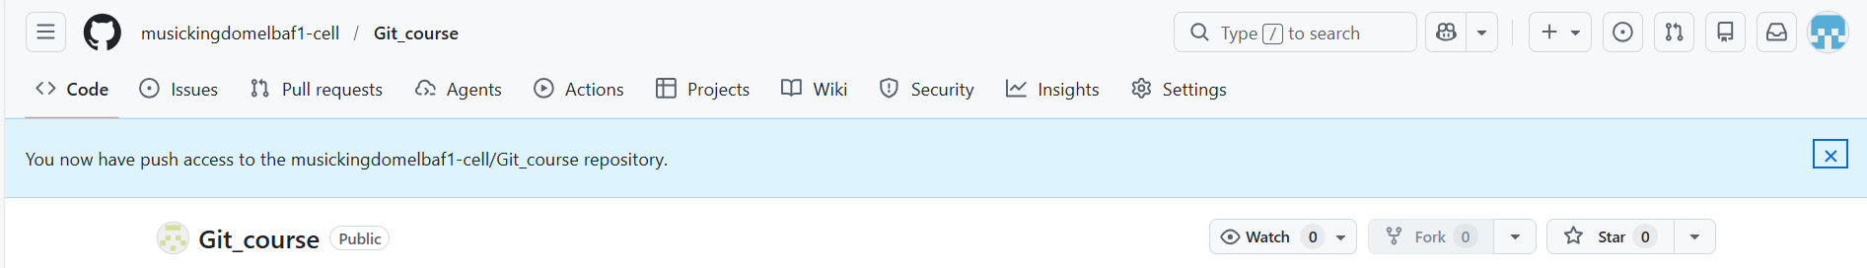

push an existing repository from the command line
# Source: ScreenShots Source: Provided by: [Persons Table -> ID Column: 1, Name_En Column: Motasem Essam] -> Tool: [Lightshot Program] -> From [Site: https://github.com] on [2/17/2026]
git remote add origin https://github.com/musickingdomelbaf1-cell/Git_course.git
git branch -M main
git push -u origin main

Clone Repository

Clone with SSH

Create SSH key
# Source: AI Source: Provided by: [Data Path: Persons Table -> ID Column: 1, Name_En Column: Motasem Essam] -> From: [Chatgpt (GPT‑5 Mini)] on [2/17/2026]
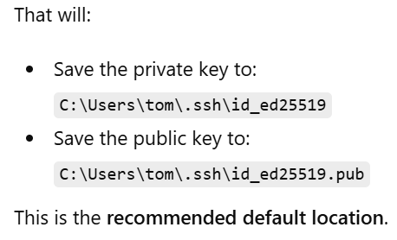
That will:
- Save the private key to:
C:\Users\tom\.ssh\id_ed25519
- Save the public key to:
C:\Users\tom\.ssh\id_ed25519.pub
This is the recommended default location

# Source: ScreenShots Source: Provided by: [Persons Table -> ID Column: 1, Name_En Column: Motasem Essam] -> Tool: [Lightshot Program] -> From [Windows] on [2/17/2026]
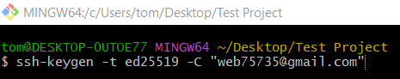
ssh-keygen -t ed25519 -C "web75735@gmail.com"
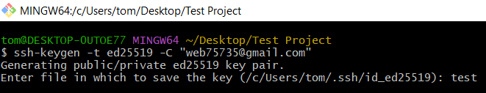
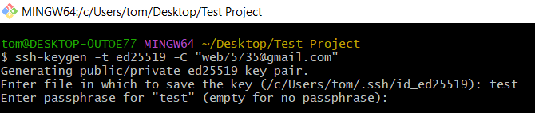
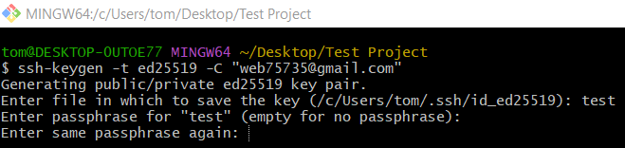
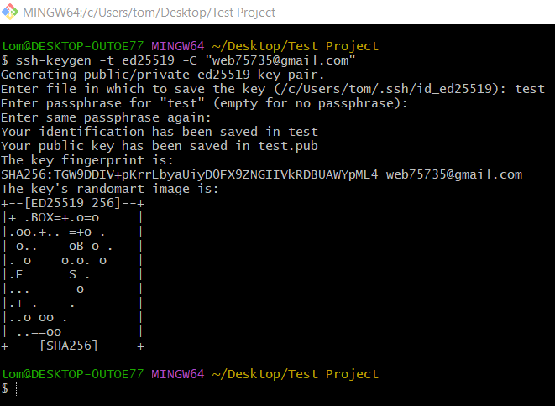
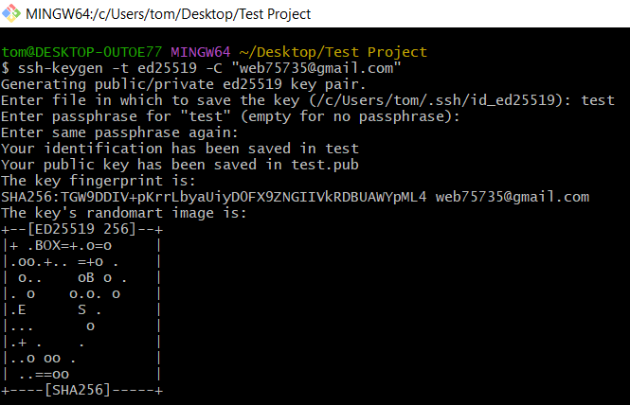
$ ssh-keygen -t ed25519 -C "web75735@gmail.com"
Generating public/private ed25519 key pair.
Enter file in which to save the key (/c/Users/tom/.ssh/id_ed25519): test
Enter passphrase for "test" (empty for no passphrase):
Enter same passphrase again:
Your identification has been saved in test
Your public key has been saved in test.pub
The key fingerprint is:
SHA256:TGW9DDIV+pKrrLbyaUiyD0FX9ZNGIIVkRDBUAWYpML4 web75735@gmail.com
The key's randomart image is:
+--[ED25519 256]--+
|+ .BOX=+.o=o |
|.oo.+.. =+o . |
| o.. oB o . |
|. o o.o. o |
|.E S . |
|... o |
|.+ . . |
|..o oo . |
| ..==oo |
+----[SHA256]-----+

Get SSH key
# Source: AI Source: Provided by: [Data Path: Persons Table -> ID Column: 1, Name_En Column: Motasem Essam] -> From: [Chatgpt (GPT‑5 Mini)] on [2/17/2026]
The command cat stands for “display the contents of a file in the terminal”.

# Source: ScreenShots Source: Provided by: [Persons Table -> ID Column: 1, Name_En Column: Motasem Essam] -> Tool: [Lightshot Program] -> From [Windows] on [2/17/2026]
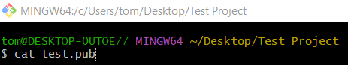
cat test.pub
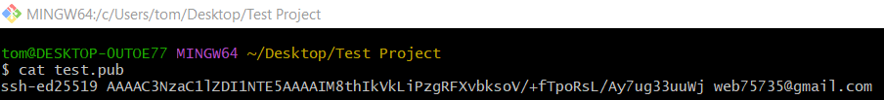
ssh-ed25519 AAAAC3NzaC1lZDI1NTE5AAAAIM8thIkVkLiPzgRFXvbksoV/+fTpoRsL/Ay7ug33uuWj web75735@gmail.com

Add SSH KEY
# Source: ScreenShots Source: Provided by: [Persons Table -> ID Column: 1, Name_En Column: Motasem Essam] -> Tool: [Lightshot Program] -> From [Site: https://github.com] on [2/17/2026]
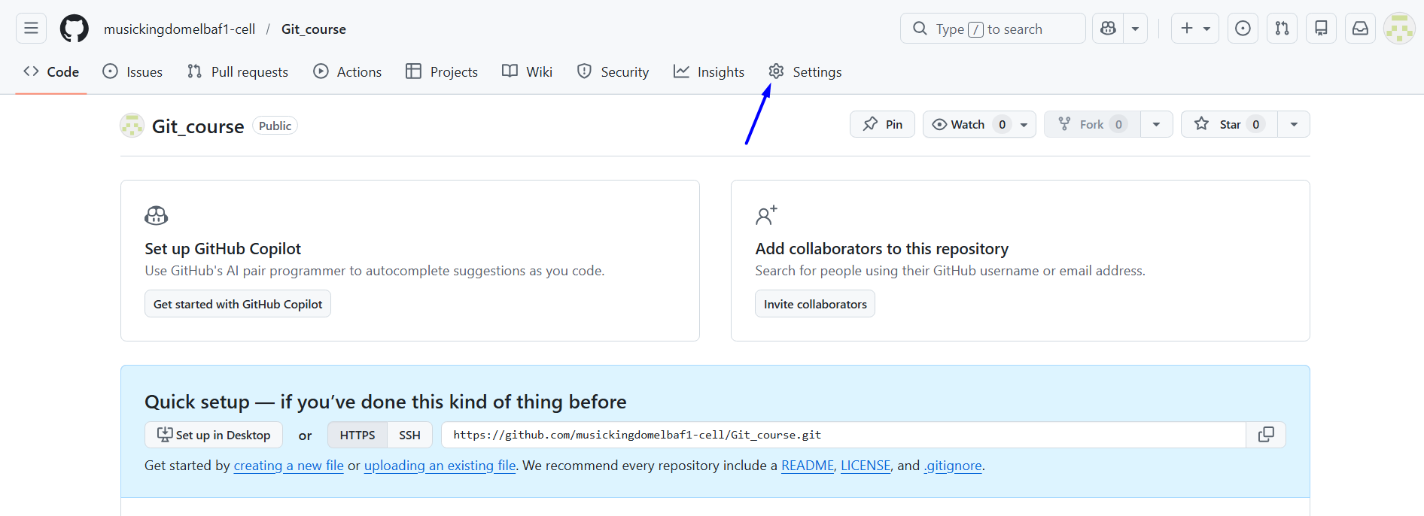
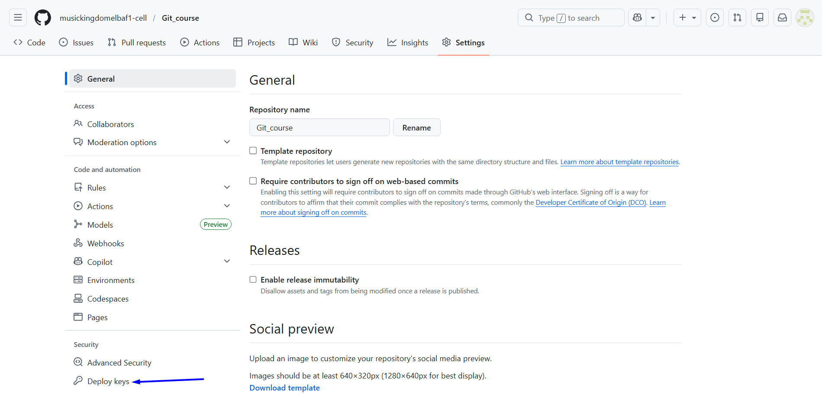
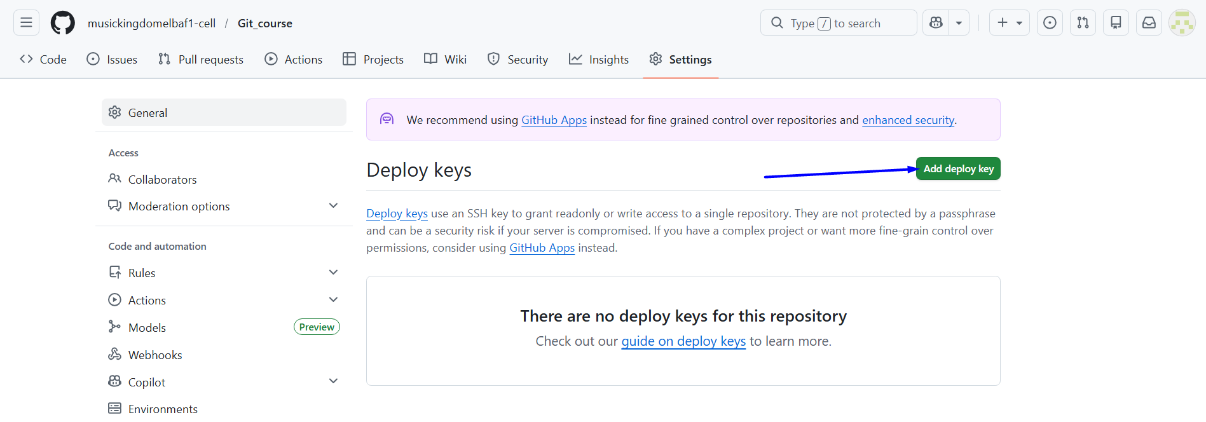
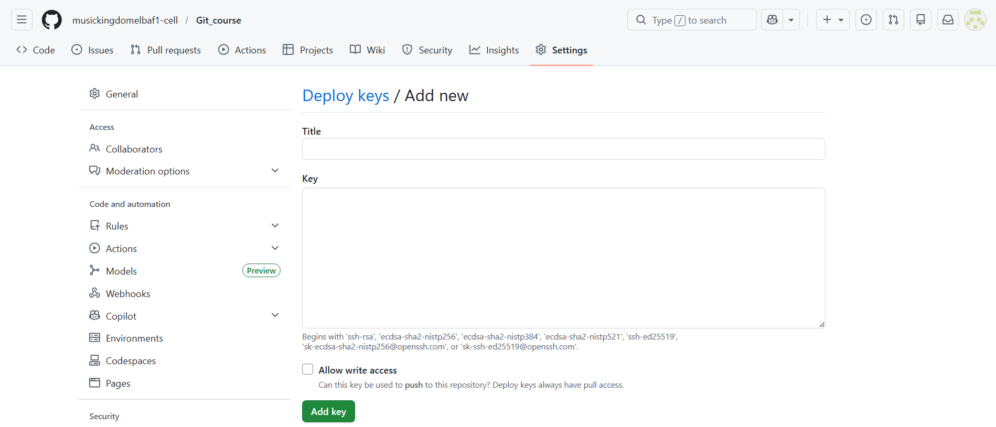
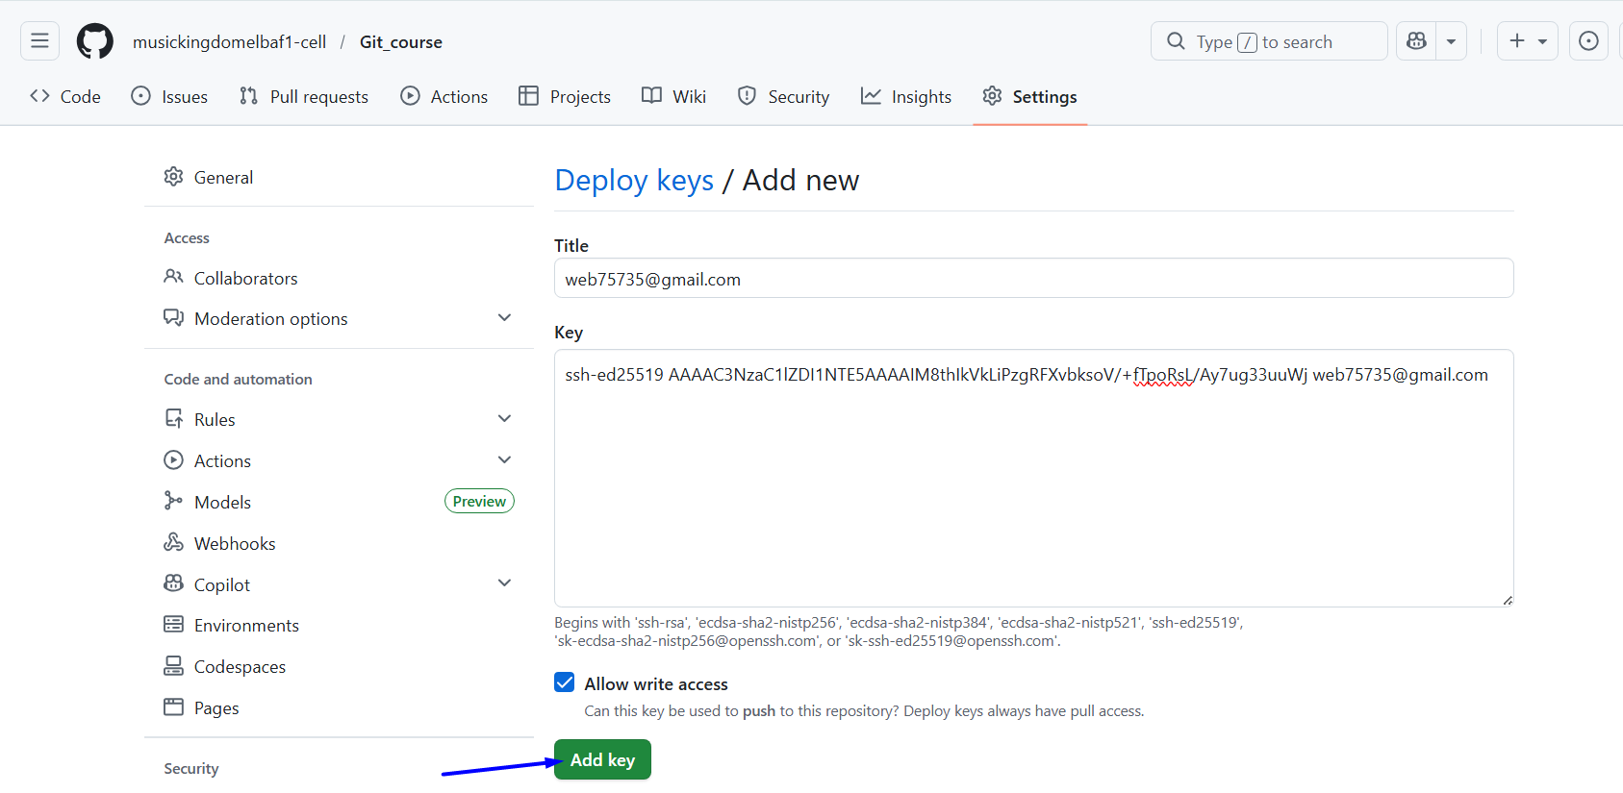

Start the SSH agent
# Source: AI Source: Provided by: [Data Path: Persons Table -> ID Column: 1, Name_En Column: Motasem Essam] -> From: [Chatgpt (GPT‑5 Mini)] on [2/17/2026]
The SSH agent is basically a helper program that manages your SSH keys for you, so you don’t have to type your passphrase every time you connect to a server (like GitHub).
What it does
- Stores your private SSH keys in memory temporarily.
  - This allows Git (or any SSH client) to use the keys without repeatedly asking for the password or passphrase.
- Handles authentication for you.
  - When you run git push or ssh git@github.com, the SSH agent provides your key to GitHub automatically.
- Keeps your keys secure
  - The private key never leaves your computer; the agent just provides proof that you own it.

Why it’s useful
- Without the agent: every time you push to GitHub over SSH, Git asks for the passphrase of your key.
- With the agent: you enter the passphrase once, and it remembers it until you log out or stop the agen

# Source: ScreenShots Source: Provided by: [Persons Table -> ID Column: 1, Name_En Column: Motasem Essam] -> Tool: [Lightshot Program] -> From [Windows] on [2/17/2026]
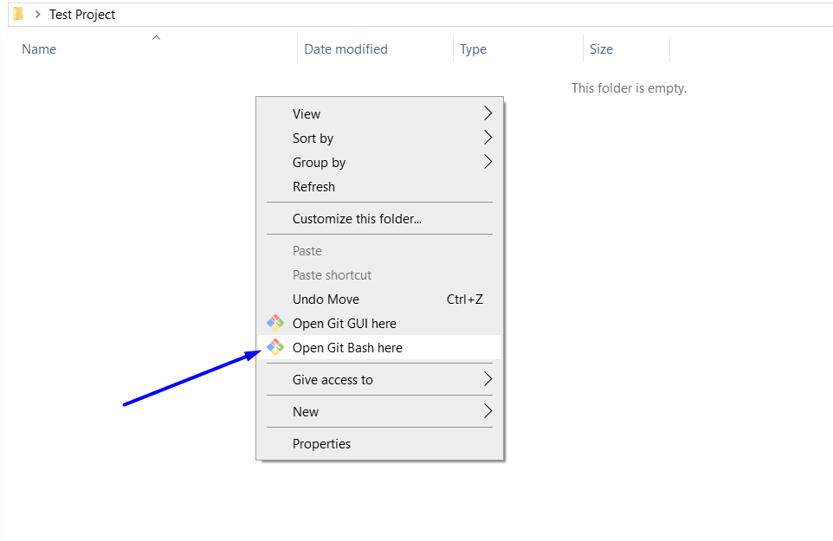
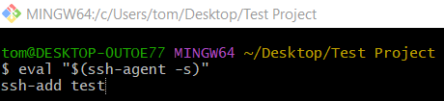
eval "$(ssh-agent -s)"
ssh-add test
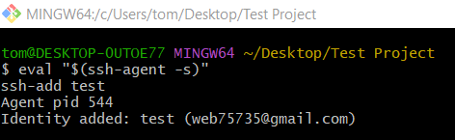

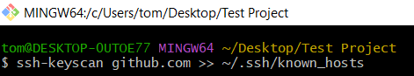
$ ssh-keyscan github.com >> ~/.ssh/known_hosts
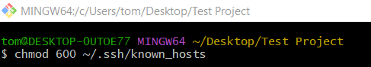
chmod 600 ~/.ssh/known_hosts

Clone Repository
# Source: ScreenShots Source: Provided by: [Persons Table -> ID Column: 1, Name_En Column: Motasem Essam] -> Tool: [Lightshot Program] -> From [Site: https://github.com] on [2/17/2026]
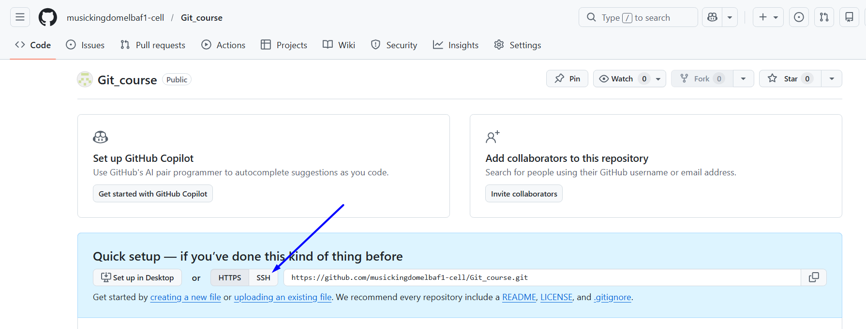
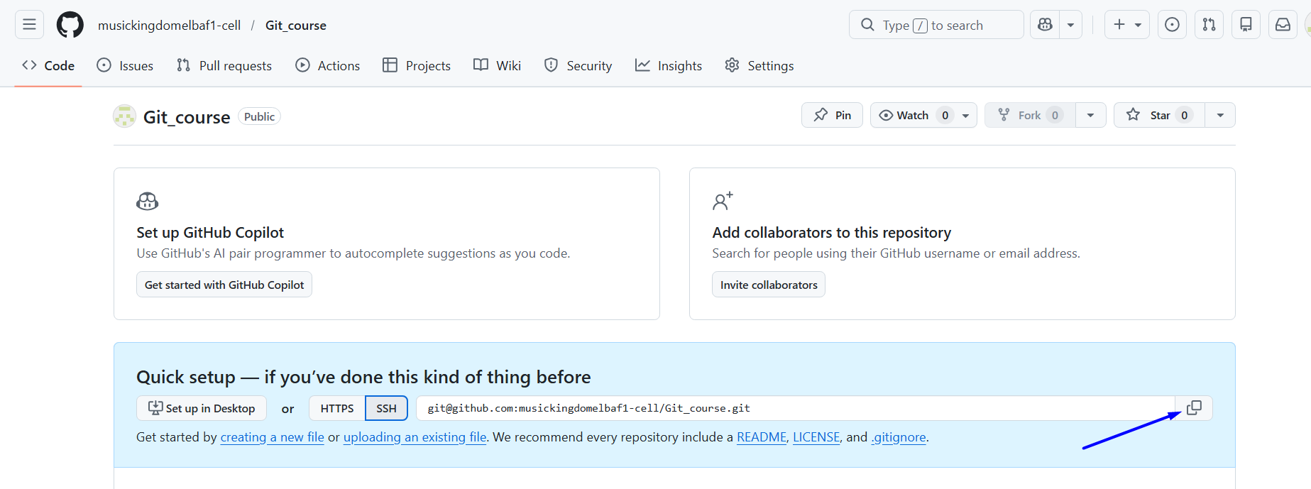

# Source: ScreenShots Source: Provided by: [Persons Table -> ID Column: 1, Name_En Column: Motasem Essam] -> Tool: [Lightshot Program] -> From [Windows] on [2/17/2026]
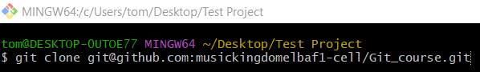
git clone git@github.com:musickingdomelbaf1-cell/Git_course.git
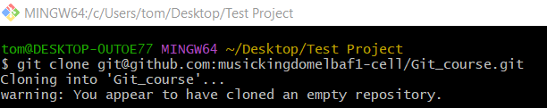

Clone with HTTPS

Normal Clone
# Source: ScreenShots Source: Provided by: [Persons Table -> ID Column: 1, Name_En Column: Motasem Essam] -> Tool: [Lightshot Program] -> From [Site: https://github.com] on [2/17/2026]
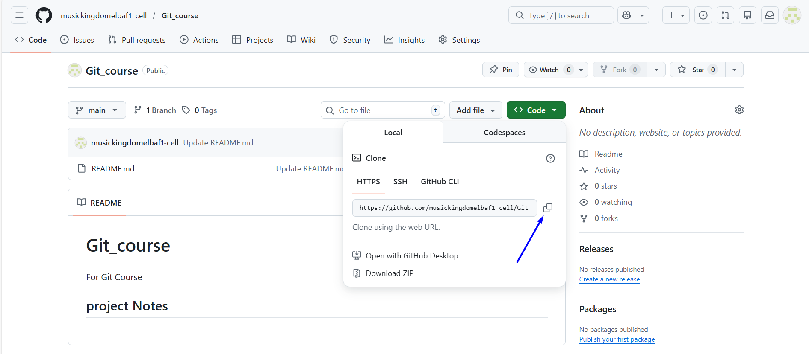
# Source: ScreenShots Source: Provided by: [Persons Table -> ID Column: 1, Name_En Column: Motasem Essam] -> Tool: [Lightshot Program] -> From [Windows] on [2/17/2026]
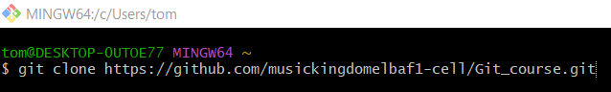
git clone https://github.com/musickingdomelbaf1-cell/Git_course.git
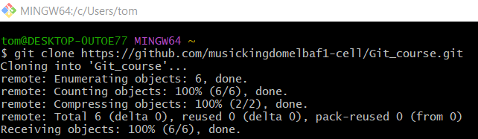
# Source: AI Source: Provided by: [Data Path: Persons Table -> ID Column: 1, Name_En Column: Motasem Essam] -> From: [Chatgpt (GPT‑5 Mini)] on [2/17/2026]
The command pwd stands for “print working directory”.

# Source: ScreenShots Source: Provided by: [Persons Table -> ID Column: 1, Name_En Column: Motasem Essam] -> Tool: [Lightshot Program] -> From [Windows] on [2/17/2026]
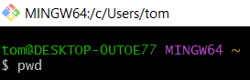
pwd
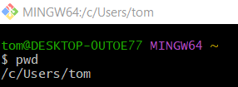
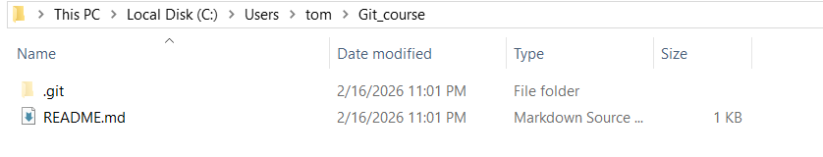

Clone with Personal access tokens
# Source: AI Source: Provided by: [Data Path: Persons Table -> ID Column: 1, Name_En Column: Motasem Essam] -> From: [Chatgpt (GPT‑5 Mini)] on [2/17/2026]
Step 1: Log in to GitHub
Go to GitHub and log in with your account.

Step 2: Go to Personal Access Tokens
- Click on your profile picture → Settings
- In the left sidebar → Developer settings
- Click Personal access tokens → Tokens (classic)
- Click Generate new token → choose Fine-grained token (recommended for new tokens) or Classic.

Step 3: Set token details
- Name: Give your token a descriptive name (e.g., Git operations)
- Expiration: Set how long it should last (e.g., 30 days, 90 days, or no expiration)
- Repository access:
  - For cloning/pushing, select your repositories
  - Usually repo or read/write permissions are enough
- Additional permissions: Only check what you need

Step 4: Generate the token
- Click Generate token
- Copy the token immediately — you won’t be able to see it again.
⚠️ Treat it like a password. Don’t share it publicly.

Step 5: Use the token with Git
For HTTPS Git operations:
git clone https://github.com/username/repo.git
- Username: your GitHub username
- Password: paste the token instead of your GitHub password

💡 Tip: You can also configure Git to store your token so you don’t have to enter it every time:
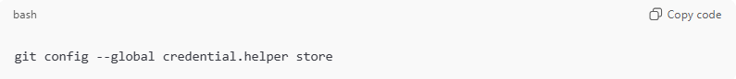
git config --global credential.helper store
Then the first time you use it, Git will save it securely.

# Source: ScreenShots Source: Provided by: [Persons Table -> ID Column: 1, Name_En Column: Motasem Essam] -> Tool: [Lightshot Program] -> From [Site: https://github.com] on [2/17/2026]
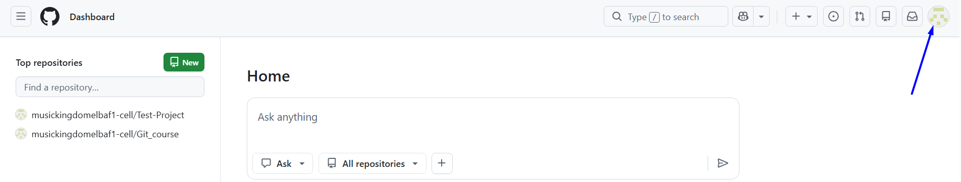
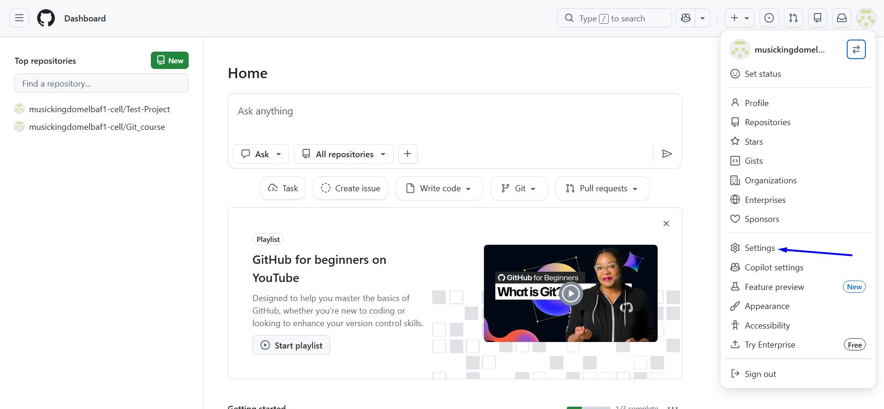
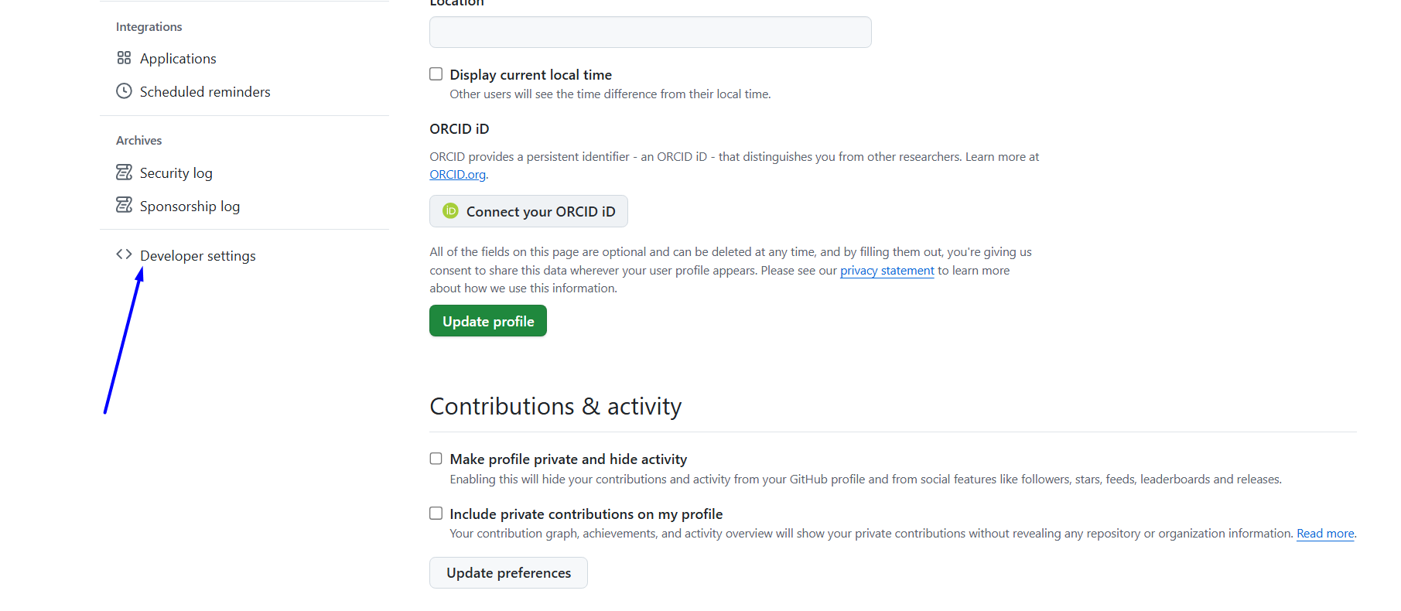
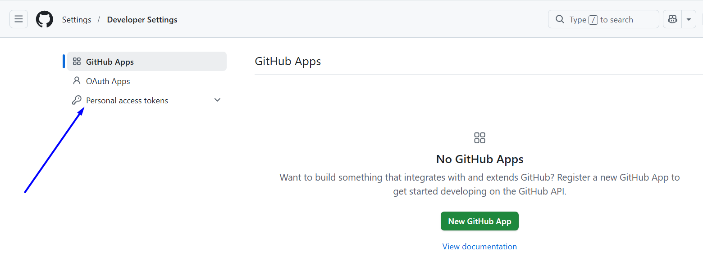

GitLab

Sign Up
# Source: ScreenShots Source: Provided by: [Persons Table -> ID Column: 1, Name_En Column: Motasem Essam] -> Tool: [Lightshot Program] -> From [Site: Google Search: All: gitlab] on [2/17/2026]
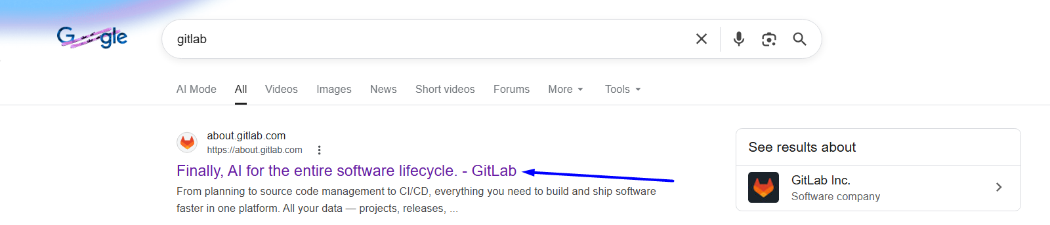
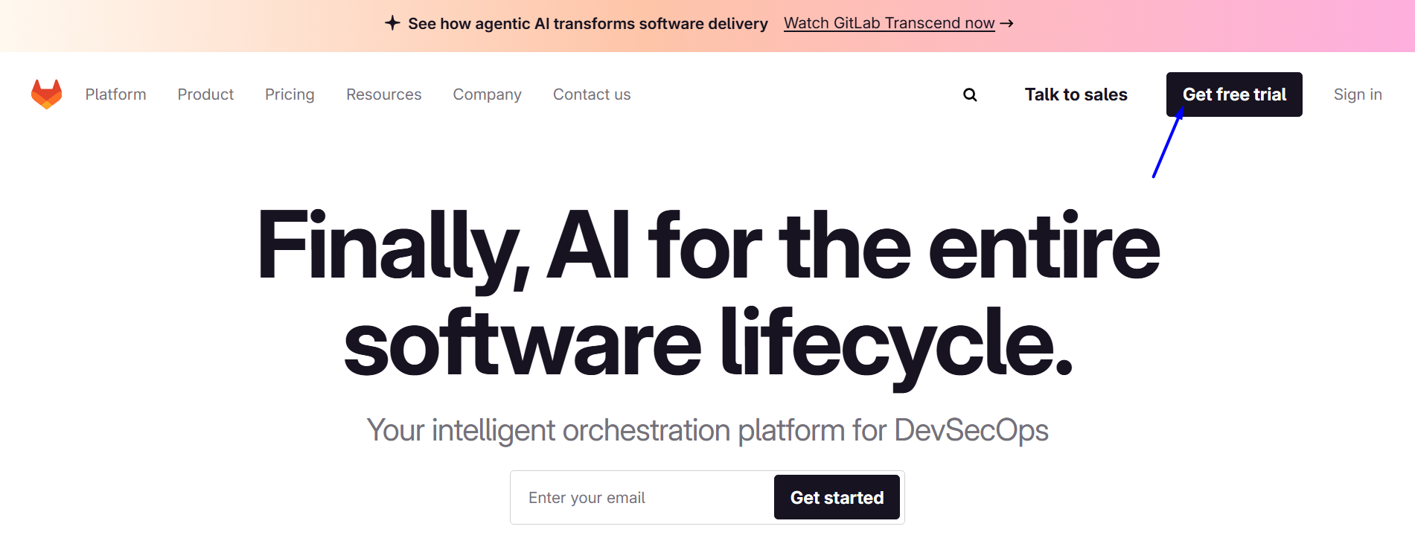
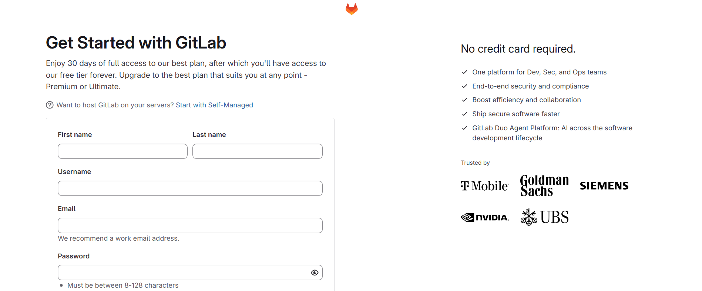
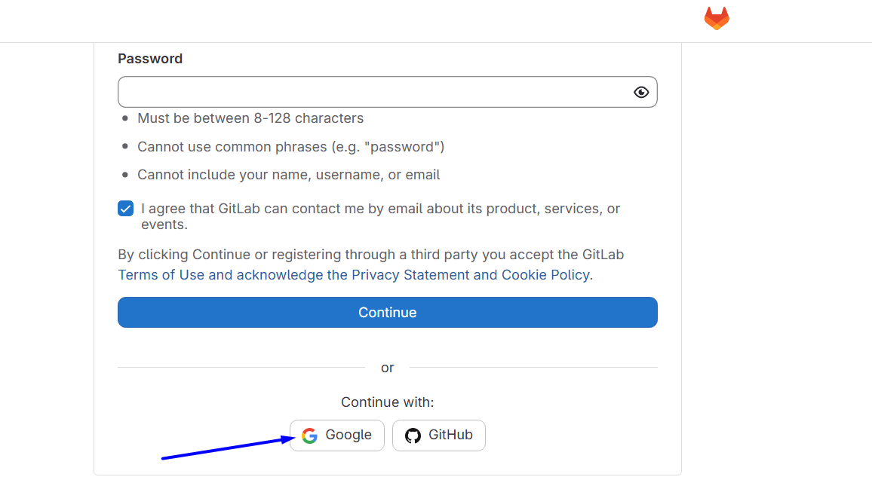
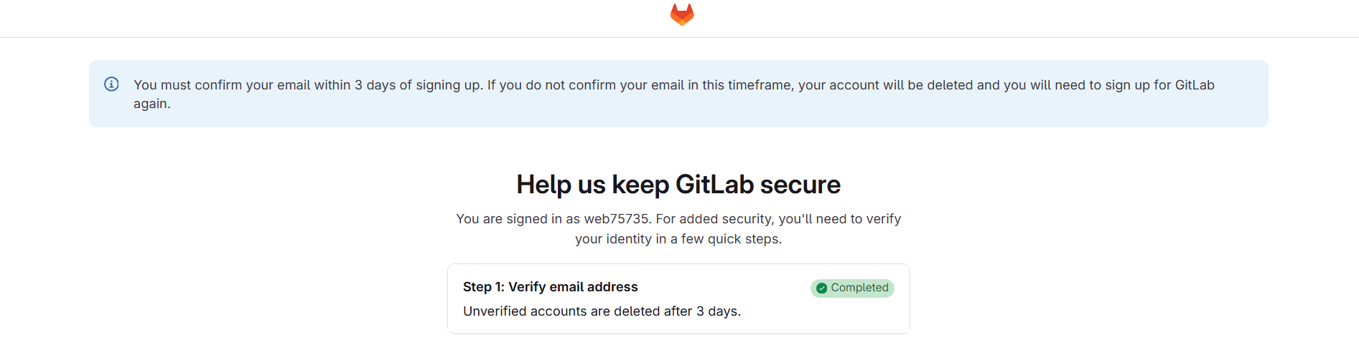

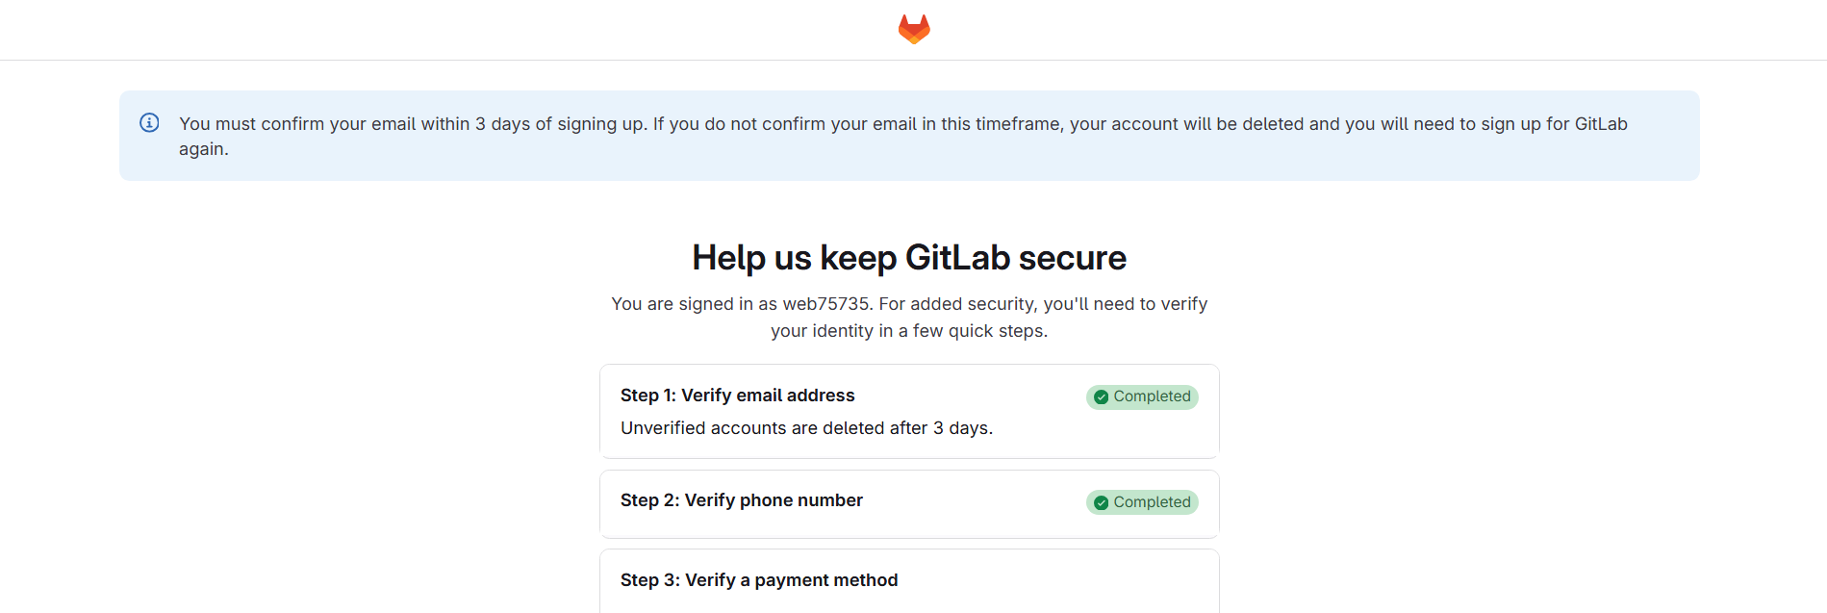
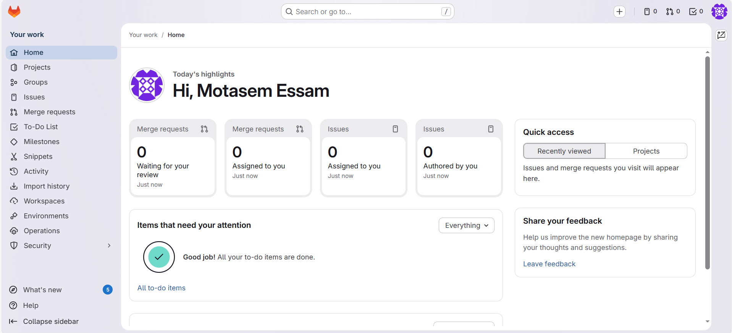

Create repository
# Source: ScreenShots Source: Provided by: [Persons Table -> ID Column: 1, Name_En Column: Motasem Essam] -> Tool: [Lightshot Program] -> From [Site: https://gitlab.com] on [2/17/2026]
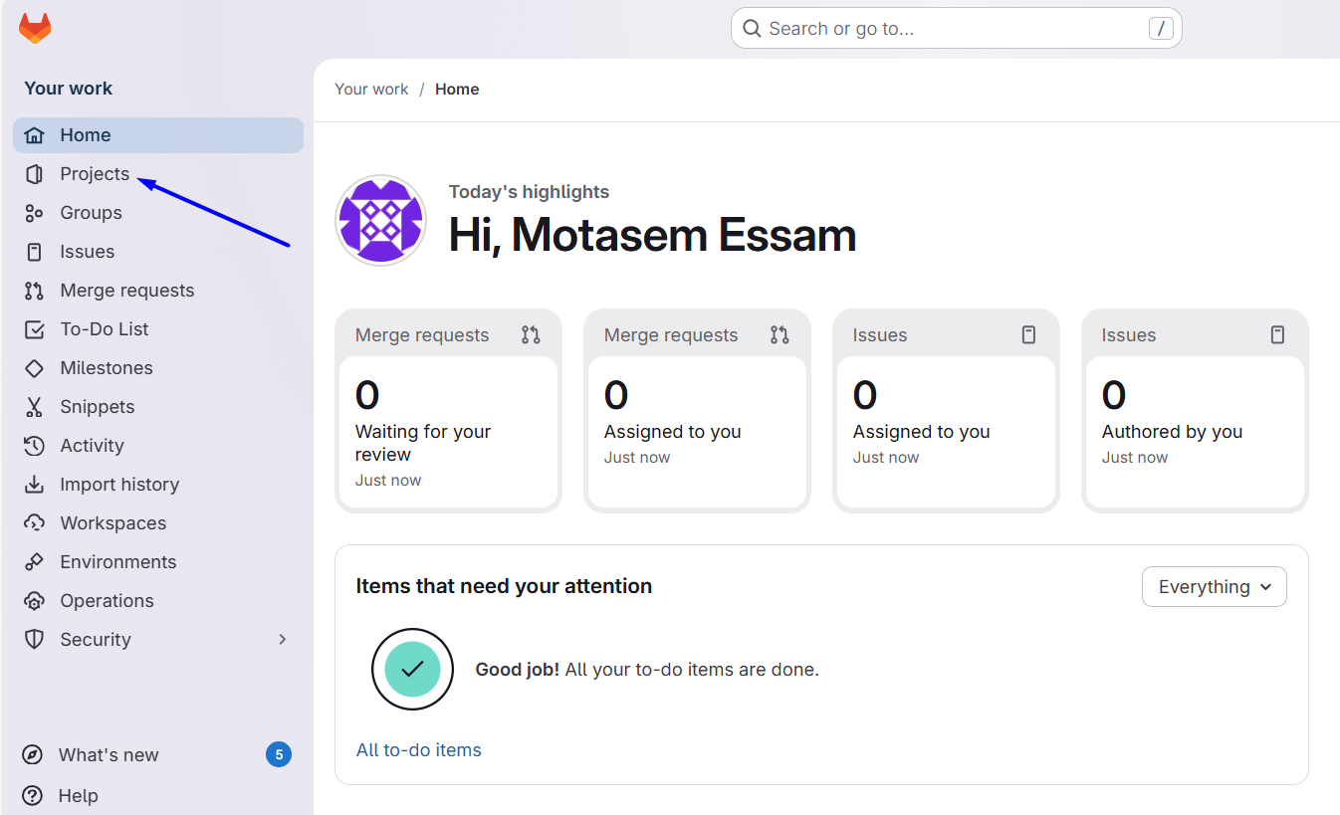
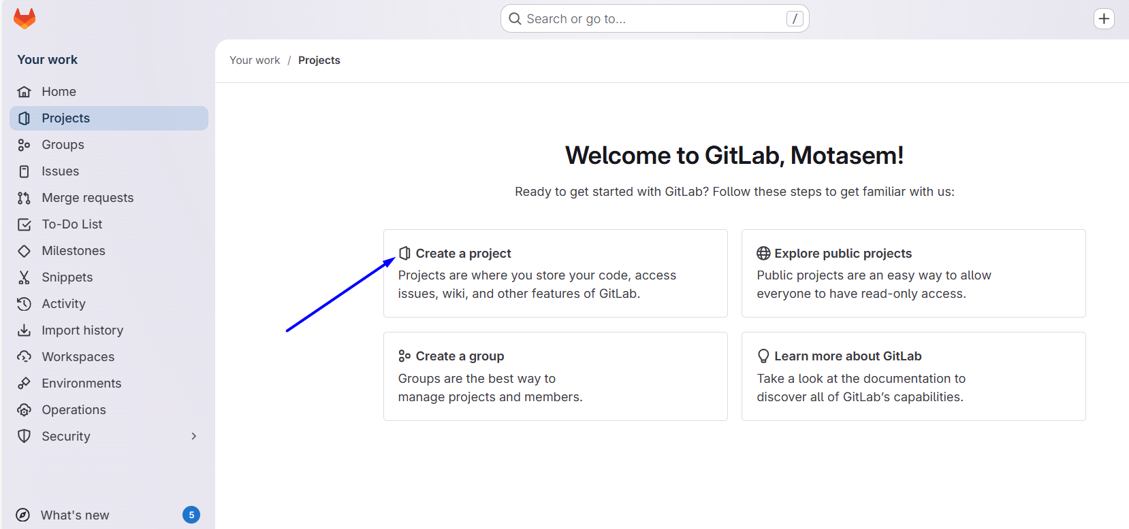
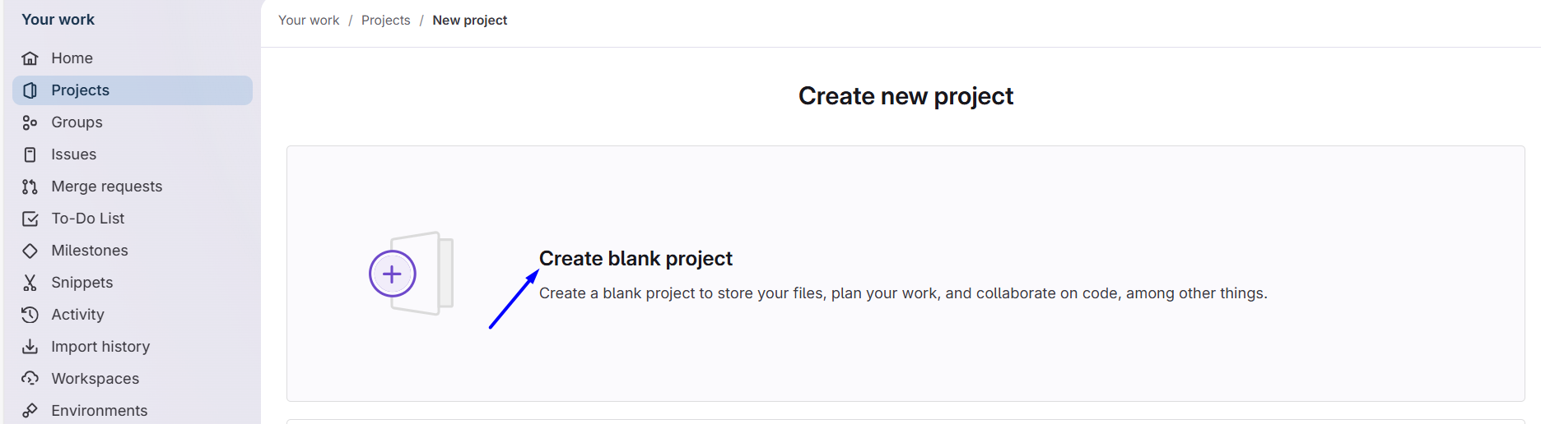
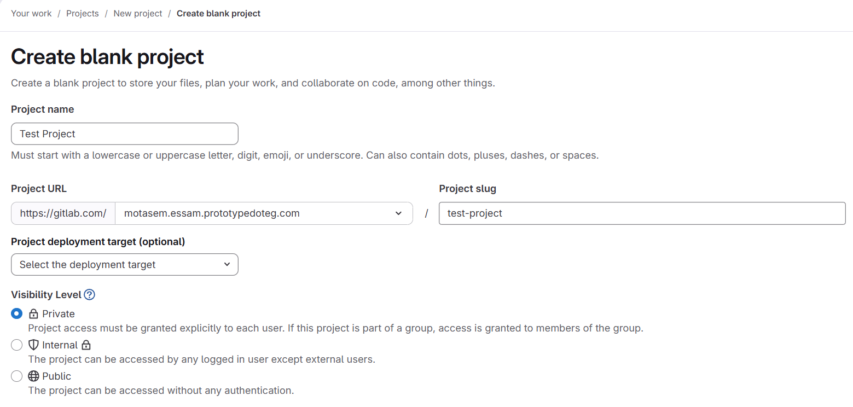
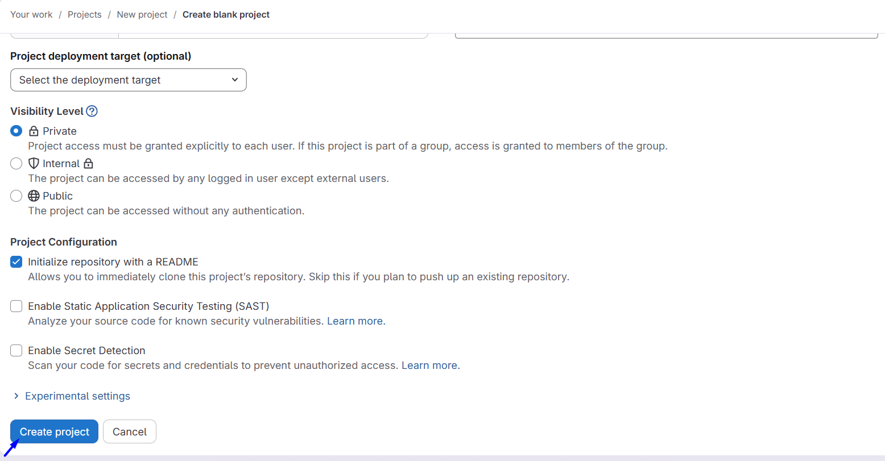
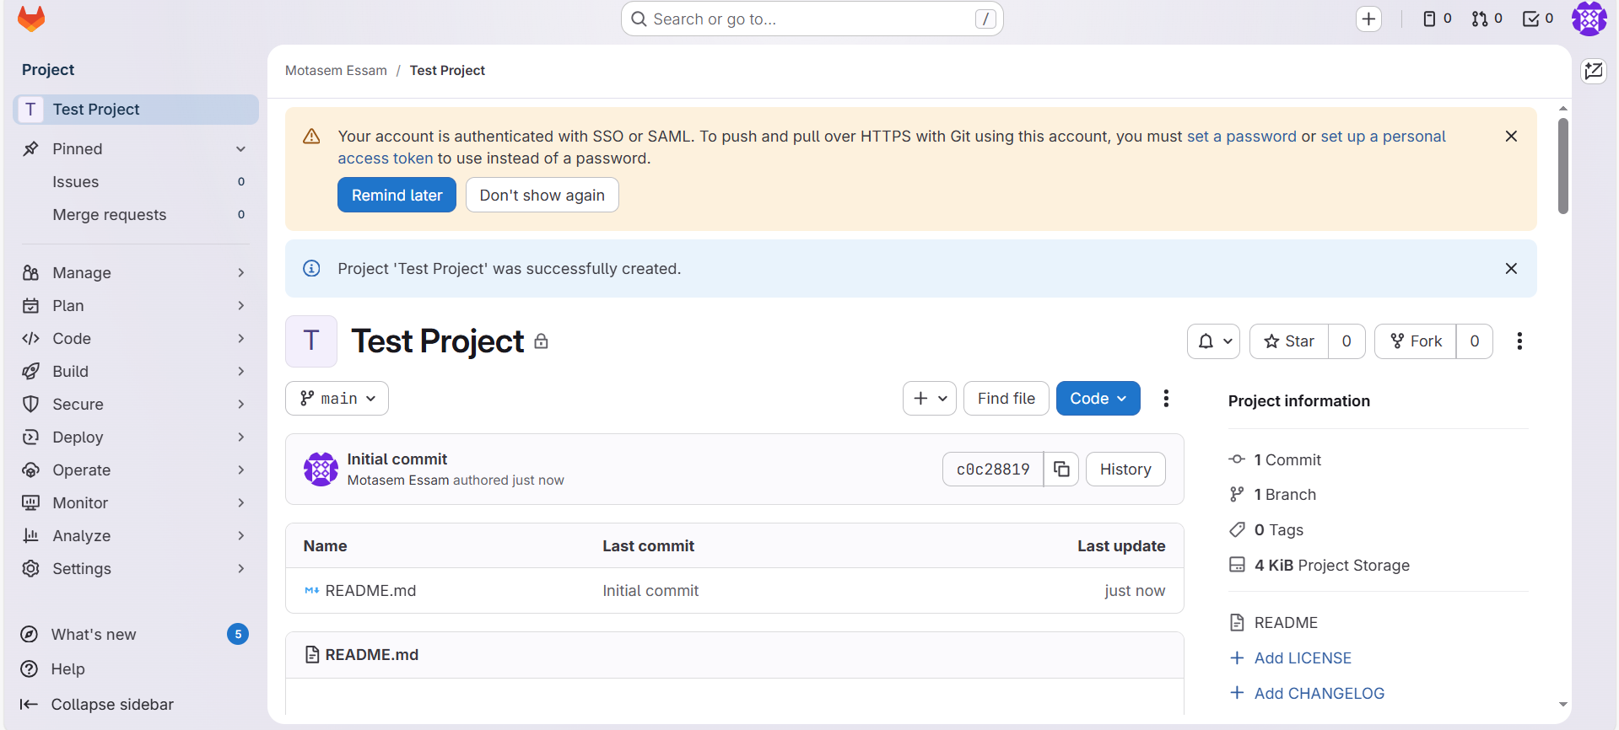

Edit Readme
# Source: ScreenShots Source: Provided by: [Persons Table -> ID Column: 1, Name_En Column: Motasem Essam] -> Tool: [Lightshot Program] -> From [Site: https://gitlab.com] on [2/17/2026]
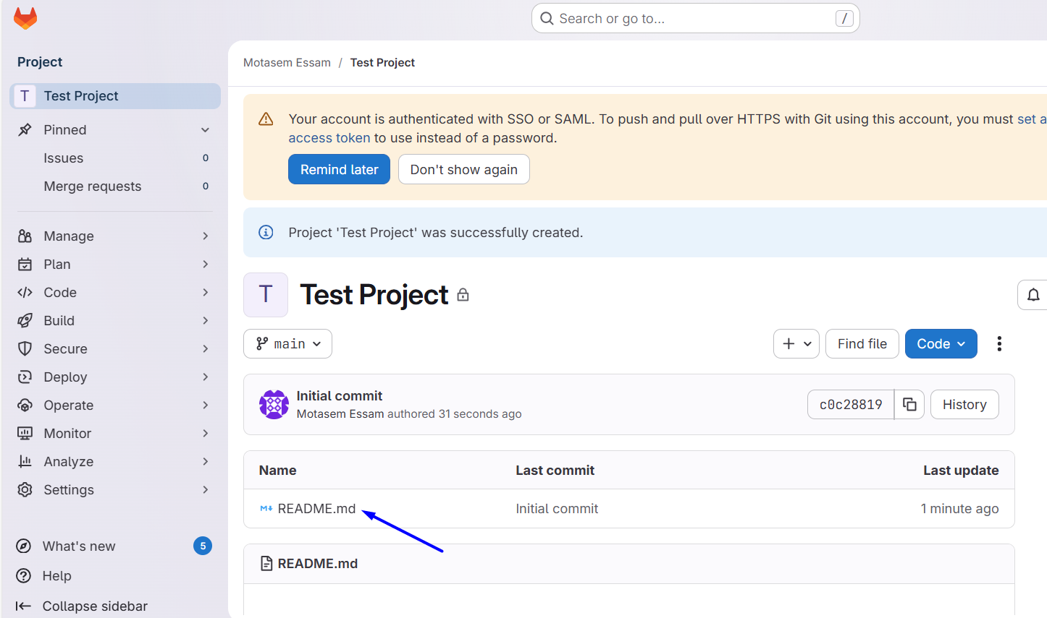

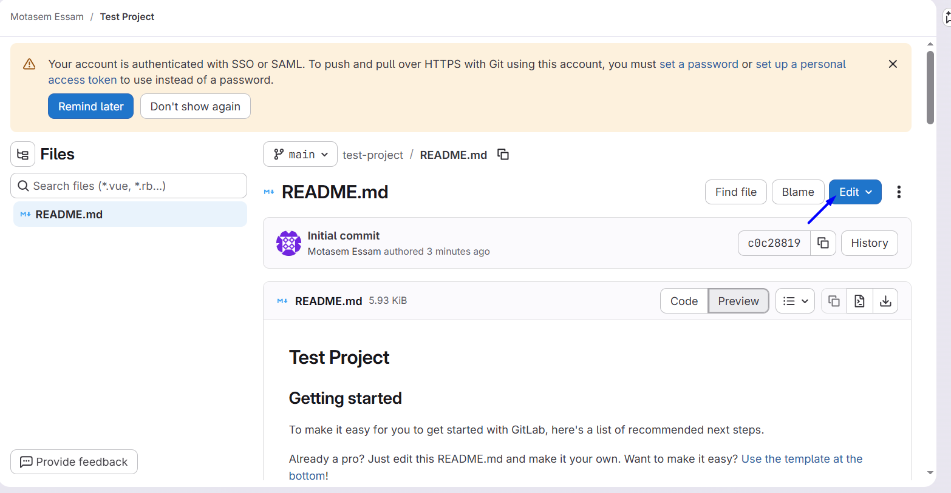
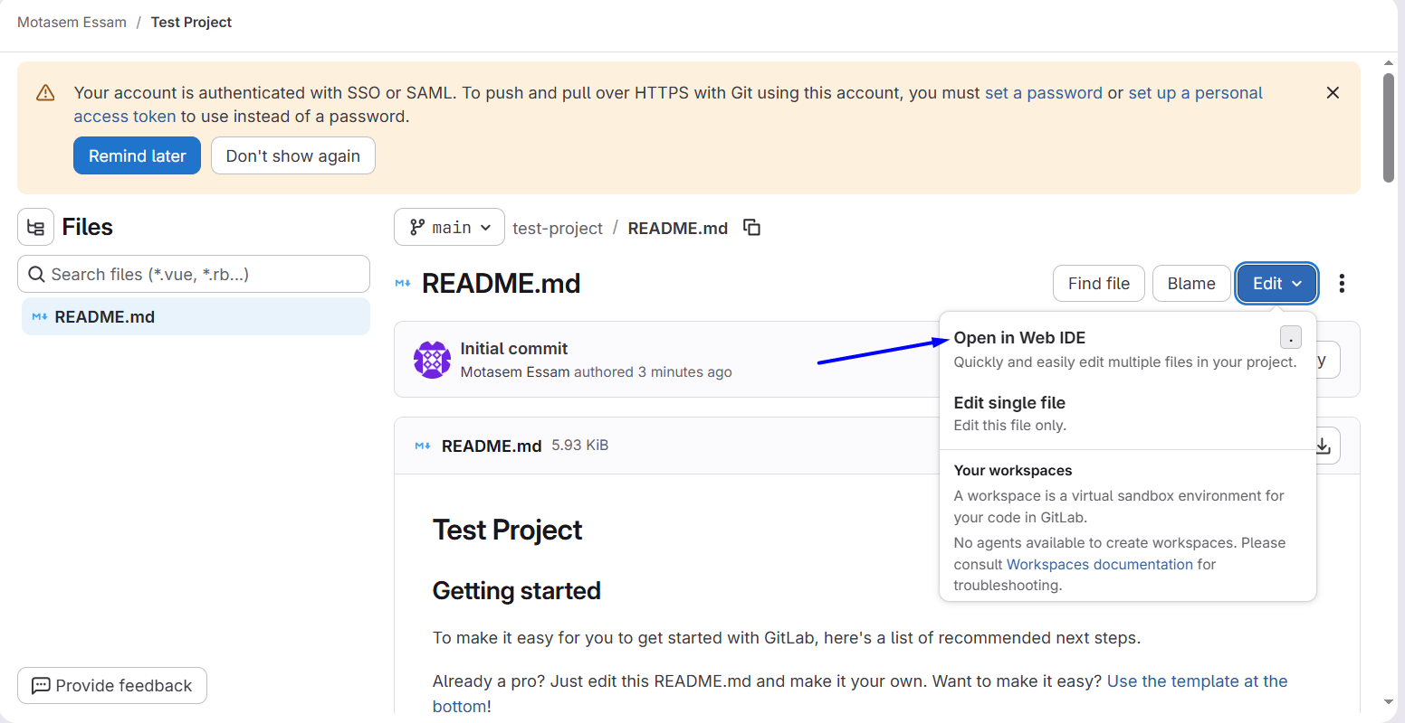
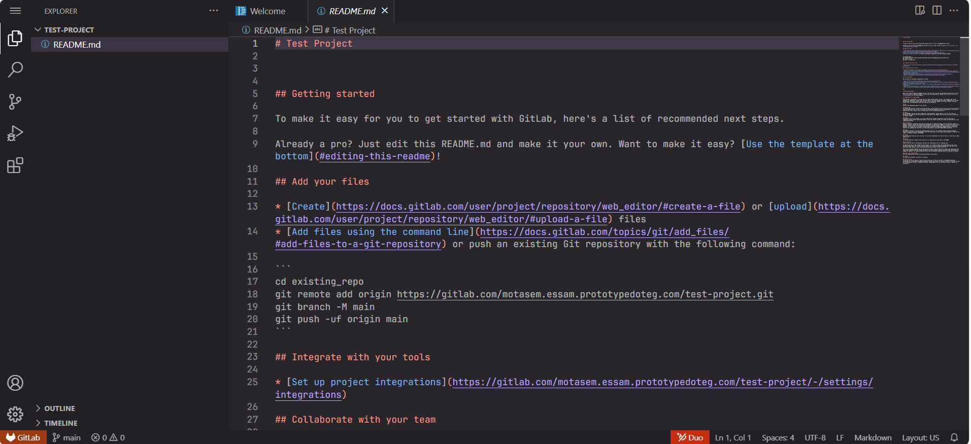
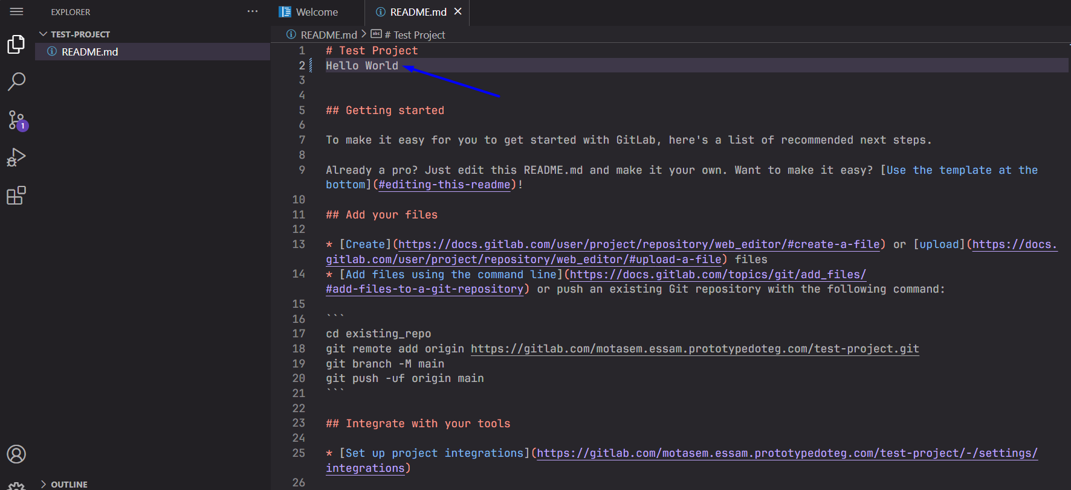
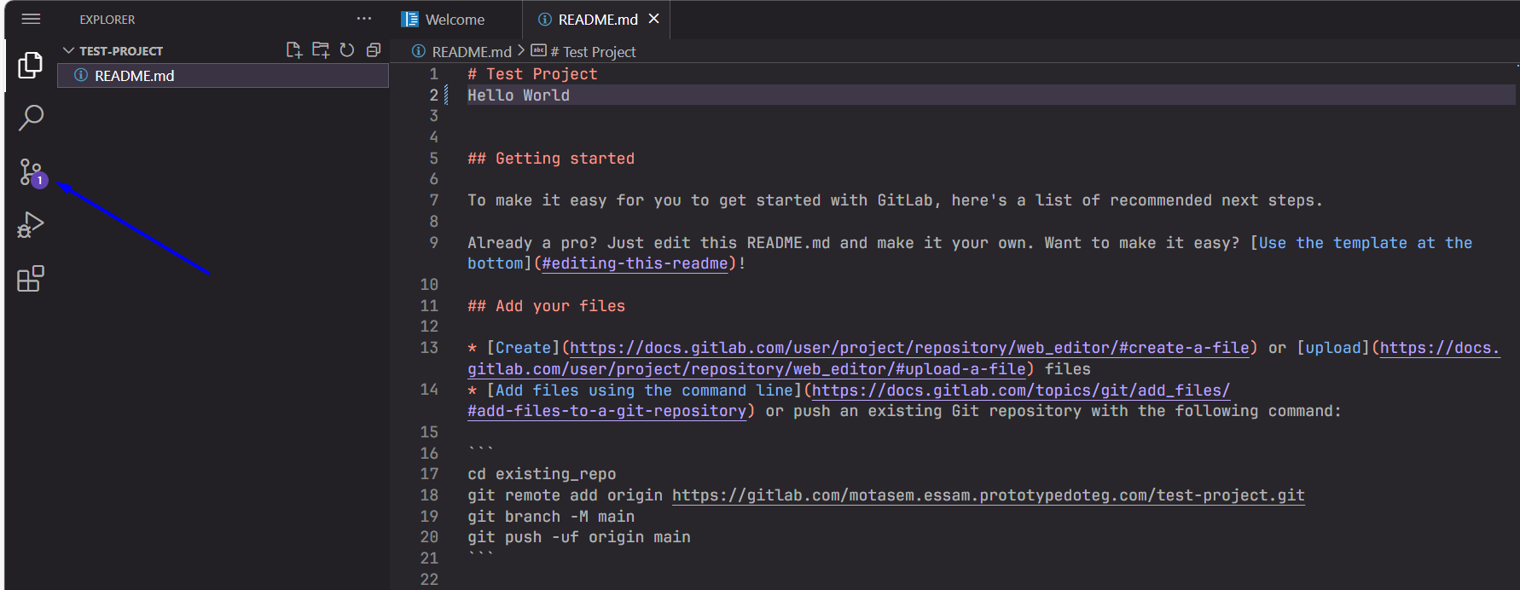
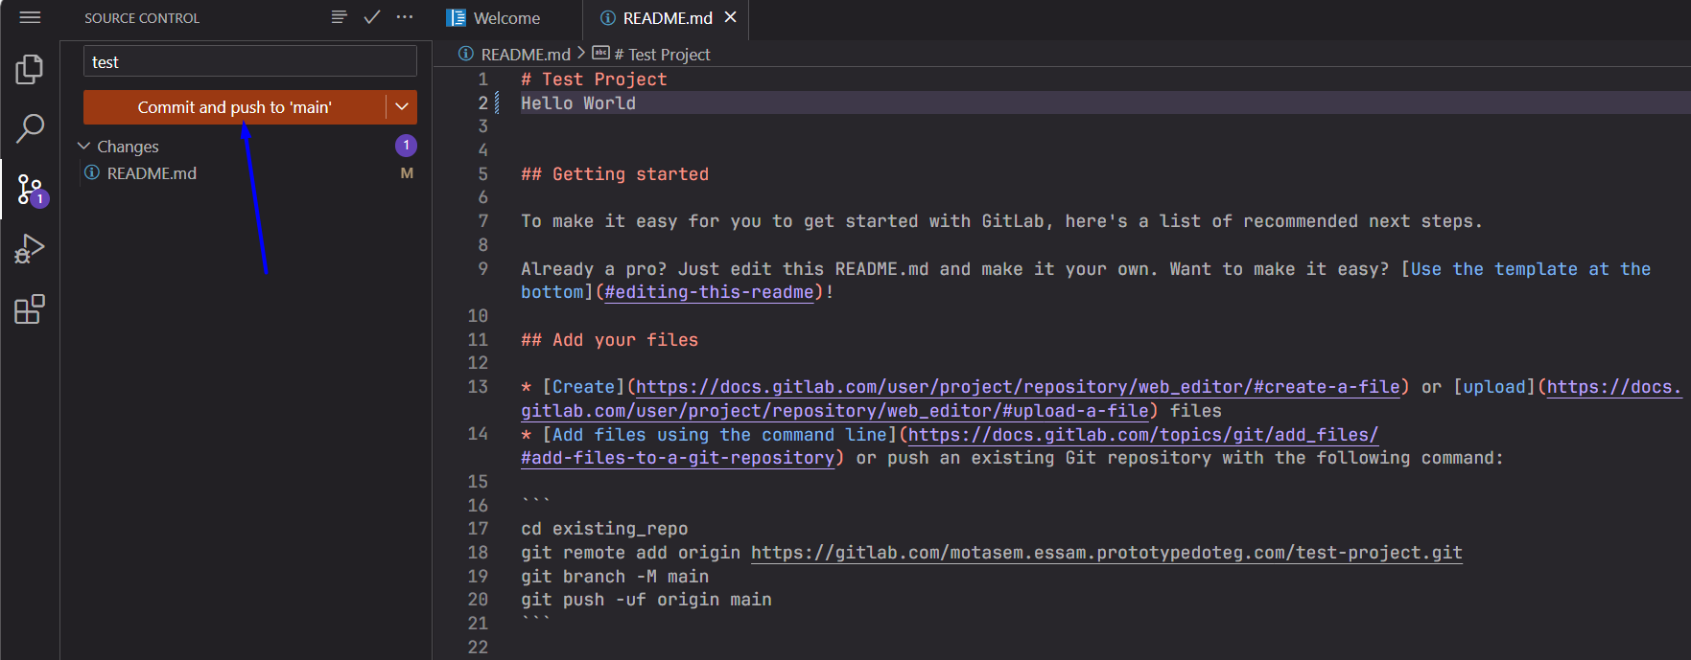
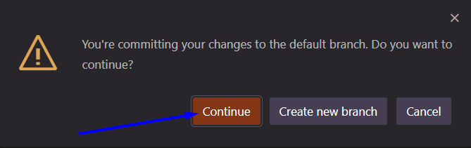
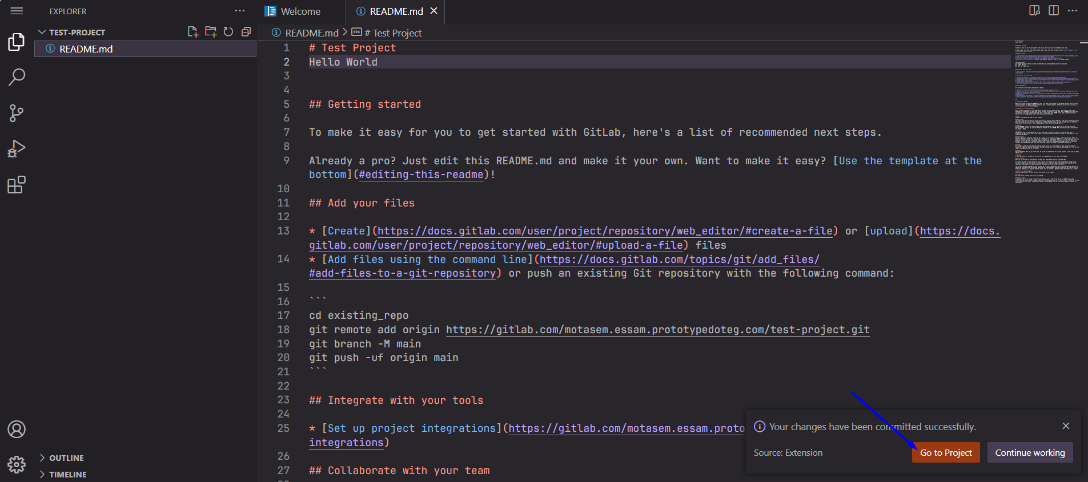
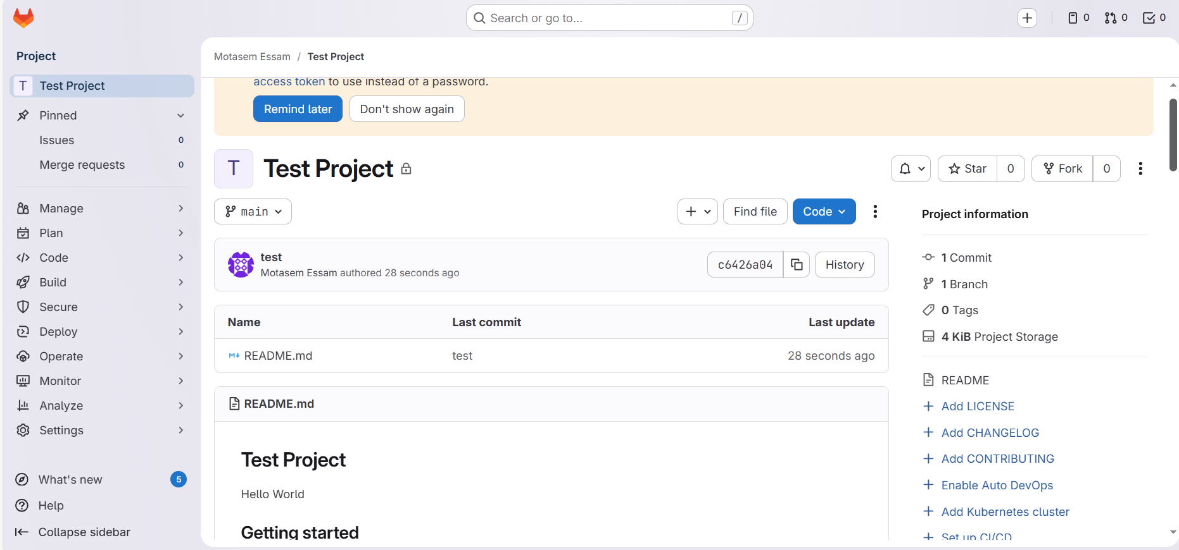

Clone Repository

Clone with SSH

Create SSH key
# Source: AI Source: Provided by: [Data Path: Persons Table -> ID Column: 1, Name_En Column: Motasem Essam] -> From: [Chatgpt (GPT‑5 Mini)] on [2/17/2026]

That will:
- Save the private key to:
C:\Users\tom\.ssh\id_ed25519
- Save the public key to:
C:\Users\tom\.ssh\id_ed25519.pub
This is the recommended default location

# Source: ScreenShots Source: Provided by: [Persons Table -> ID Column: 1, Name_En Column: Motasem Essam] -> Tool: [Lightshot Program] -> From [Windows] on [2/17/2026]

$ ssh-keygen -t ed25519 -C "web75735@gmail.com"





$ ssh-keygen -t ed25519 -C "web75735@gmail.com"
Generating public/private ed25519 key pair.
Enter file in which to save the key (/c/Users/tom/.ssh/id_ed25519): test
Enter passphrase for "test" (empty for no passphrase):
Enter same passphrase again:
Your identification has been saved in test
Your public key has been saved in test.pub
The key fingerprint is:
SHA256:TGW9DDIV+pKrrLbyaUiyD0FX9ZNGIIVkRDBUAWYpML4 web75735@gmail.com
The key's randomart image is:
+--[ED25519 256]--+
|+ .BOX=+.o=o |
|.oo.+.. =+o . |
| o.. oB o . |
|. o o.o. o |
|.E S . |
|... o |
|.+ . . |
|..o oo . |
| ..==oo |
+----[SHA256]-----+

Get SSH key
# Source: AI Source: Provided by: [Data Path: Persons Table -> ID Column: 1, Name_En Column: Motasem Essam] -> From: [Chatgpt (GPT‑5 Mini)] on [2/17/2026]
The command cat stands for “display the contents of a file in the terminal”.

# Source: ScreenShots Source: Provided by: [Persons Table -> ID Column: 1, Name_En Column: Motasem Essam] -> Tool: [Lightshot Program] -> From [Windows] on [2/17/2026]

cat test.pub
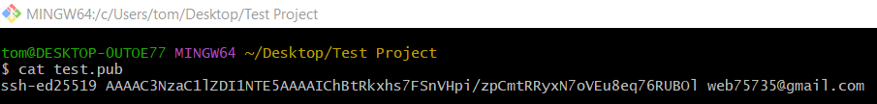
ssh-ed25519 AAAAC3NzaC1lZDI1NTE5AAAAIChBtRkxhs7FSnVHpi/zpCmtRRyxN7oVEu8eq76RUBOl web75735@gmail.com

Add SSH KEY
# Source: ScreenShots Source: Provided by: [Persons Table -> ID Column: 1, Name_En Column: Motasem Essam] -> Tool: [Lightshot Program] -> From [Site: https://gitlab.com] on [2/17/2026]
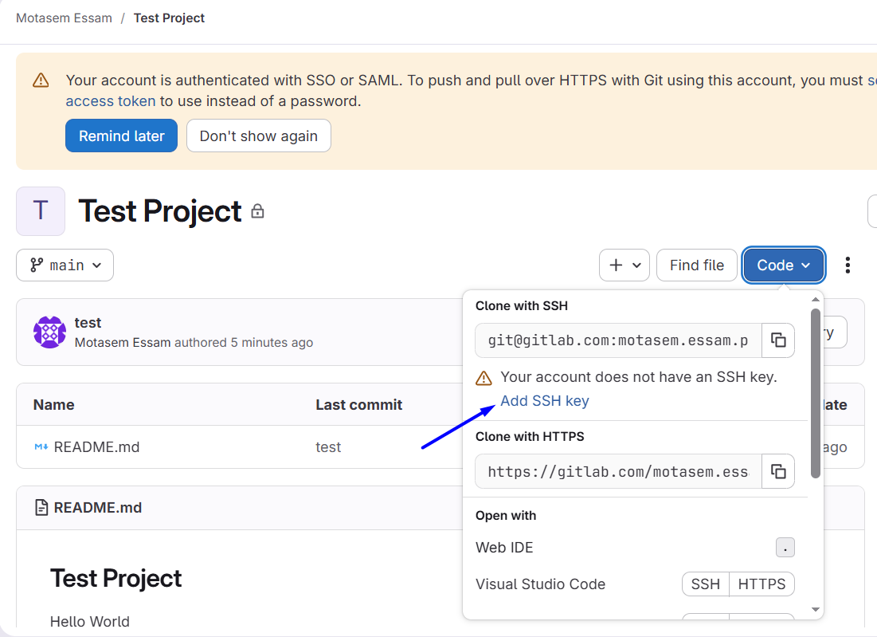
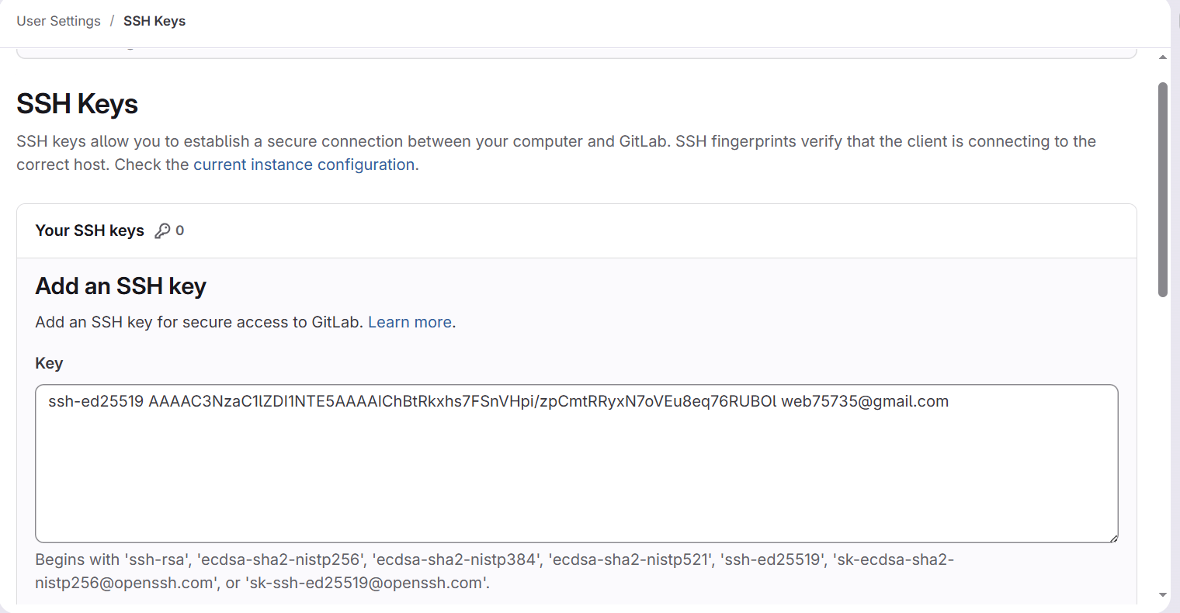
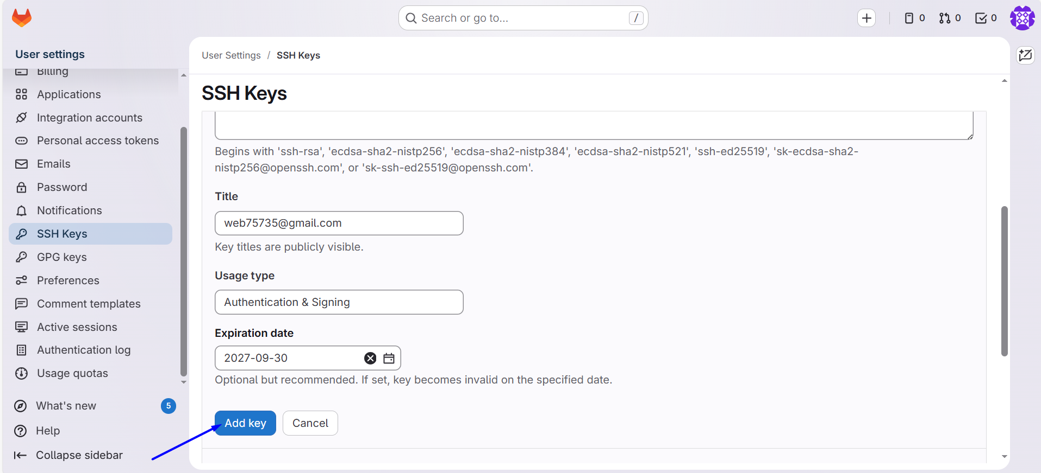
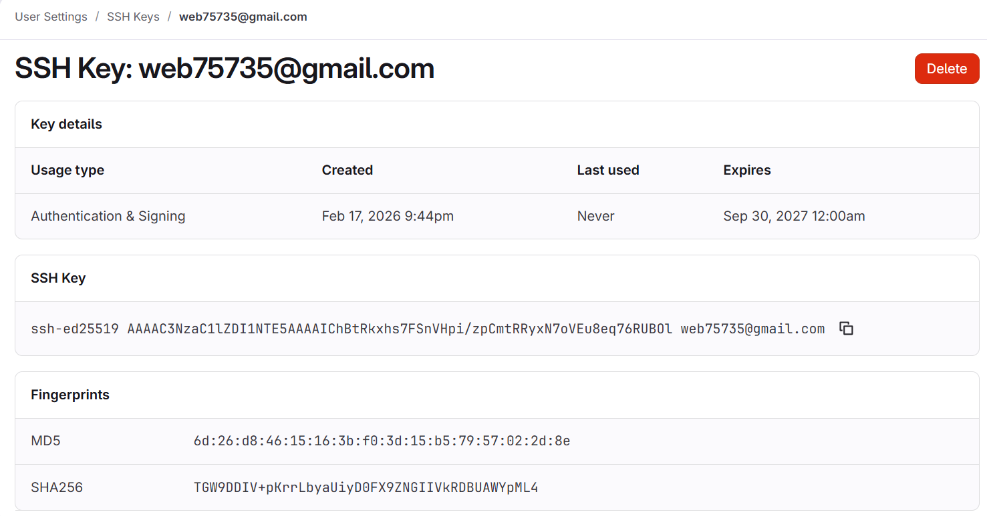

Clone Repository
# Source: ScreenShots Source: Provided by: [Persons Table -> ID Column: 1, Name_En Column: Motasem Essam] -> Tool: [Lightshot Program] -> From [Site: https://gitlab.com] on [2/17/2026]
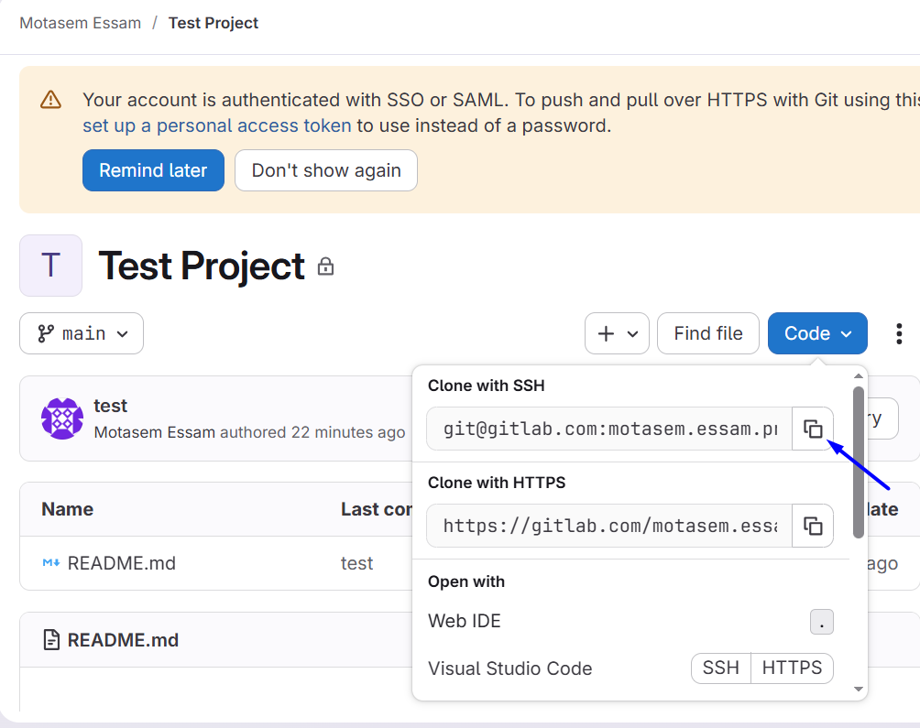

# Source: ScreenShots Source: Provided by: [Persons Table -> ID Column: 1, Name_En Column: Motasem Essam] -> Tool: [Lightshot Program] -> From [Windows] on [2/17/2026]


eval "$(ssh-agent -s)"
ssh-add test


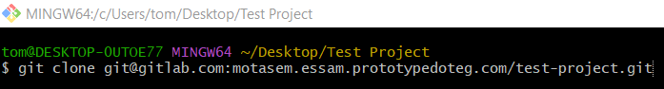
git clone git@gitlab.com:motasem.essam.prototypedoteg.com/test-project.git
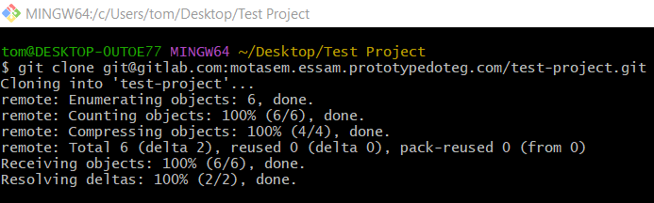
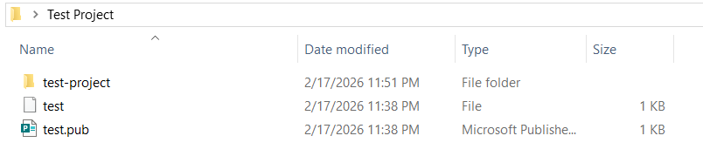

Clone with HTTPS

Normal Clone
# Source: AI Source: Provided by: [Data Path: Persons Table -> ID Column: 1, Name_En Column: Motasem Essam] -> From: [Chatgpt (GPT‑5 Mini)] on [2/17/2026]
For GitLab HTTPS, the username should be your GitLab username, not your email or token.
Example:
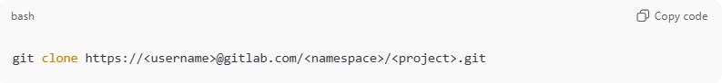
git clone https://<username>@gitlab.com/<namespace>/<project>.git
- <username> → your GitLab username (e.g., motasem.essam)
- When prompted for password → paste your PAT

# Source: ScreenShots Source: Provided by: [Persons Table -> ID Column: 1, Name_En Column: Motasem Essam] -> Tool: [Lightshot Program] -> From [Site: https://gitlab.com] on [2/17/2026]
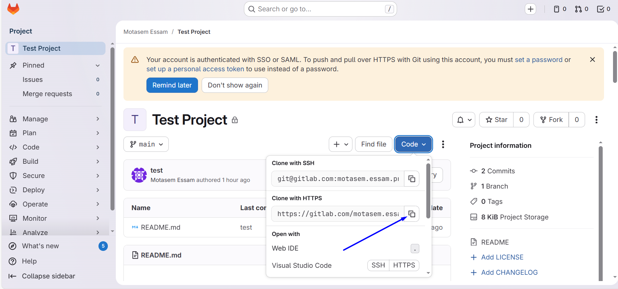
https://gitlab.com/motasem.essam.prototypedoteg.com/test-project.git

# Source: ScreenShots Source: Provided by: [Persons Table -> ID Column: 1, Name_En Column: Motasem Essam] -> Tool: [Lightshot Program] -> From [Windows] on [2/17/2026]
git clone https://motasem.essam.prototypedoteg.com@gitlab.com/motasem.essam.prototypedoteg.com/test-project.git

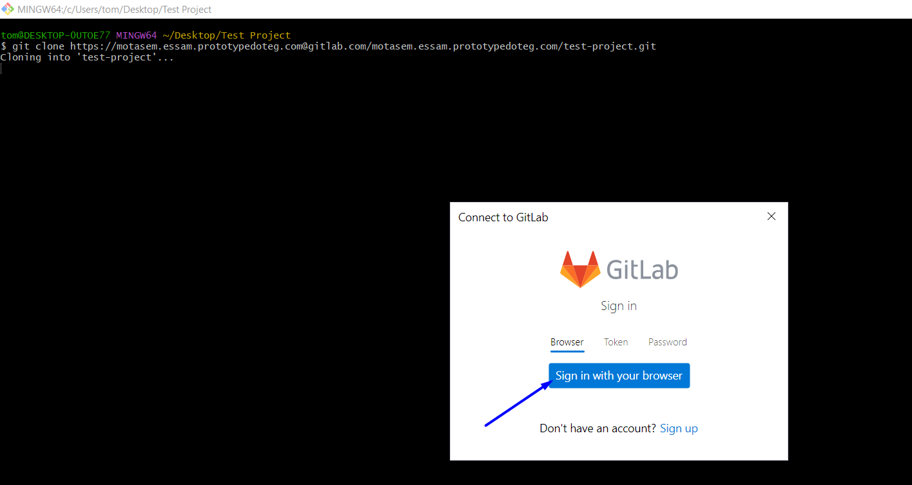
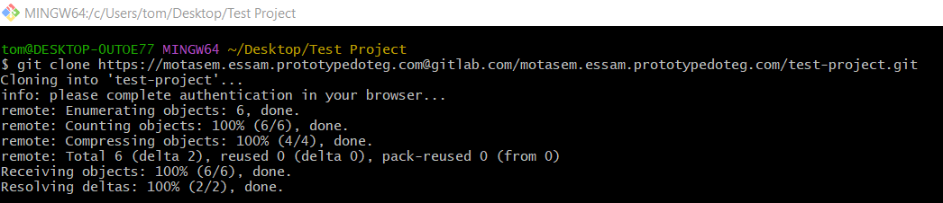

# Source: ScreenShots Source: Provided by: [Persons Table -> ID Column: 1, Name_En Column: Motasem Essam] -> Tool: [Lightshot Program] -> From [Site: https://gitlab.com] on [2/17/2026]
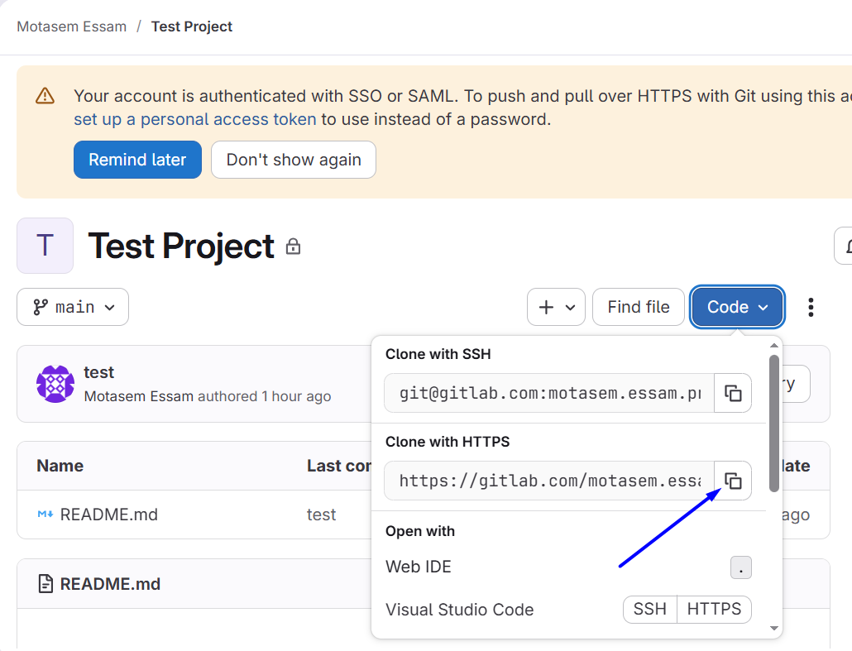

# Source: ScreenShots Source: Provided by: [Persons Table -> ID Column: 1, Name_En Column: Motasem Essam] -> Tool: [Lightshot Program] -> From [Windows] on [2/17/2026]

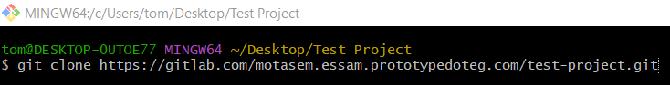
git clone https://gitlab.com/motasem.essam.prototypedoteg.com/test-project.git

Clone with Personal access tokens
# Source: AI Source: Provided by: [Data Path: Persons Table -> ID Column: 1, Name_En Column: Motasem Essam] -> From: [Chatgpt (GPT‑5 Mini)] on [2/17/2026]
Here’s how to create a Personal Access Token (PAT) in GitLab step by step:

1️⃣ Open GitLab Token Page
Go directly to:
https://gitlab.com/-/profile/personal_access_tokens
Or manually:
- Click your avatar (top right) → Edit profile
- Left sidebar → Access Tokens

2️⃣ Fill in Token Details
- Name: e.g. Git HTTPS Token
- Expiration date: choose a date (recommended for security)
- Scopes (permissions):
For normal Git usage select:
- ✅ read_repository → clone & pull
- ✅ write_repository → push (optional but recommended)
(Optional scopes)
- api → only if you use GitLab API
- read_user → rarely needed

3️⃣ Create the Token
Click Create personal access token
⚠️ IMPORTANT:
- Copy the token immediately (you won’t see it again)
- Treat it like a password (never share it)

4️⃣ Use the Token with Git (HTTPS)
Clone normally:
git clone https://gitlab.com/USERNAME/REPO.git
When Git asks:
Username: your_gitlab_username
Password: <paste your token>
👉 The token replaces your password.

5️⃣ (Optional) Save the Token So You Don’t Re-enter It
git config --global credential.helper manager
Then clone/push once → Git will store the token securely.

Common Errors
HTTP Basic: Access denied
→ Token missing read_repository scope OR wrong token
403 You are not allowed
→ No permission to that repo OR wrong account
Authentication failed
→ Token expired or copied incorrectly

# Source: ScreenShots Source: Provided by: [Persons Table -> ID Column: 1, Name_En Column: Motasem Essam] -> Tool: [Lightshot Program] -> From [Site: https://gitlab.com] on [2/17/2026]
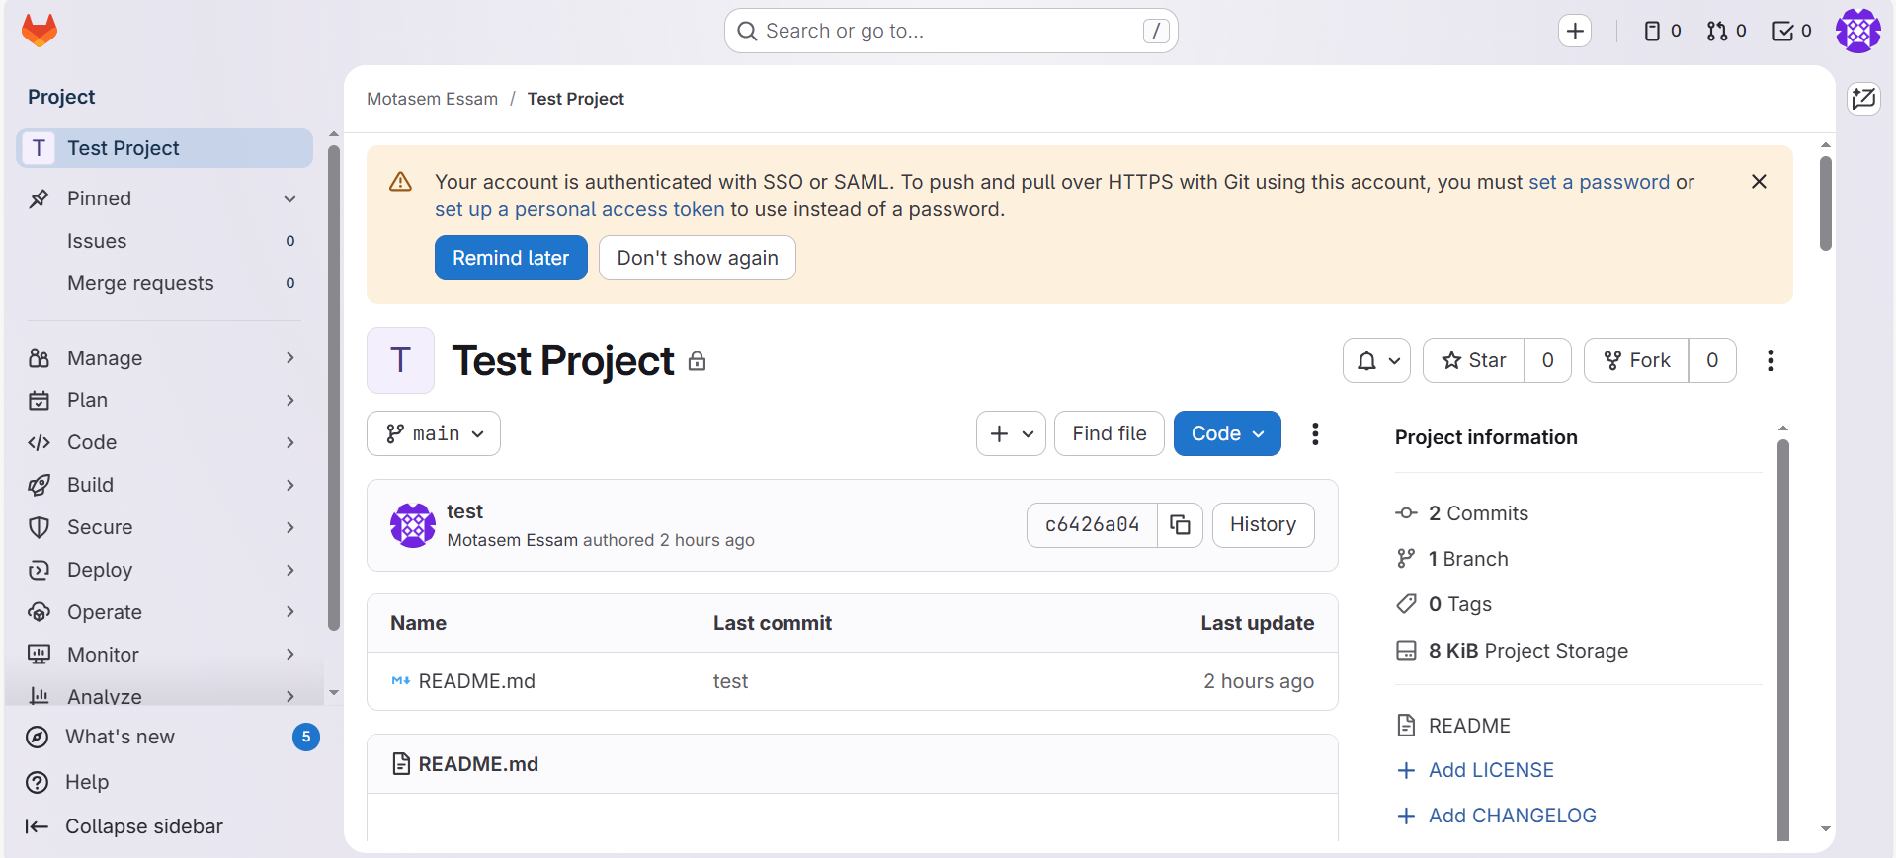
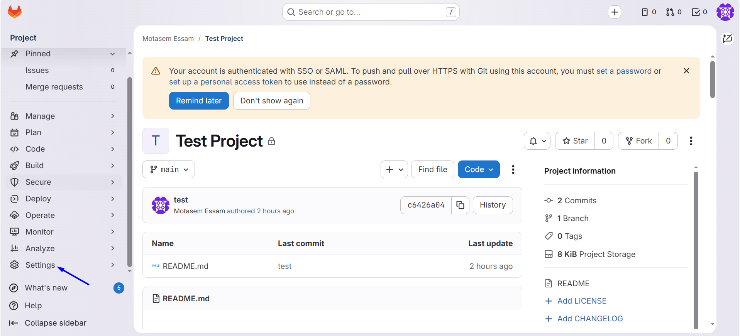
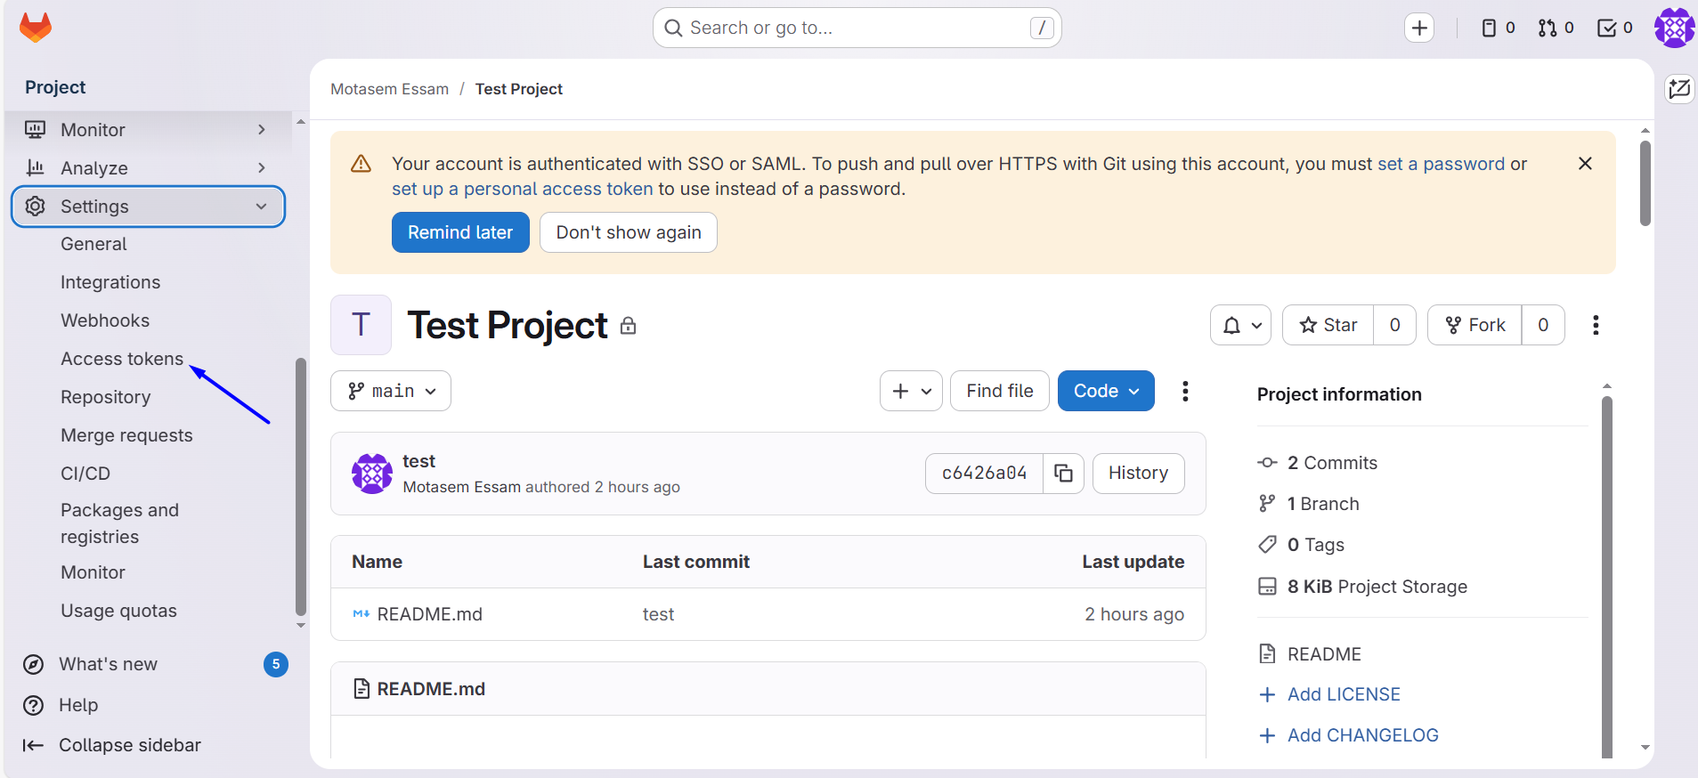
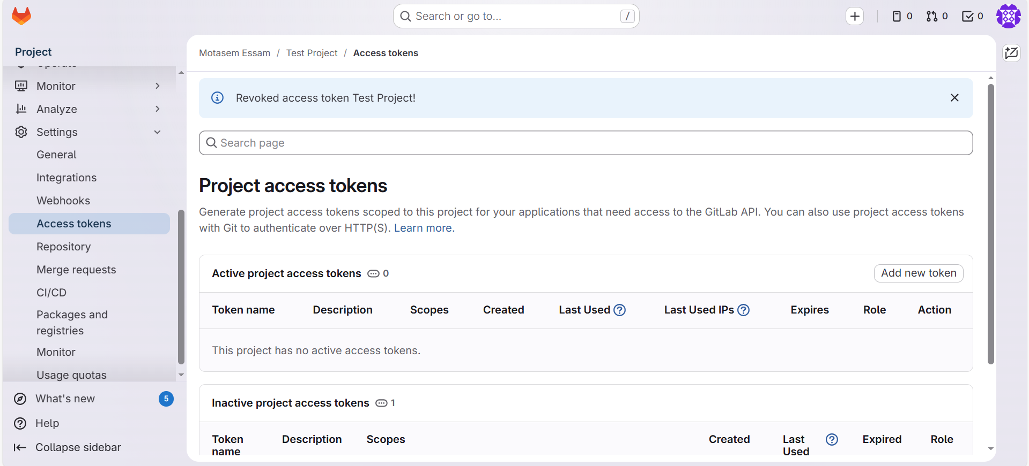

Git GUI

Create New Repository
# Source: ScreenShots Source: Provided by: [Persons Table -> ID Column: 1, Name_En Column: Motasem Essam] -> Tool: [Lightshot Program] -> From [Windows] on [2/17/2026]
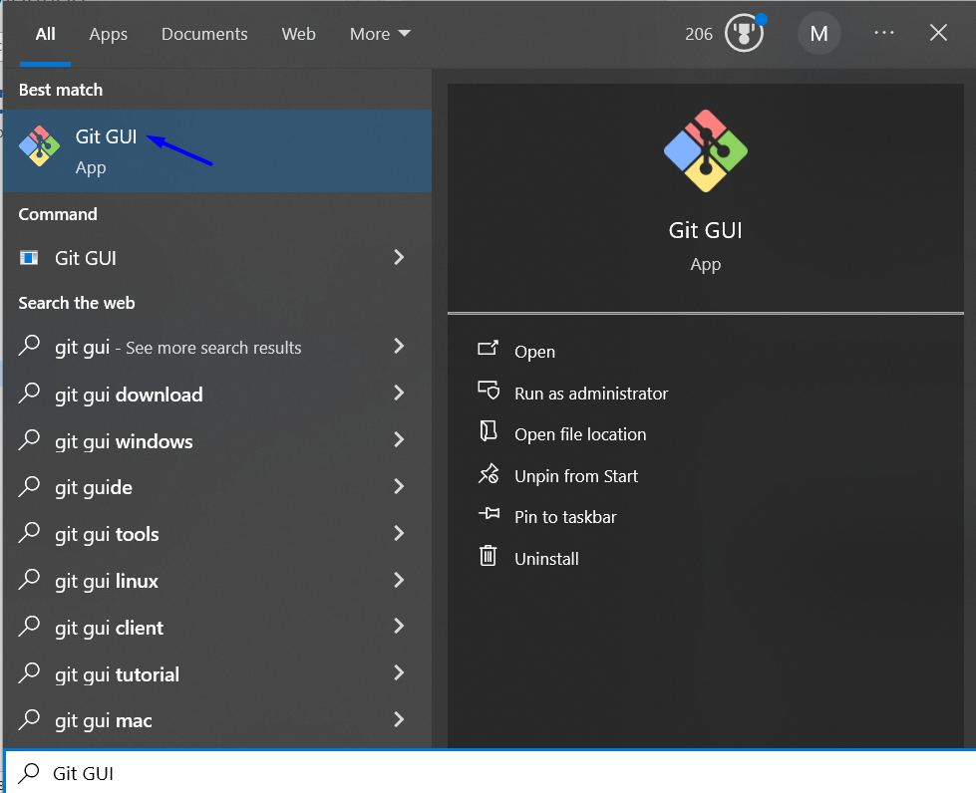
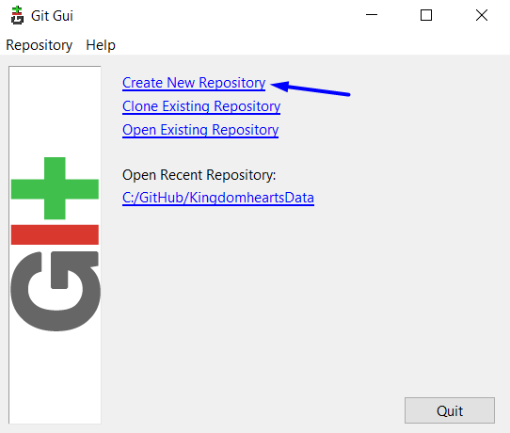
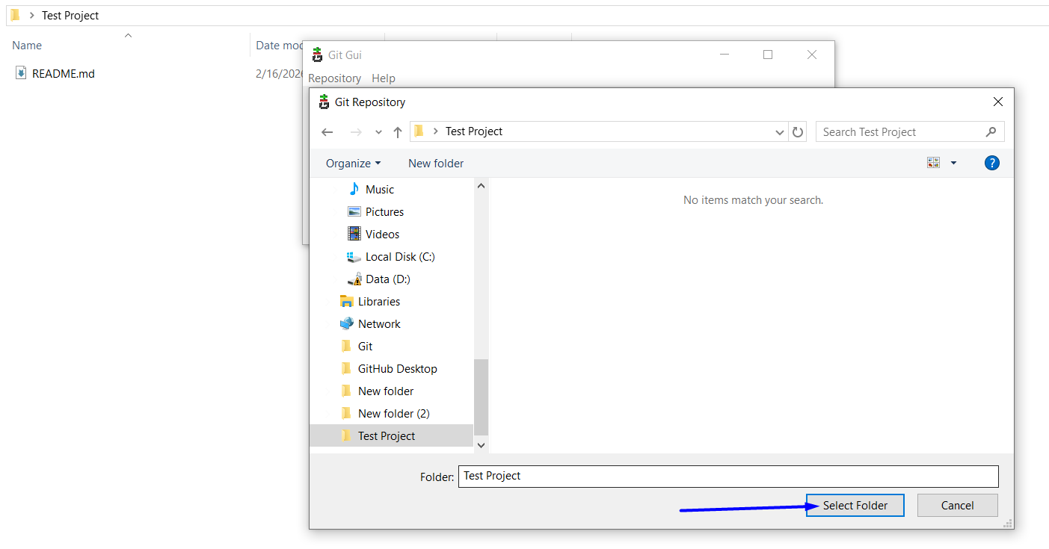
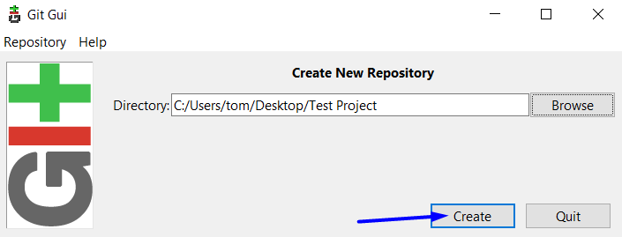
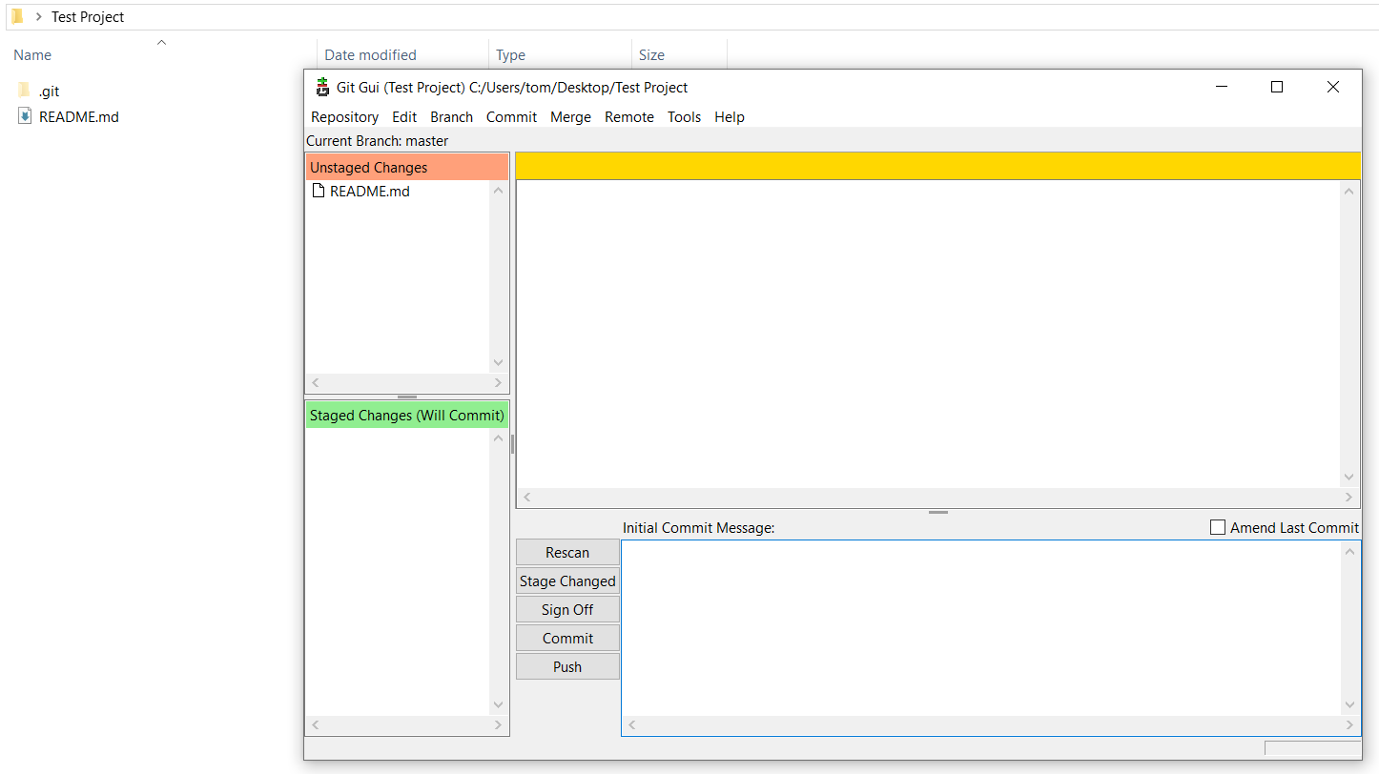

Already Exists Errors
# Source: ScreenShots Source: Provided by: [Persons Table -> ID Column: 1, Name_En Column: Motasem Essam] -> Tool: [Lightshot Program] -> From [Windows] on [2/17/2026]


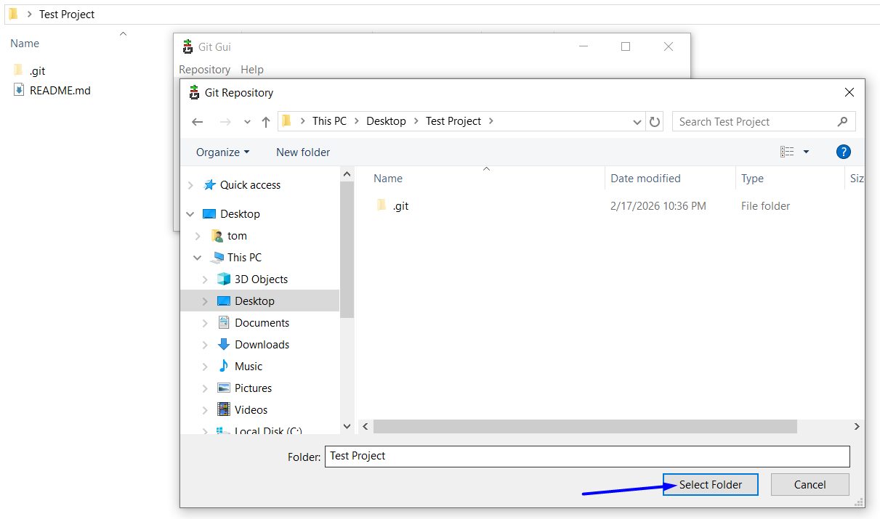
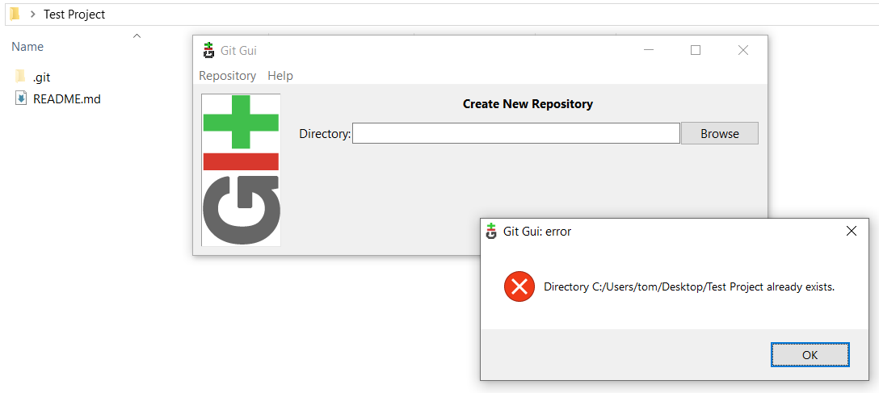
# Source: Person Source: Provided by: [Data Path: Persons Table -> ID Column: 1, Name_En Column: Motasem Essam] Written by: [Data Path: Persons Table -> ID Column: 1, Name_En Column: Motasem Essam] on [2/17/2026]
Be sure to choose folder that has no. git Folder

Open Existing Repository
# Source: ScreenShots Source: Provided by: [Persons Table -> ID Column: 1, Name_En Column: Motasem Essam] -> Tool: [Lightshot Program] -> From [Windows] on [2/17/2026]
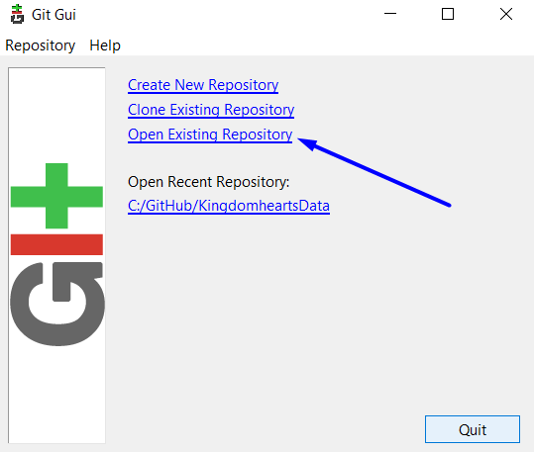
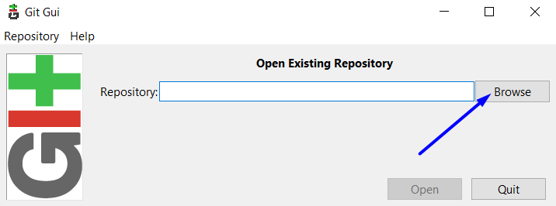
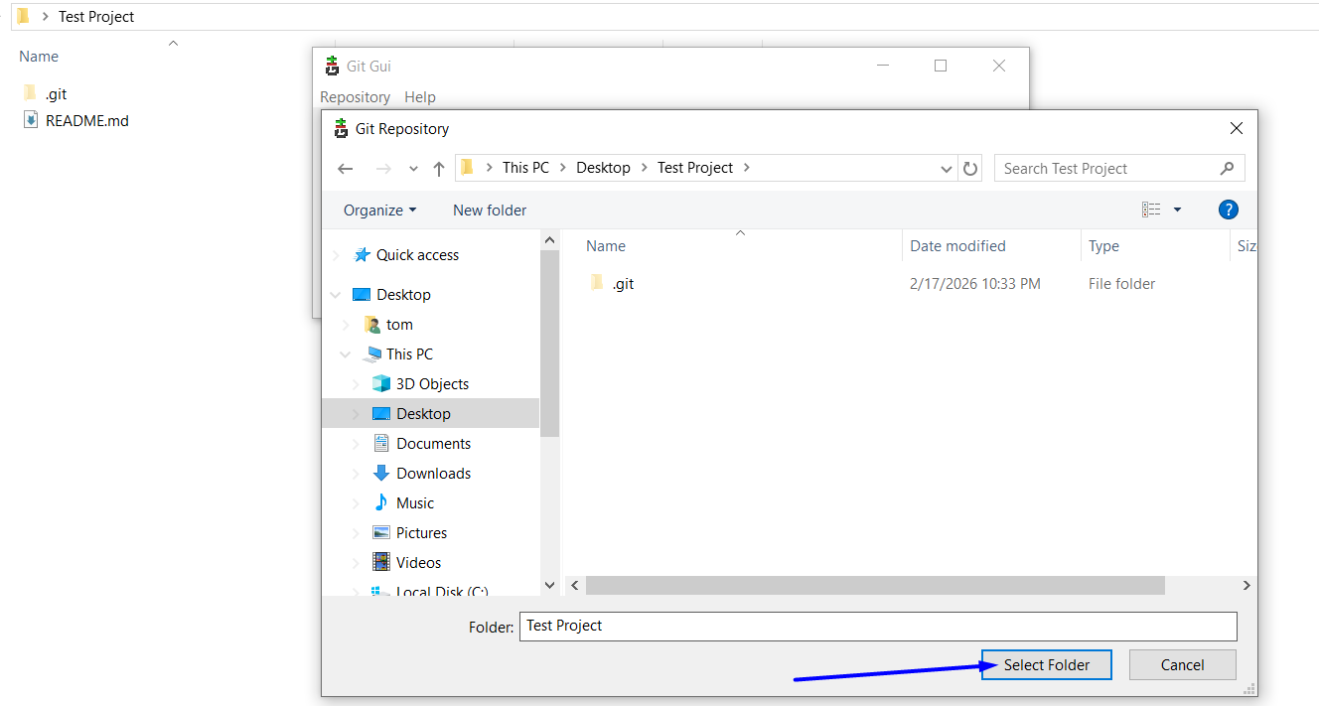
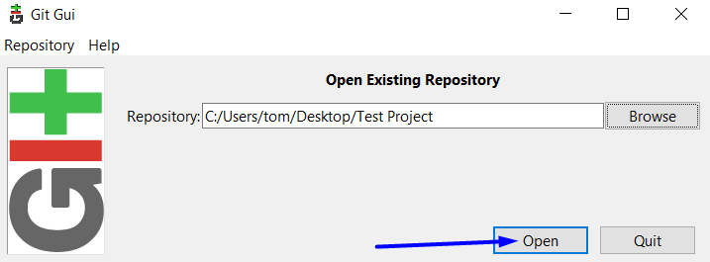
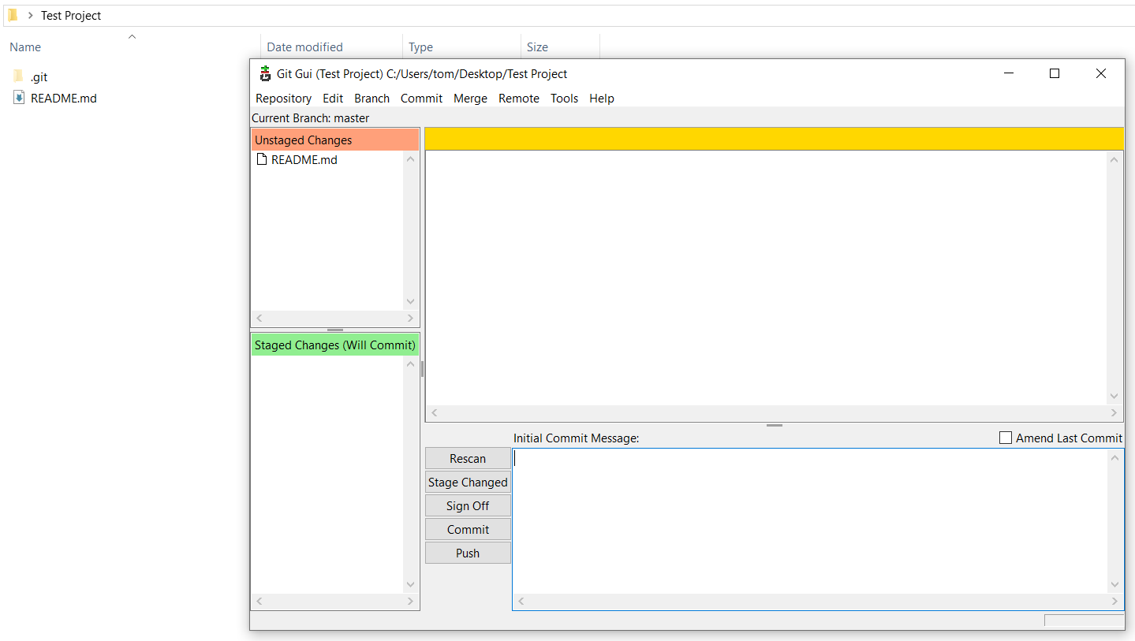

Clone Existing Repository
# Source: ScreenShots Source: Provided by: [Persons Table -> ID Column: 1, Name_En Column: Motasem Essam] -> Tool: [Lightshot Program] -> From [Windows] on [2/17/2026]
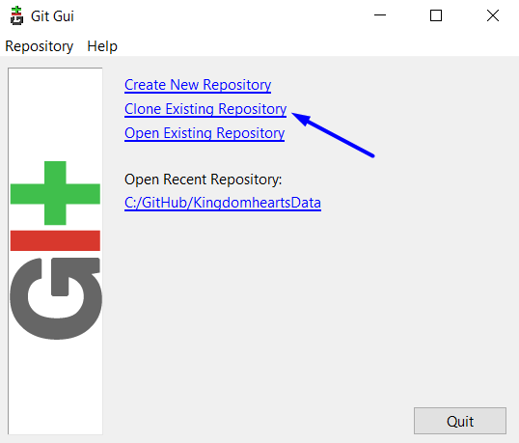
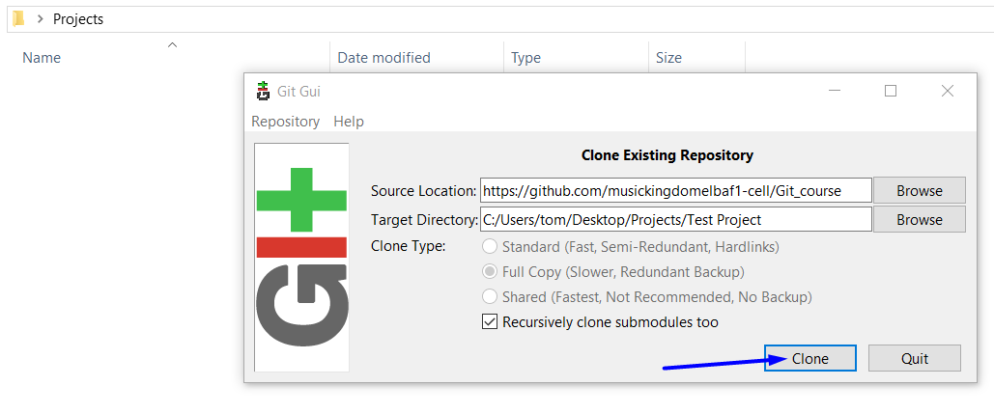
https://github.com/musickingdomelbaf1-cell/Git_course
C:/Users/tom/Desktop/Projects/Test Project
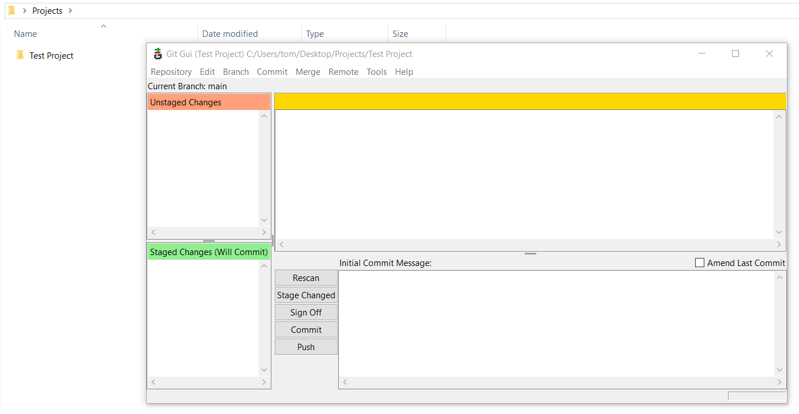
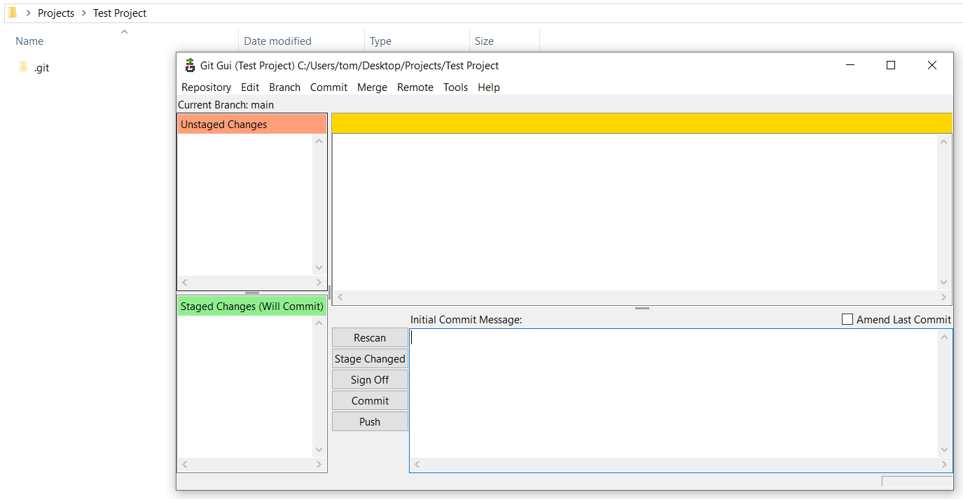

Already Exists Errors
# Source: ScreenShots Source: Provided by: [Persons Table -> ID Column: 1, Name_En Column: Motasem Essam] -> Tool: [Lightshot Program] -> From [Windows] on [2/17/2026]

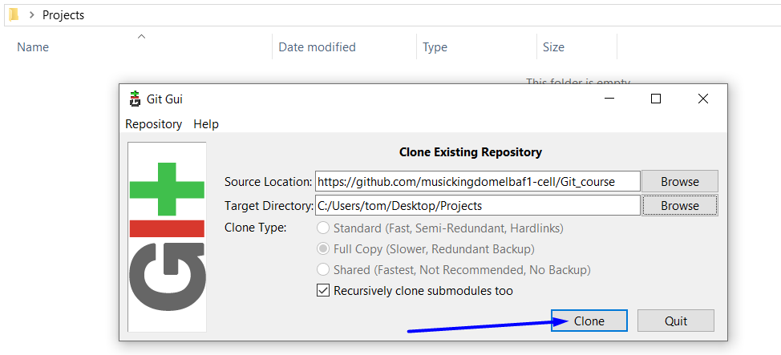
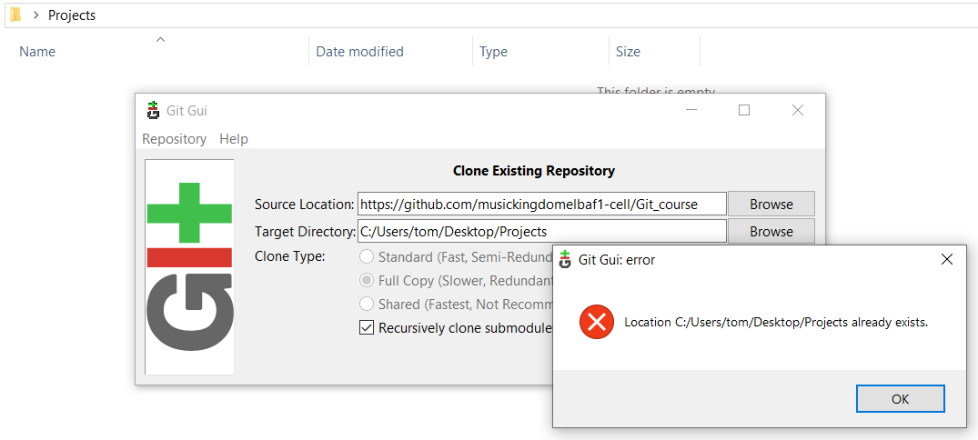
https://github.com/musickingdomelbaf1-cell/Git_course
C:/Users/tom/Desktop/Projects

# Source: Person Source: Provided by: [Data Path: Persons Table -> ID Column: 1, Name_En Column: Motasem Essam] Written by: [Data Path: Persons Table -> ID Column: 1, Name_En Column: Motasem Essam] on [2/17/2026]
when clone to Target Directory Don’t write folder already exists
but write folder is not exist

